AMBA AHB ARBITER

Table of Contents

Author 2
Copyright & License 2
Revision No. 2
Disclaimer 2
Introduction 3
Limitations of Design 3
Synthesizability 3
Port Definitions 4
Black Box....................................................................................................................................5
Reset operation 6
Default Master.............................................................................................................................7
Master Switch over ......................8
Clock cycle delay in master switch over.....................................................................................9
Wrap cycle with wait state 10
General Doubts Related to AHB Specification....................................................................11
References...........................................................................................................................11

Author
TooMuch Semiconductor Solutions (info@toomuchsemi.com)

Copyright & License
Copyright (c) 2007 TooMuch Semiconductor Solutions Pvt Ltd.

Revision No.
1.0

Disclaimer
This source file may be used and distributed without restriction provided that this copyright statement is not removed from the file and that any derivative work contains the original copyright notice and the associated disclaimer.
This software is provided “as is” and without any express or implied warranties, including, but not limited to, the implied warranties of merchantability and fitness for a particular purpose. in no event shall the author or contributors be liable for any direct, indirect, incidental, special, exemplary, or consequential damages (including, but not limited to, procurement of substitute goods or services; loss of use, data, or profits; or business interruption) however caused and on any theory of liability, whether in contract, strict liability, or tort (including negligence or otherwise) arising in any way out of the use of this software, even if advised of the possibility of such damage.

Introduction
This ARBITER is AMBA AHB complaint. It is designed for generic number of Masters. The priority of the master increments from 8 to 0 (number of master are taken as 9 and can be changed by changing the value of parameter “size”) . The default bus grant goes to master with lowest priority. The address and data bus are taken as 8 bit wide. The burst supported by arbiter are Single, Inc, Inc4, Wrap4, Inc8, Wrap8, Inc16 and Wrap16. The transfer type supported by arbiter are Sequential, Non-Sequential, Idle and Busy.

Limitations of Design
- No error, retry and split cases have been considered in the design.
- Word size is 8 bits. It can be modified as per requirement.
- The change over of the master requires 1 clock cycle.

Synthesizability
This code is completely synthesizable in Xilinx 6.3 i .

Port Definitions

Port Name | Direction | Size | Source
haddr | in | 8 | AHB Master
htrans | in | 2 | AHB Master
hwrite | out | 1 | AHB Master (not supported )
hsize | out | 3 | AHB Master (not supported)
hburst | in | 3 | AHB Master
hwdata | out | 8 | AHB Master
hrdata | out | 32 | AHB Master (not supported)
hready | in | 1 | AHB Slave
hresp | in | 2 | AHB Slave (not supported)
hgrant | out | 4 | Arbiter output
data_out | out | 8 | Arbiter output
addr_out | out | 8 | Arbiter Output
hburst_out | out | 3 | Arbiter Output
htrans_out | out | 2 | Arbiter Output
hmaster | out | 4 | Arbiter Output
hmaster_lock | out | 1 | Arbiter Output
hclk | in | 1 | AHB Master
hresetn | in | 1 | AHB Master

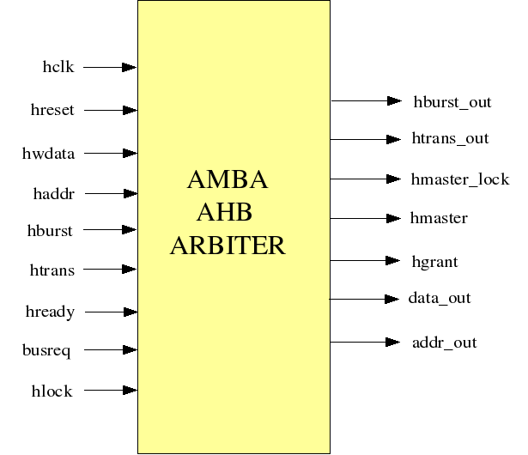

Fig 1: Black Box
Representing Arbiter inputs and outputs

Reset operation
The WISHBONE Reset signal is active Low and is used to reset the system and bus. This reset has been asserted and deasserted synchronously after the rising edge of Clock.

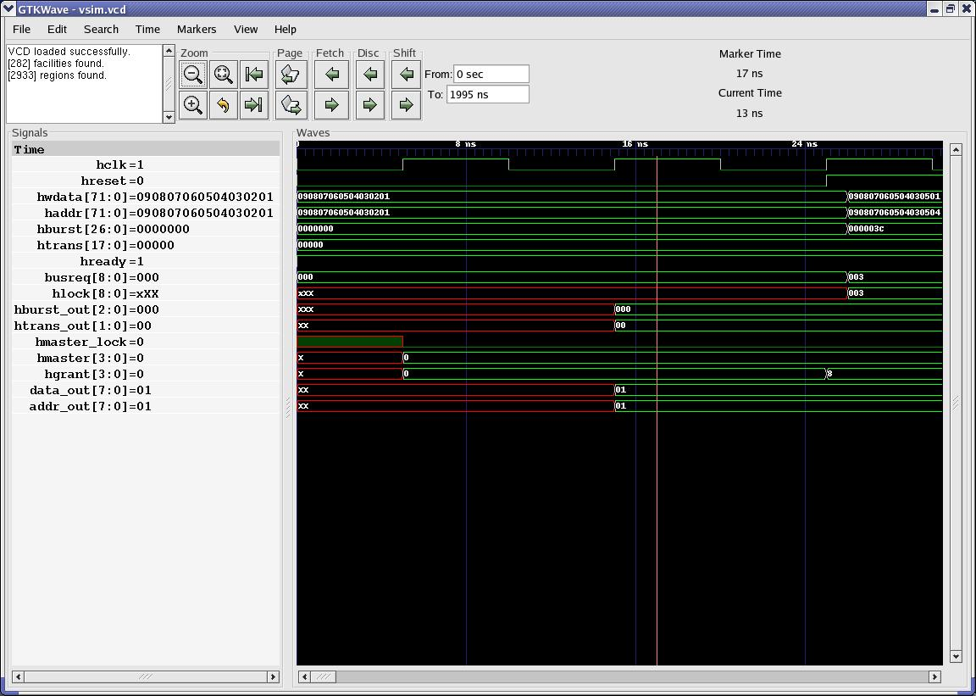

Fig 2 : Reset Operation

Default Master

The default master is the master with the lowest priority so when ever there will not be any request for the bus, from any of the master, then by default the bus will be granted to the the master with the lowest priority.

In fig 3 , at the first positive clock edge as the busreq & hlock signal are low and no locked transfer is going on so the bus is granted to the master 8 as it is the default master.

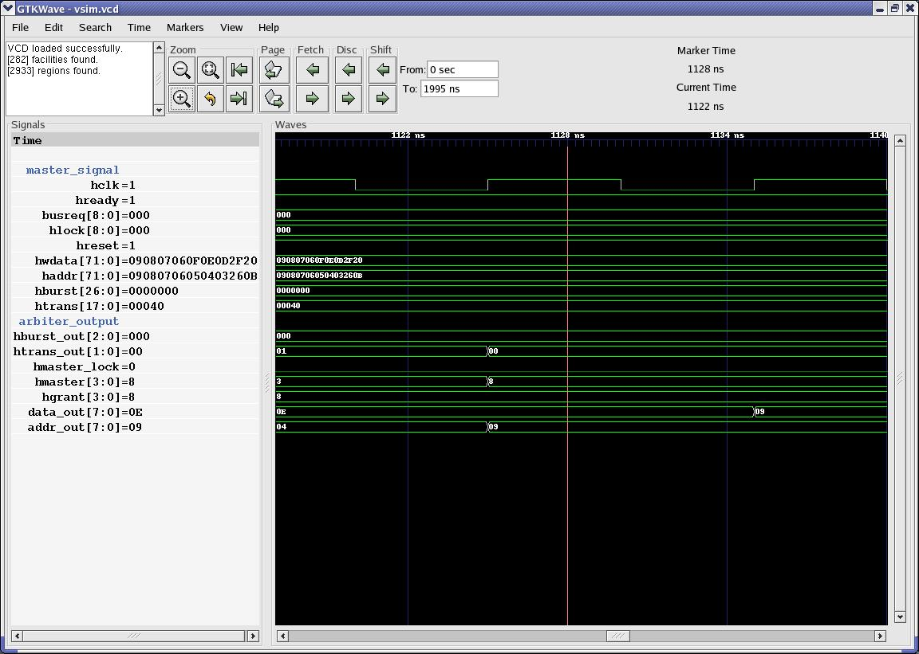
Fig 3 : Default Master

Master switchover
If the Master which is currently granted the bus has completed the transfer and its corresponding lock signal is low, then the bus is granted to master of the highest priority, among the master which are requesting for the bus.

In Fig 4, the master 0 was currently granted the bus, but as at the first positive edge of clock the hmaster signal is going low and at the same time the master 1 is requesting for the bus, the bus is granted to the master 1.

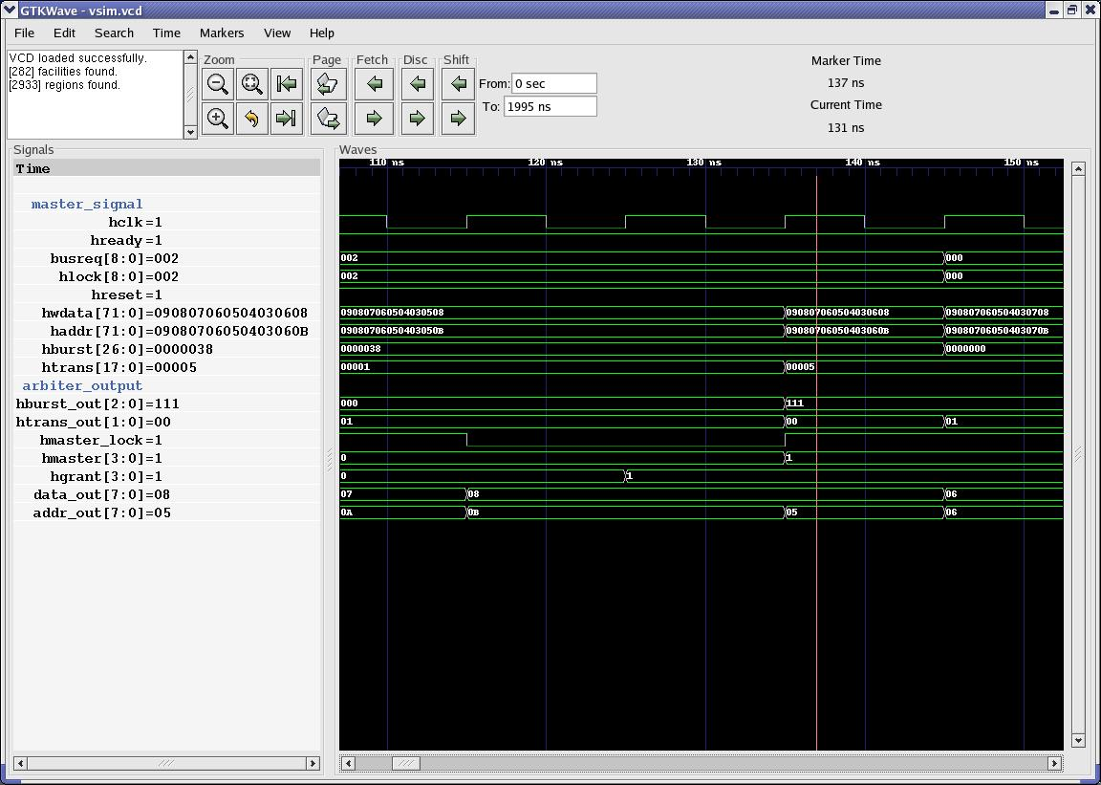

Fig 4 :Master Switch Over

Clock Delay in Master Switchover

If the master switch over is going on, after locked transfer ,this release of our design takes a delay of the 1 cycle to give the control of the bus from current master to next master.

In Fig 5, at the third positive edge of clock the address phase of the first master is over. But this version of design will take a delay of 1 clock cycle, to start the address phase of the next master. So the address phase of the next master will start at the 5th clock edge.

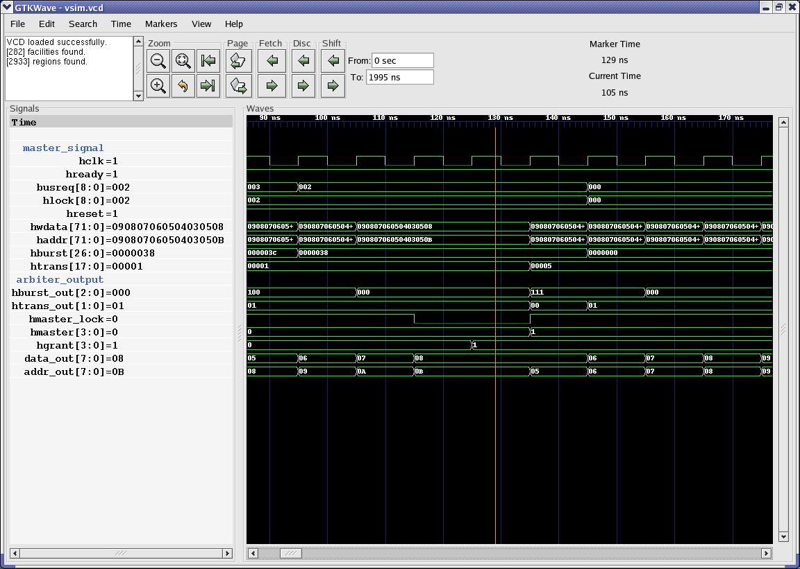
Fig 5 :Clock Delay in Master Switch Over

Wrap Cycle With Wait State and Idle State

This version of the design supports wait and idle state. For both wait and idle state the data is not sampled by the slave.

In fig 6, at 4th and 5th positive clock edge the idle signal comes and hence no address or data phase occurs in these two cycles and on the 6th positive clock edge the address and the data phase of the master starts as htrans is now sequential.

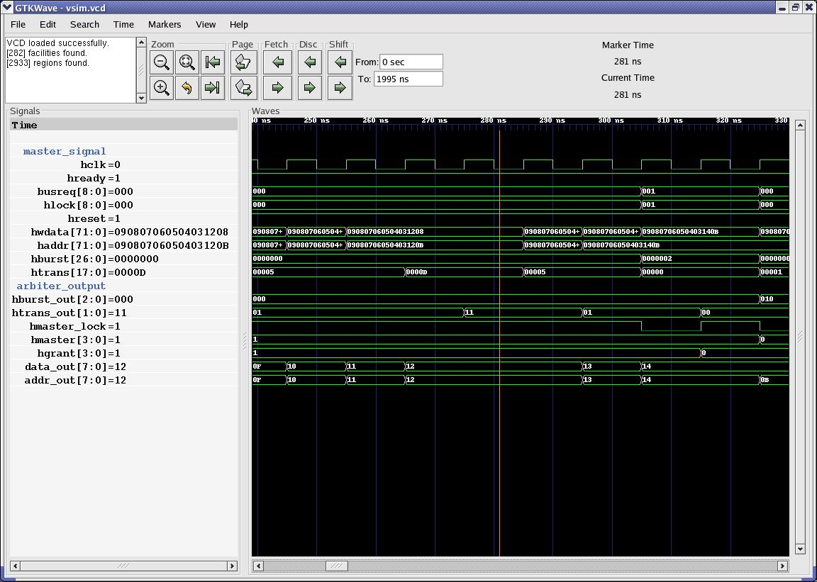

Fig 6 : Wait State While Burst

General Doubts Related to AHB Specification
Under written are the doubts which designers have while making AMBA AHB Design.

- As per AMBA AHB specification Master switch over should be done in zero cycle delay and hence the next slave should always be ready for the next master's address cycle.

2. An AHB slave must have the Hready signal both as input and output. Hready is required as an output from a slave so that the slave can extend the data phase of a transfer. Hready is also required as an input so that the slave can determine when the previously selected slave has completed its final transfer and the first data phase transfer for this slave is about to commence.

References

- http://www.arm.com AMBA Specification (Rev. 2.0)
- http://www.arm.com/support/AMBA.html

