

Color Converter

Authors : Michail Tsvetkov,
Vyacheslav Gulyaev
cms@mail.ru
vv_gulyaev@mail.ru

Rev. 0.9
July 30, 2026

This page has been intentionally left blank.
Revision History
Rev. | Date | Author | Description
0.8 | 06.17.06 | Vyacheslav Gulaev | Initial release.
0.9 | 07.30.06 | Michael Tsvetkov | Add some text and IO Port description.

Contents
Introduction 1
Architecture 2
Operation 3
Registers 4
List of Registers 4
Register 1 – Description 5
IO Ports 6
Appendix A 7
Appendix B 8
Index 9

Introduction
The main purpose of the core is a color transform tasks such as CIE XYZ<->RGB, different RGB<->RGB and RGB<->YCbCr operations. The main part of color conversions from one to another color system concludes in 3x3 matrix multiplication with vector addition. Therefore the present core performs true 3x3 matrix multiplication and vectors addition of the input data stream.
In the package ccfactors_pkg.vhd presents matrixes for all of the most popular conversions. You can use these defines or type own factors.
Input DATA_WIDTH is changeable and defines by the GENERIC param of the module. Precision of the matrix factors also is changeable. Default precision – 10-E6. Better than enough for color conversion tasks.

Architecture
The input vector [X1 X2 X3] adds with shift vector [B1x B2x B3x]. The result vector goes to vector multiplier, where it multiplies on matrix of factors Aij. The result of multiply after rounding adds with shift vector [B1y B2y B3y]. The result of conversion goes to output after round. The shift register is necessary for generating RDY signal and easy integration with FIFO.

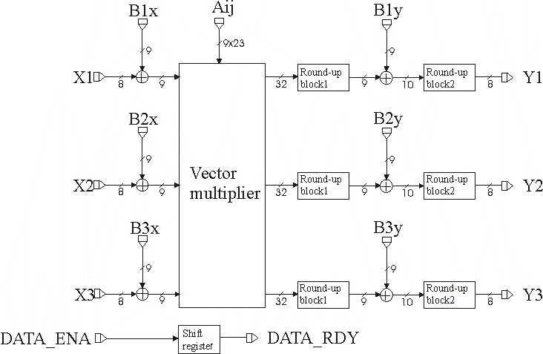

Figure 1. Block diagram of color converter
(bus widths shown for the 8-bit input and 23-bit factors)

Operation
To correct conversion from one to another color system is necessary to load corresponding matrix of factors and shift vectors in FPGA. Before start of conversion is necessary to reset all registers in ‘0’, by establish the RESET signal in ‘0’. When RESET signal back in ‘1’ it is possible to enter sequences for conversion. The read of result of conversion possible when output signal DOUT_RDY is establish in ‘1’.

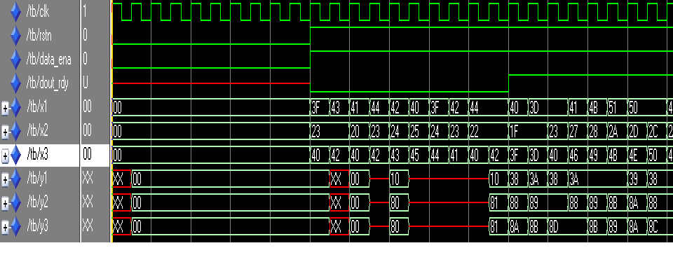

Figure 2. The example of operation of color converter.

Registers
Registers will be added in the future with adding wishbone-compliance.

List of Registers
Name | Address | Width | Access | Description
Table 1: List of registers

Register 1 – Description
(You shall choose the style of register you prefer. Do not use both options in one and the same document.)
Bit # | Access | Description
Reset Value:
Reg_Name: 0000h

31 | 30 | 29 | 28 | ... | 8 | 7 | 6 | 5 | 4 | 3 | 2 | 1 | 0
Table 2: Description of registers
Reset Value:
Reg_Name: 0000h

IO Ports
All ports, except rstn, synchronous with rising edge of the clk

Port | Width | Direction |  | Description
clk | 1 | Input | Clock Input
rstn | 1 | Input | Reset Input, active level = ‘0’
data_ena | 1 | Input | Signal of the valid input data
dout_rdy | 1 | Output | Signal of the valid output data
X1 | DATA_WIDTH | Input | First input vector’s component
X2 | DATA_WIDTH | Input | Second input vector’s component
X3 | DATA_WIDTH | Input | Third input vector’s component
B1x | FACTORS_WIDTH | Input | Input add factor’s component
B2x | FACTORS_WIDTH | Input | Input add factor’s component
B3x | FACTORS_WIDTH | Input | Input add factor’s component
A11 | FACTORS_WIDTH | Input | Matrix factor
A12 | FACTORS_WIDTH | Input | Matrix factor
A13 | FACTORS_WIDTH | Input | Matrix factor
A21 | FACTORS_WIDTH | Input | Matrix factor
A22 | FACTORS_WIDTH | Input | Matrix factor
A23 | FACTORS_WIDTH | Input | Matrix factor
A31 | FACTORS_WIDTH | Input | Matrix factor
A32 | FACTORS_WIDTH | Input | Matrix factor
A33 | FACTORS_WIDTH | Input | Matrix factor
B1y | FACTORS_WIDTH | Input | Output add factor’s component
B2y | FACTORS_WIDTH | Input | Output add factor’s component
B3y | FACTORS_WIDTH | Input | Output add factor’s component
Y1 | DATA_WIDTH | Output | First output vector’s component
Y2 | DATA_WIDTH | Output | Second output vector’s component
Y3 | DATA_WIDTH | Output | Third output vector’s component
Table 3: List of IO ports

Different color convertions
This section may be added to outline different specifications.

Matlab verification results
This section may be added to outline different specifications.

