UoS Educational CPU Architecture

CPU
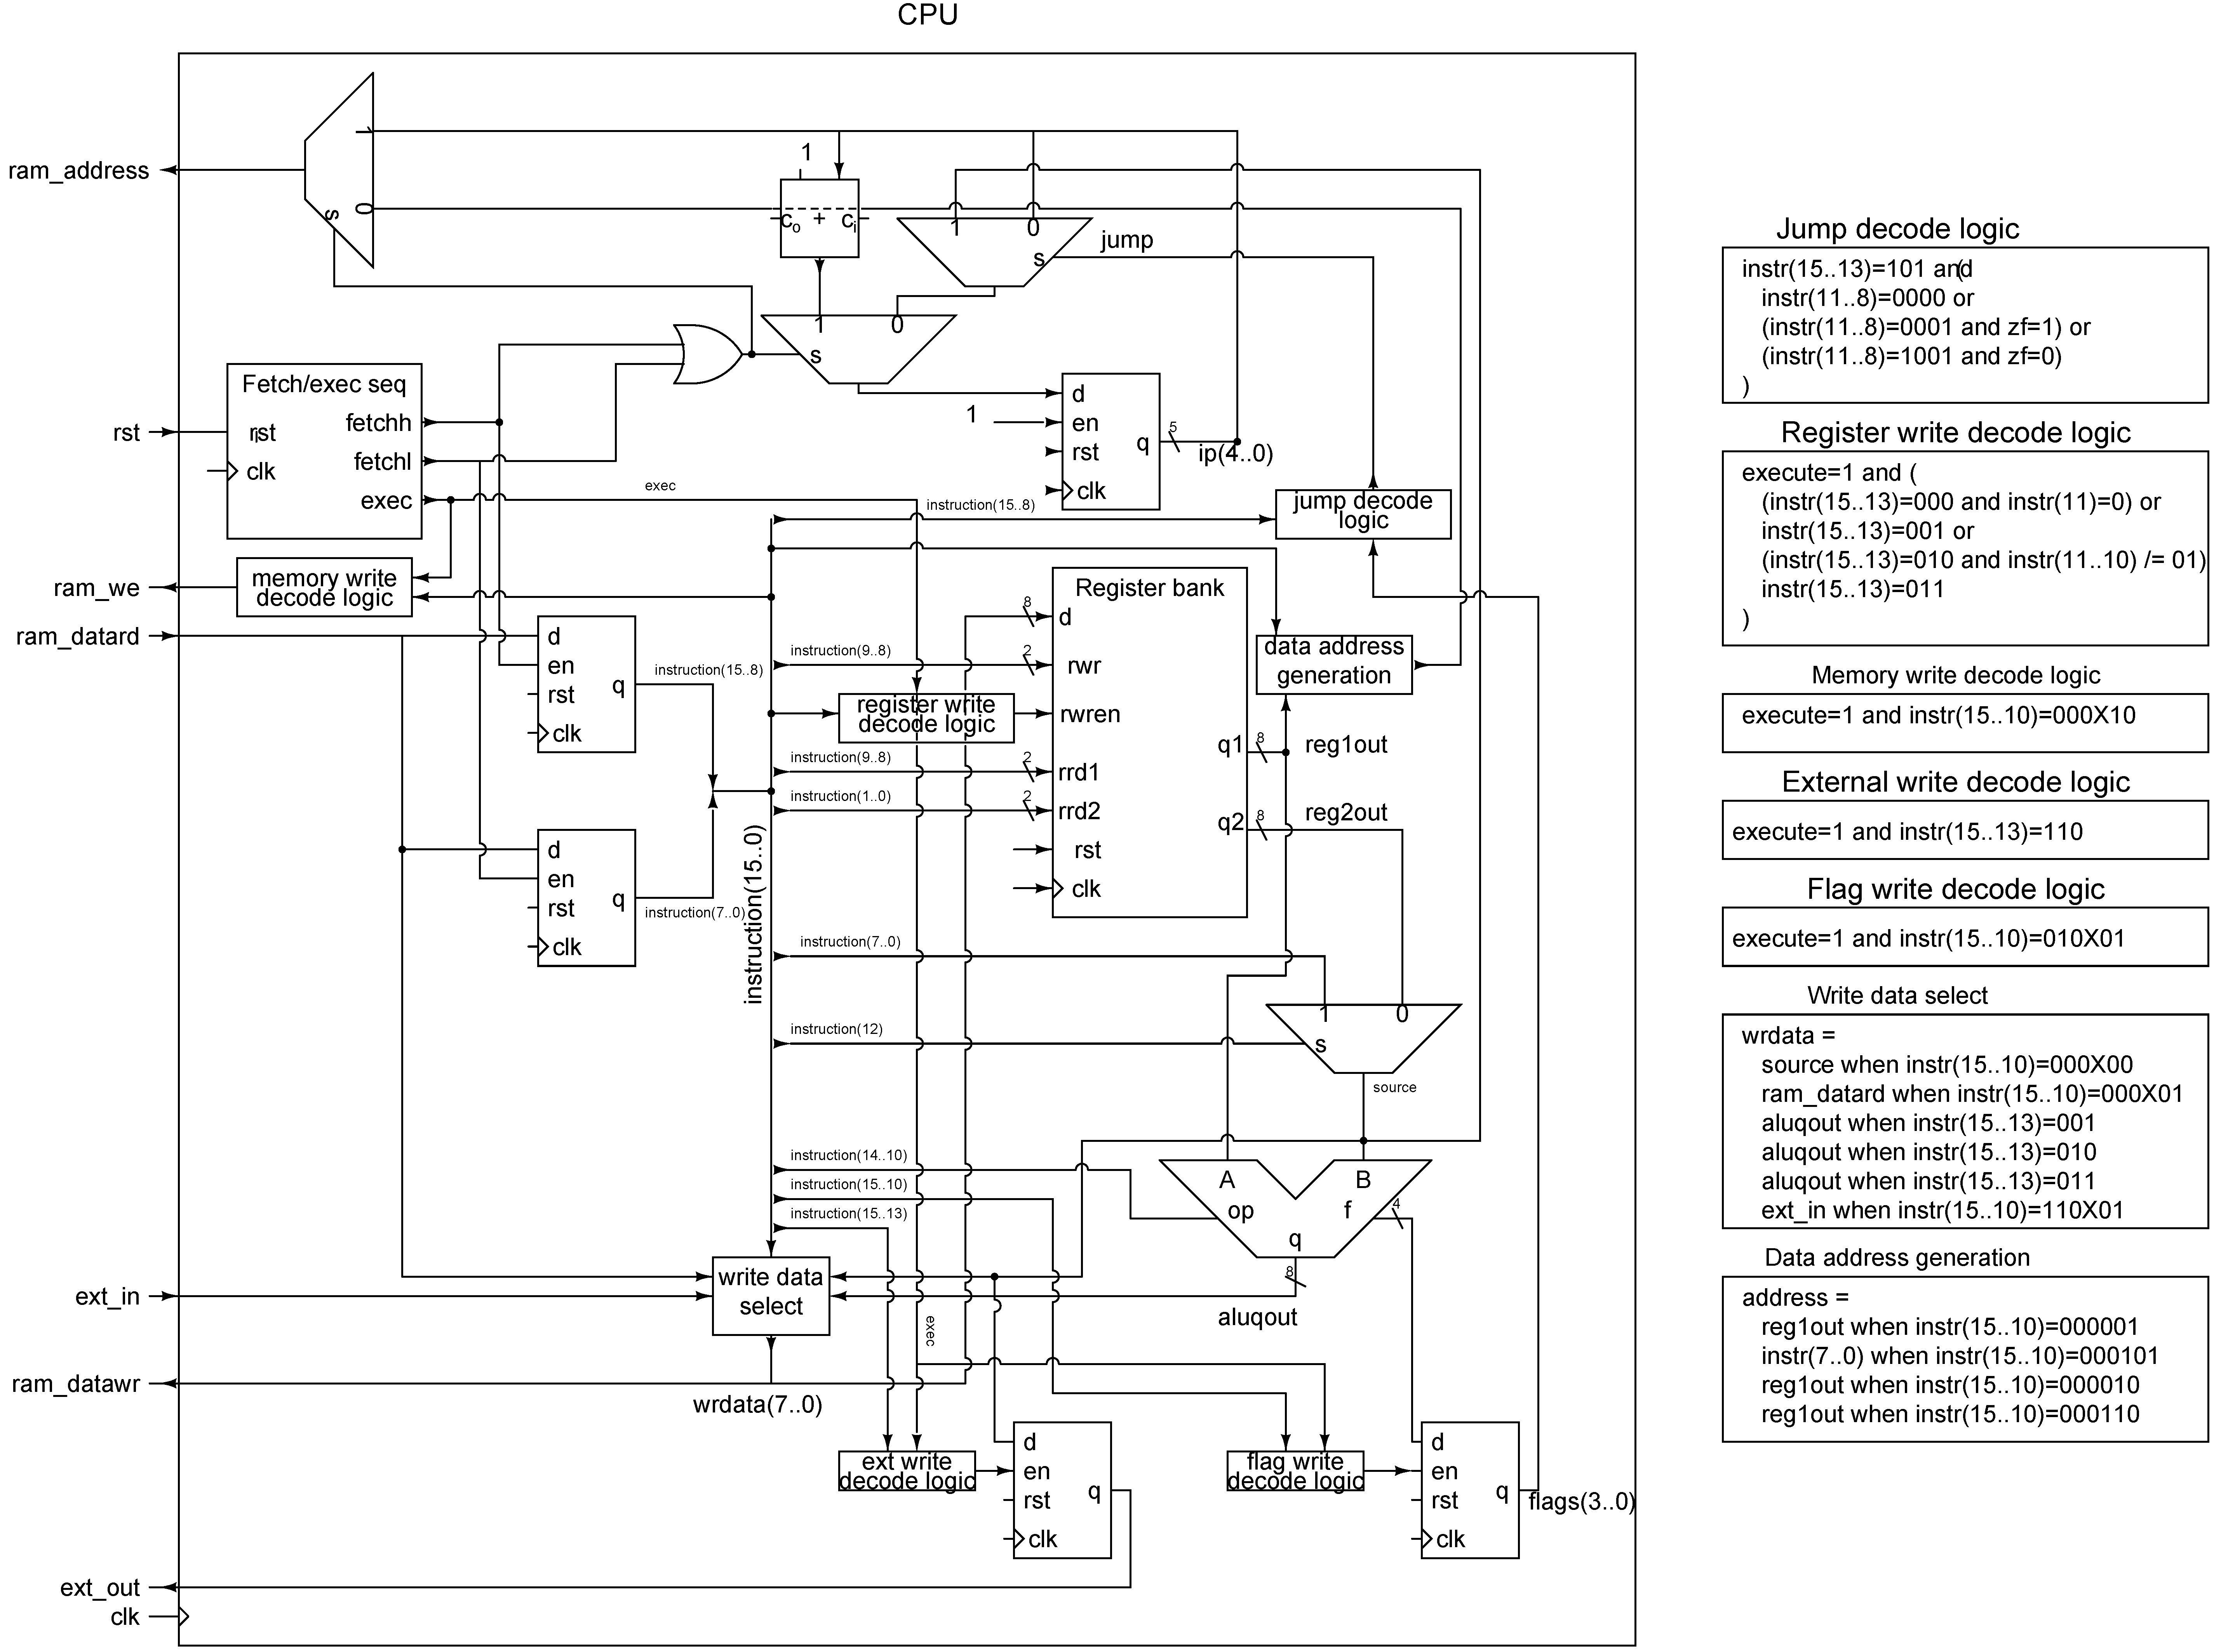

Instruction fetch/execute state sequence
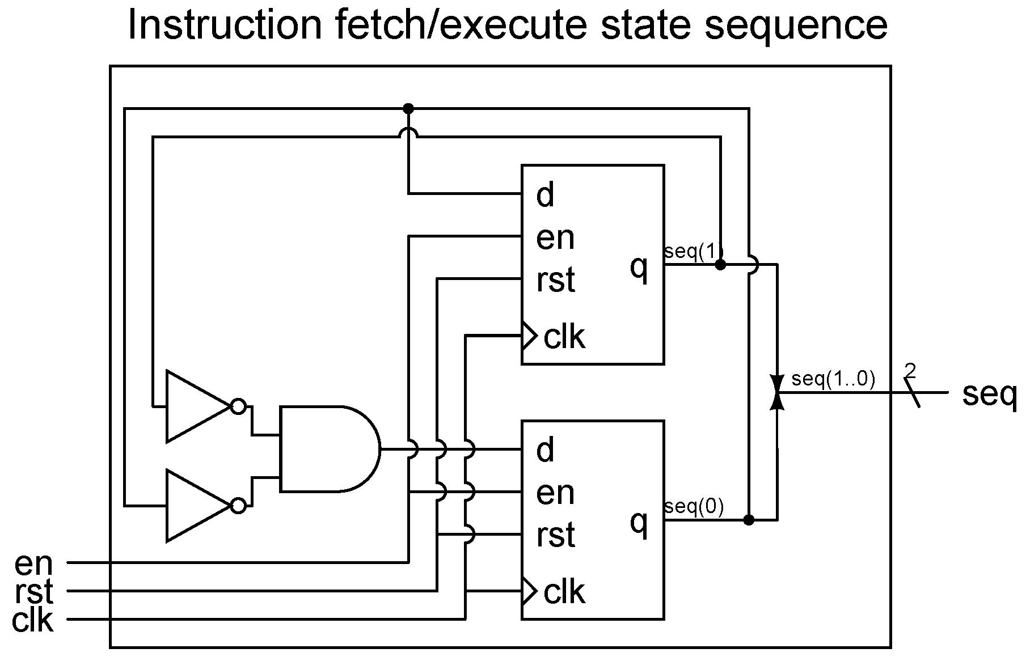

Register bank
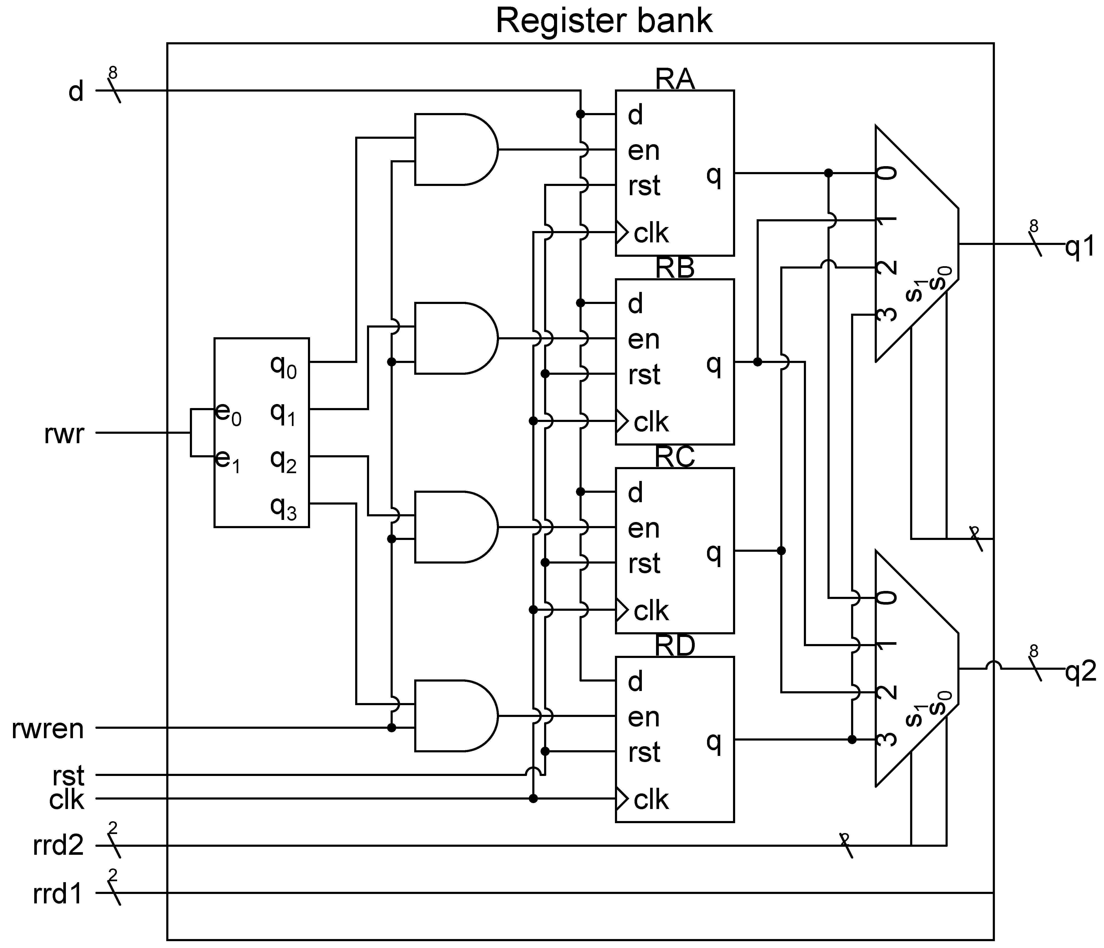

ALU
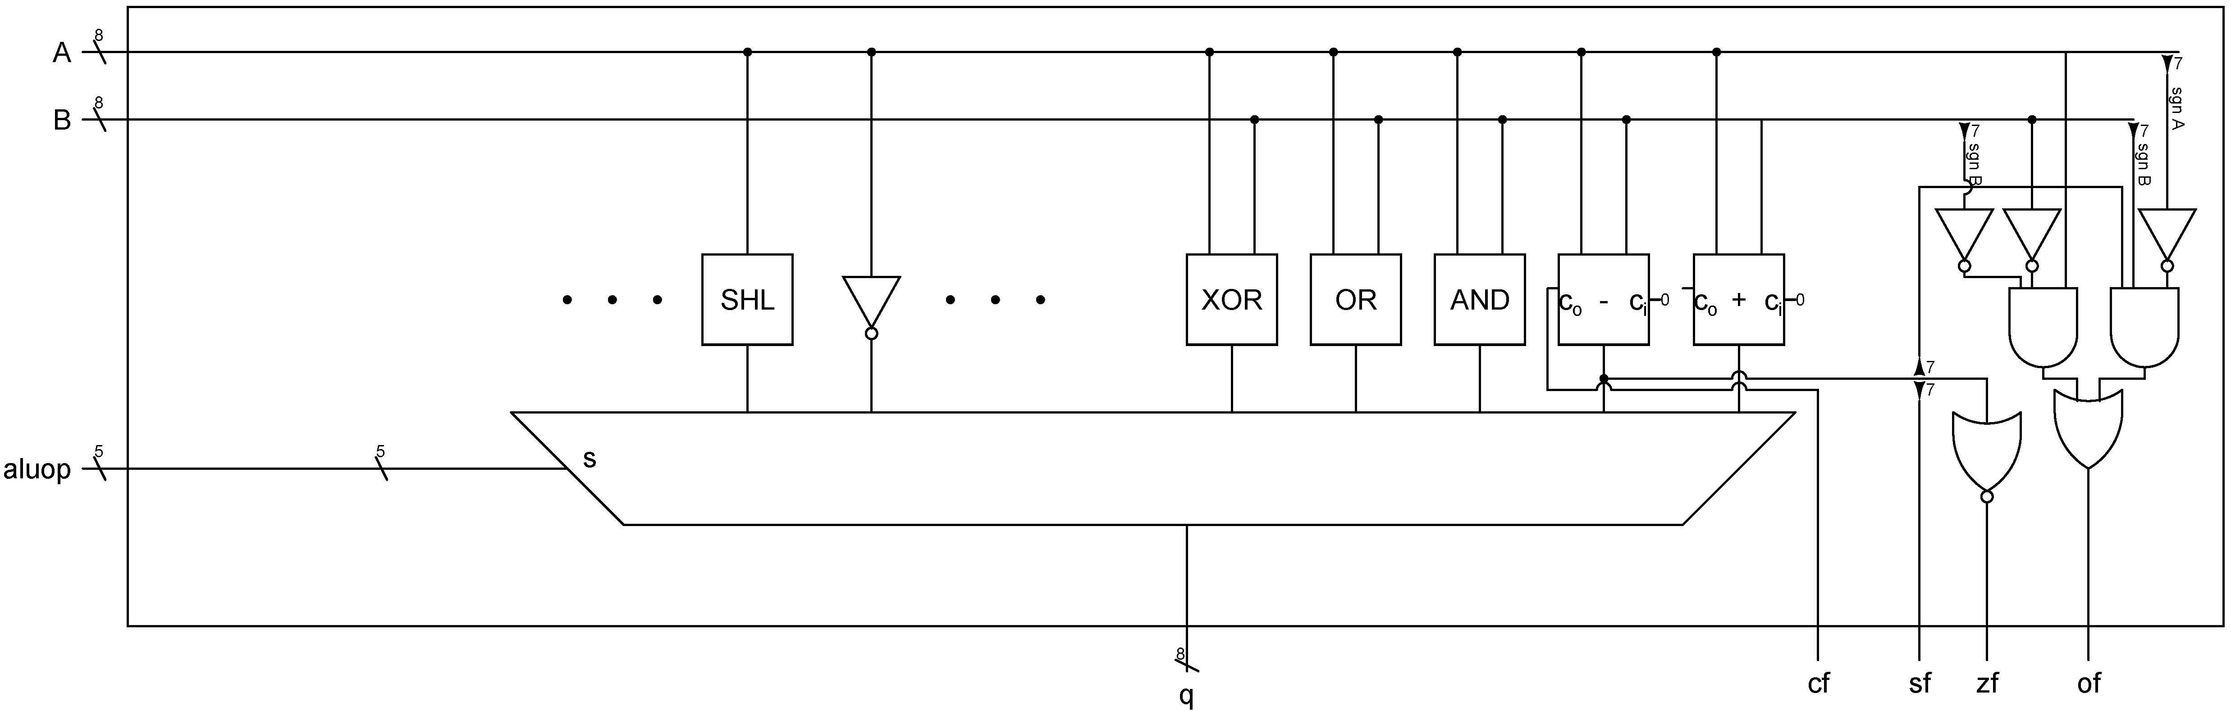

Aluop are the 5-bit instruction(14 downto 10). The multiplexer is configured as follows:
aluop | Function
01X00 | add
01X01 | sub
01X10 | and
01X11 | or
10X00 | xor
10X01 | N/A
11000 | not
11001 | shr
11010 | ror
11011 | asr
11100 | rl

