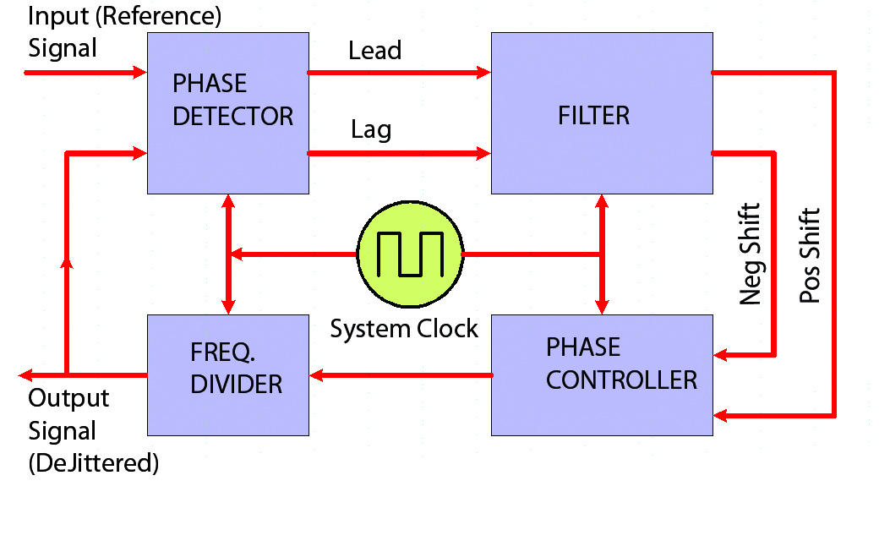

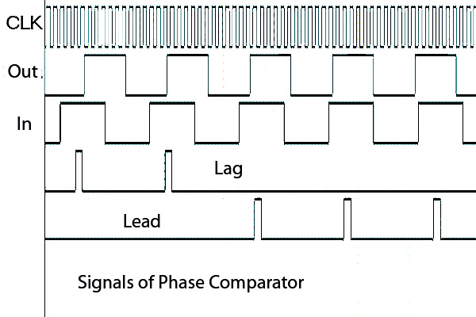

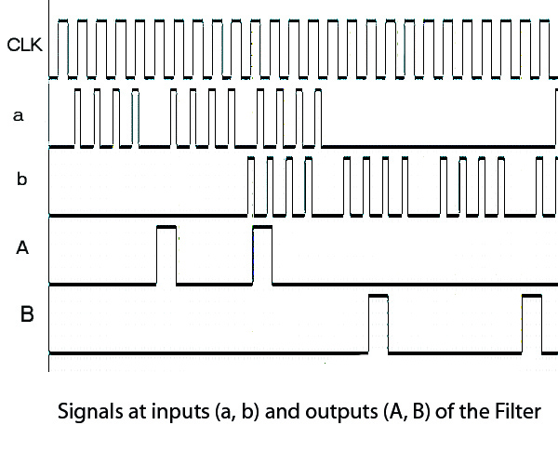
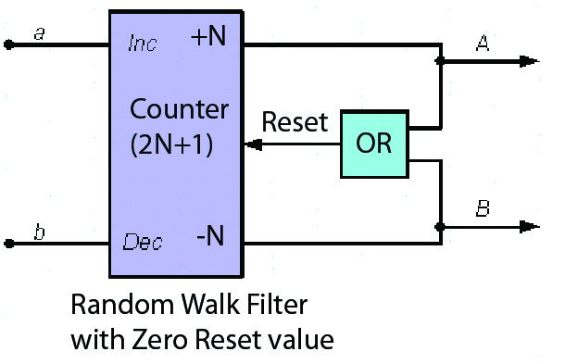
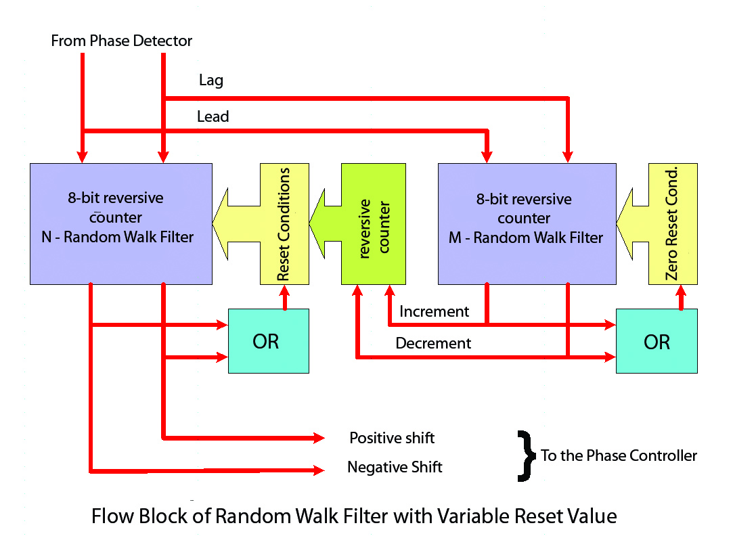

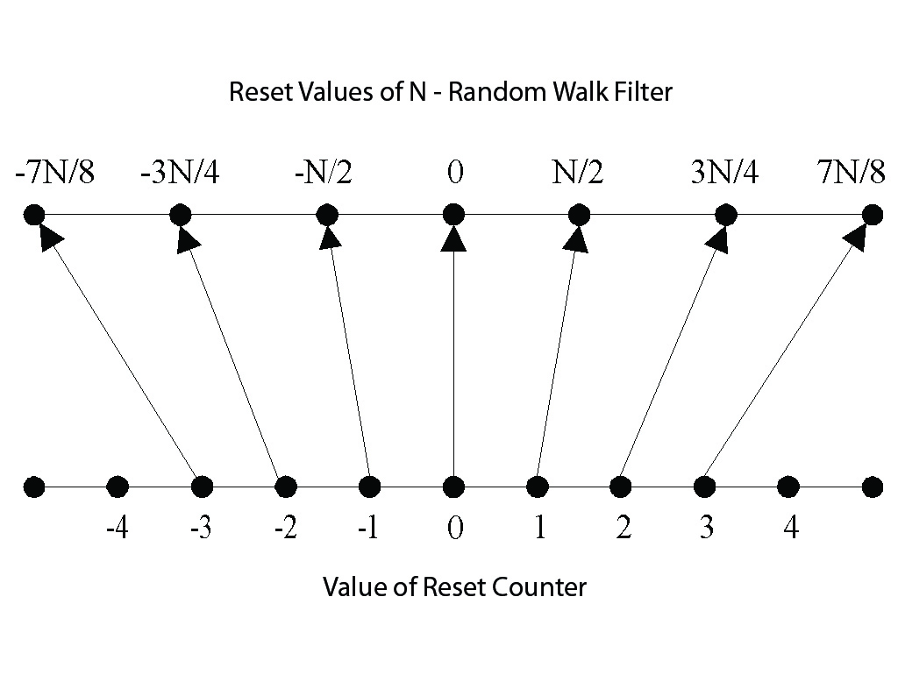
DPLL.V

/* Top module */
module dpll(SignalIn, SignalOut, MainClock,
Positive, Negative, Lead, Lag
);
input SignalIn; // input signal
input MainClock; // reference signal
output SignalOut; // output
output Positive, Negative; // internal DPLL signals
output Lead, Lag; // internal DPLL signals

// phase comparator
phasecomparator inst_ph_cmp(.MainClock(MainClock), .InputSignal(SignalIn),
.OutputSignal(SignalOut), .Lead(Lead), .Lag(Lag)
);
/*
// "Zero-Reset Random Walk Filter"
randomwalkfilter inst_zrwf(.MainClock(MainClock), .Lead(Lead), .Lag(Lag),
.Positive(Positive), .Negative(Negative)
);
*/

// "Variable-Reset Random Walk Filter"
variableresetrandomwalkfilter inst_zrwf(.MainClock(MainClock), .Lead(Lead), .Lag(Lag),
.Positive(Positive), .Negative(Negative)
);

// controlled frequency divider
freqdivider inst_freqdiv(.MainClock(MainClock), .FrequencyOut(SignalOut),
.Positive(Positive), .Negative(Negative)
);

Endmodule
FREQDIVIDER.V
/* frequency divider and phase controller */

module freqdivider(MainClock, Positive, Negative, FrequencyOut);
input MainClock; // main clock
input Positive, Negative; // signals Positive, Negative are synchronous with MainClock
output FrequencyOut; // output frequency

/* needed counter length */
parameter DividerLength = 7;

/* controlled prescaler, after this prescales the "divider by 2" installed, */
/* so composite divide coefficient will be equivalent of 96 (in this example) - */
/* it's necessary for work DPLL on frequency 192kHz with oscillator */
/* frequency 18432kHz */
/* additional divider by 2 used for getting output signal with duty factor of 2 */

parameter DividerMaxValue = 48;
reg [DividerLength-1 : 0] DividerCounter;
reg FrequencyOut; // registered output
/* Process of freq. division according to signals from Random Deviations Filter: */
/* if "lag" then counter will incremented by 2 */
/* if "lead" then counter will not changed */
/* if there is no phase lead or lag then counter normally incremented by 1 */
always @(posedge MainClock)
begin
if(DividerCounter >= (DividerMaxValue - 1))
DividerCounter <= 0;
else if(Negative) DividerCounter <= DividerCounter + 2;
else if(Positive) DividerCounter <= DividerCounter;
else DividerCounter <= DividerCounter + 1;
if(DividerCounter == 0) FrequencyOut <= ~FrequencyOut; // additional divider by 2 - for producing 50% duty factor of the output signal
end
endmodule
PHASECOMPARATOR.V
/* phase comparator */
module phasecomparator(InputSignal, OutputSignal, MainClock, Lead, Lag);

input InputSignal, OutputSignal; // PLL input(reference) and output(dejittered clock) signals
input MainClock; // System Clock
output Lead, Lag; // Lead and Lag signals

reg [1:0] InputSignalEdgeDet; // detector of the rising edge
always @(posedge MainClock)
begin
InputSignalEdgeDet <= { InputSignalEdgeDet[0], InputSignal };
end

/* this signal checked at rising edge of MainClock. */
/* It's simple detector of the Input signal rising edge - */
/* When it detected then we check the level of the output.*/
/* There is possible to place additional 2 registers for */
/* output signal for eliminatig the cmp. constant phase error */
wire InputSignalEdge = (InputSignalEdgeDet == 2'b01);

/* "Lead" signal will be generate in case of output==1 during input rising edge*/
reg Lead, Lag; // outputs "Lead", "Lag" are registered
always @(posedge MainClock)
begin
Lag <= ((InputSignalEdge == 1'b1) && (OutputSignal == 1'b0));
Lead <= ((InputSignalEdge == 1'b1) && (OutputSignal == 1'b1));
end

endmodule

RANDOMWALKFILTER.V
/* Random Walk Filter with reset value of 0*/
module randomwalkfilter(MainClock, Lead, Lag, Positive, Negative);
input MainClock, Lead, Lag; // System Clock and Phase Comparator signals
output Positive, Negative; // "positive shift" and "negative shift" outputs
/* some parametere are accessible from outside */
parameter FilterLength = 8;
parameter FilterResetValue = 4;
parameter FilterMaxValue = FilterResetValue;
parameter FilterMinValue = 256 - FilterResetValue;

/* reversive counter */
reg [FilterLength-1 : 0] FilterCounter;

/* calculation of output pulses synchrinized with MainClock */
always @(posedge MainClock)
begin
if((FilterCounter == FilterMaxValue) || (FilterCounter == FilterMinValue))
FilterCounter <= 0;
else
begin
if(Lead) FilterCounter <= FilterCounter + 1;
if(Lag) FilterCounter <= FilterCounter - 1;
end
end
/* making "Lead" and "Lag" signals when */
/* counter reached max or min levels */
reg Positive, Negative;
always @(posedge MainClock)
begin
Positive <= (FilterCounter == FilterMaxValue);
Negative <= (FilterCounter == FilterMinValue);
end
endmodule
VARIABLERESETRANDOMWALKFILTER.V
/* random-walk filter with variable reset */

module variableresetrandomwalkfilter(MainClock, Lead, Lag, Positive, Negative);
input MainClock, Lead, Lag; // System Clock and Phase Comparator signals
output Positive, Negative; // "positive shift" and "negative shift" outputs

parameter N_FilterLength = 8;
parameter N_FilterResetValue = 8;
parameter N_FilterMaxValue = N_FilterResetValue;

/* 256=2_PWR_8(counter length). Use this value because unsigned arithmetic */
parameter N_FilterMinValue = 256 - N_FilterResetValue;

/* the counter length of reset scheme must be short */
parameter ResetterCounterLength = 4;
parameter ResetterCounterMaxValue = 3;

/* 16=2_PWR_4 */
parameter ResetterCounterMinValue = 16 - 3;

/* counter "N - RandomWalkFilter" */
reg [N_FilterLength-1 : 0] N_FilterCounter;

/* connections of "M - RandomWalkFilter" */
wire Up, Down;
randomwalkfilter inst_M_Filter(.MainClock(MainClock), .Lead(Lead), .Lag(Lag),
.Positive(Up), .Negative(Down));
defparam inst_M_Filter.FilterResetValue = 32; // length "M-RWF" = 32

/* Reset Scheme. This counter changes on "M-RWF" counter */
reg [ResetterCounterLength-1 : 0] ResetterCounter;

always @(posedge MainClock)
begin
if(Up)
begin
if((ResetterCounter < ResetterCounterMaxValue) || (ResetterCounter >= ResetterCounterMinValue))
ResetterCounter <= ResetterCounter + 1;
end
else if(Down)
begin
if((ResetterCounter <= ResetterCounterMaxValue) || (ResetterCounter > ResetterCounterMinValue))
ResetterCounter <= ResetterCounter - 1;
end
if((ResetterCounter > ResetterCounterMaxValue) && (ResetterCounter < ResetterCounterMinValue))
ResetterCounter <= 0;
end

/* Look-Up Table between ResetterCounter value and reset state of "N-RWF" */
reg [N_FilterLength-1 : 0] ResetterValue;
always @(1)
begin
case(ResetterCounter)
16 - 3: ResetterValue = 256 - 7;
16 - 2: ResetterValue = 256 - 6;
16 - 1: ResetterValue = 256 - 4;
0: ResetterValue = 0;
1: ResetterValue = 4;
2: ResetterValue = 6;
3: ResetterValue = 7;
default: ResetterValue = 0;
endcase
end

/* "N-RWF" Filter has different reset states */
/* in accordance ResetterCounter value */
always @(posedge MainClock)
begin
if((N_FilterCounter == N_FilterMaxValue) || (N_FilterCounter == N_FilterMinValue))
N_FilterCounter <= ResetterValue;
else
begin
if(Lead) N_FilterCounter <= N_FilterCounter + 1;
if(Lag) N_FilterCounter <= N_FilterCounter - 1;
end
end

/* making "Lead" and "Lag" signals when */
/* counter reached max or min levels */
reg Positive, Negative;
always @(posedge MainClock)
begin
Positive <= (N_FilterCounter == N_FilterMaxValue);
Negative <= (N_FilterCounter == N_FilterMinValue);
end

endmodule

