HASM

HASM is a simple instruction simulator for use in the generation of testbenches that must behave as system processors. HASM is meant to attach to a bus model that mimics the device attached to the FPGA or CPLD under test. HASM can be used as though it were a processor within the simulation environment without the tremendous increase in simulation times due to the overhead involved in simulating a real processor. HASM supports single and bursted data read and write cycles. In addition HASM has a single interrupt line that may be used to change the instruction execution stream due to stimulus from the DUT.

Simulator to Bus Model Communications

Communications between the bus model and the HASM core are kept as simple as possible. The following signals form this interface:

Signal | Width | Direction | Function
Enable_Machine | 1 | To Simulator | Set high to start vector execution.
Cyc_Siz | 2 | To Bus Model | Sets width of current data transfer. Encoding is: 0b00 8-bit, 0b01 16-bit, 0b10 32-bit, 0b11 24-bit
Cyc_Rdwr | 1 | To Bus Model | Read/Write Cycle Indicator. Read when high.
Cyc_RMW | 1 | To Bus Model | Read-Modify-Write Indicator. Set high after execution of RMW_EN. Cleared after RMW_DIS.
Cyc_Addr | 32 | To Bus Model | Address of operation
Cyc_Data_In | 32 | To Simulator | Data bus in from Bus Model
Cyc_Data_Out | 32 | To Bus Model | Data bus out to Bus Model
Cyc_Start | 1 | To Bus Model | Tells Bus Model that addr/data/control are ready, execute the cycle. Set for the duration of the cycle. Cleared by Cyc_Done.
Cyc_Done | 1 | To Simulator | Tells HASM simulator that cycle is complete and Cyc_Data_In contains valid data (if a read cycle)
Brst_Cyc | 1 | To Bus Model | Indicates that simulator wants to run a burst cycle. Cycle is started by Cyc_Start. Brst_Cyc is active throughout length of burst cycle
Brst_Last | 1 | To Bus Model | Indicates that current transfer is last in a burst cycle.
Brst_Data_Rdy | 1 | To Simulator | Bus Model sets this bit high at the completion of each data transfer in a burst.
Reg_User | 32 | To Bus Mode | This bus mirrors the state of the User Register. It can be used for signals specific to a particular model such as Address Modifiers in VME.
Machine_Interrupt | 1 | To Simulator | Set high to cause simulator to jump to the instructions indicated by the .isr directive. Instruction immediately after the current instruction is pushed on the stack.
Clr_Machine_Interrupt | 1 | To Bus Model | Set by simulator to clear machine_interrupt in the bus model simulator. Bus model must immediately clear machine_interrupt on this signal.

A typical HASM cycle appears as follows in the Modelsim simulator.

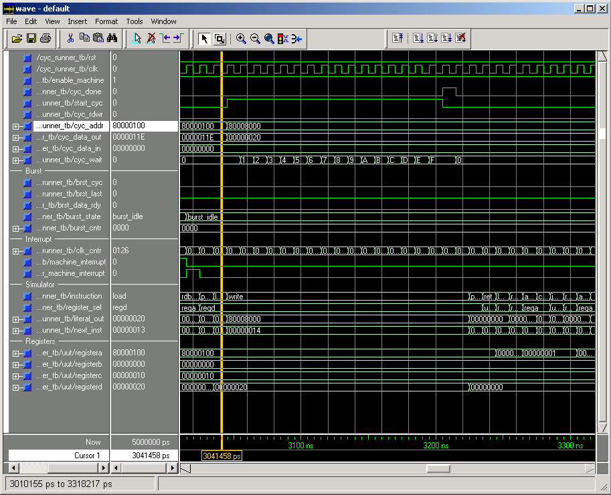

Shown above is a simple, one-word write instruction to the bus model from the HASM simulator. The cycle begins when the simulator loads the cyc_addr, cyc_data_out and cyc_rdwr lines with the data for the cycle. The simulator then brings the start_cyc signal high. The bus model recognizes the start_cyc signal and begins executing the bus cycle on the target FPGA (not shown). The counter cyc_wait simulates the time taken by the bus model to run the cycle. Once the cycle completes the bus model asserts the cyc_done signal. Assertion of cyc_done causes the simulator to clear the cyc_start signal. The simulator then waits for cyc_done to clear at which point the simulator begins executing the next instruction.

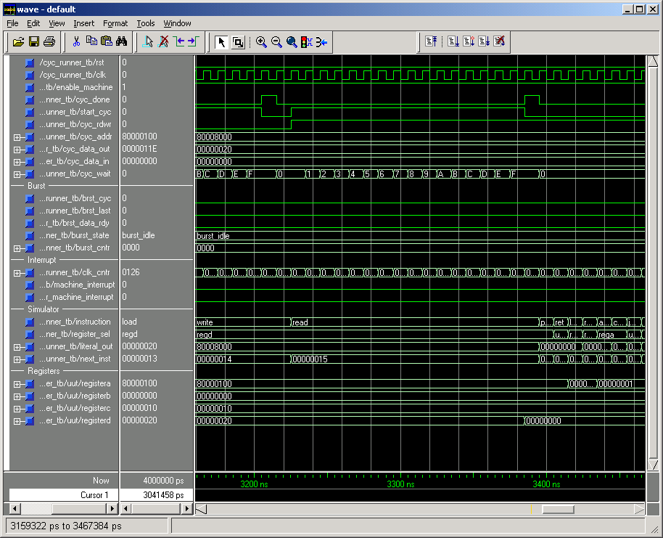

A simple one-word read cycle is shown above. Execution of a read cycle is exactly as that of a write cycle except that the simulator will read the data on cyc_data_in on the rising edge of cyc_done (the above simulation does not have a attached bus model so cyc_data_in does not change).

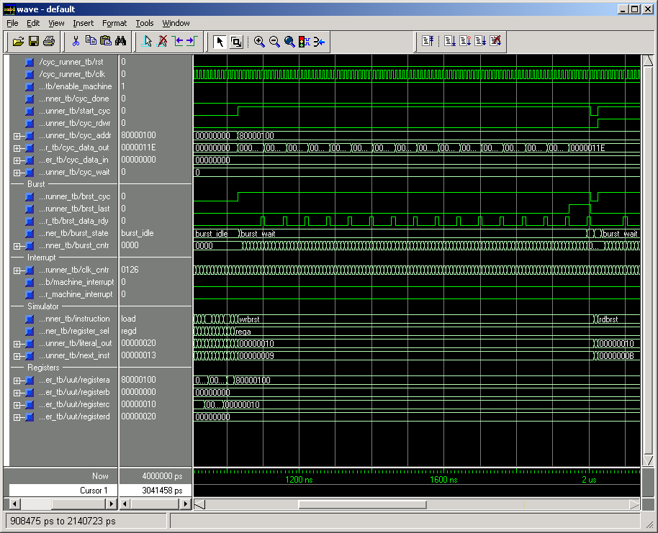

The waveform above illustrates a 16-word bursted write cycle. Execution of the burst cycle starts with the simulator asserting the brst_cyc signal in tandem with the start_cyc signal. The first value to be written is presented on cyc_data_out. The bus model asserts brst_data_rdy each time it completes a write to the target. The simulator then changes cyc_data_out to the next value to be written and waits for the next brst_data_rdy. On the last cycle of the burst the simulator sets brst_last high on the falling edge of brst_data_rdy from the bus model. Note that the simulator does not change the target address after the start of the cycle. It is the responsibility of the bus model (or possibly the target FPGA) to keep track of the address for the current write in the burst cycle. Note that the bus model is not required to assert cyc_done upon the completion of the burst cycle.

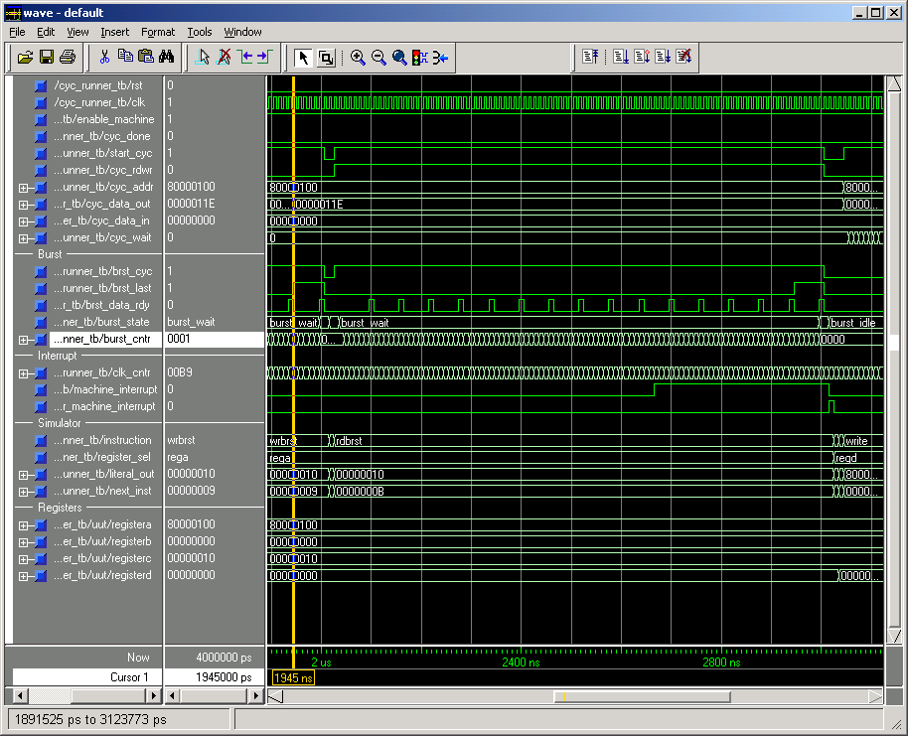

A burst read is shown above. Burst reads work exactly as burst writes except that the simulator latches cyc_data_in into the simulators internal memory bank on the rising edge of each brst_data_rdy (the above simulation does not contain a bus model so cyc_data_in is not changing).

The above simulation illustrates the HASM simulator responding to the machine_interrupt signal. Once the previous cycle completes (in this case the burst cycle from before) the simulator jumps to the interrupt offset defined by the .isr directive. (see the next section for a snapshot of the source code). The simulator asserts clr_machine_interrupt to tell the bus model to clear the machine_interrupt line. Note that the simulator will wait until the machine interrupt line is cleared before it begins executing the isr instructions.

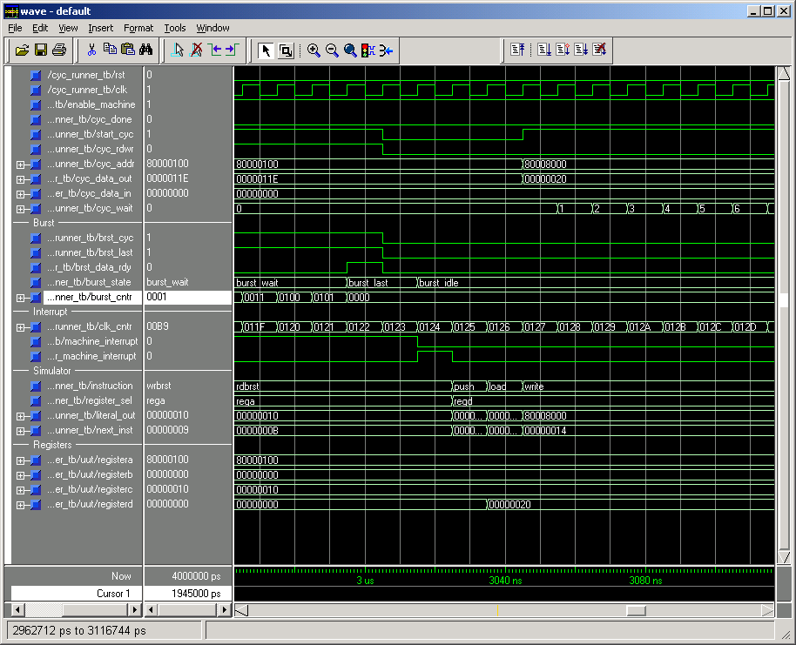

HASM Assembler User Interface

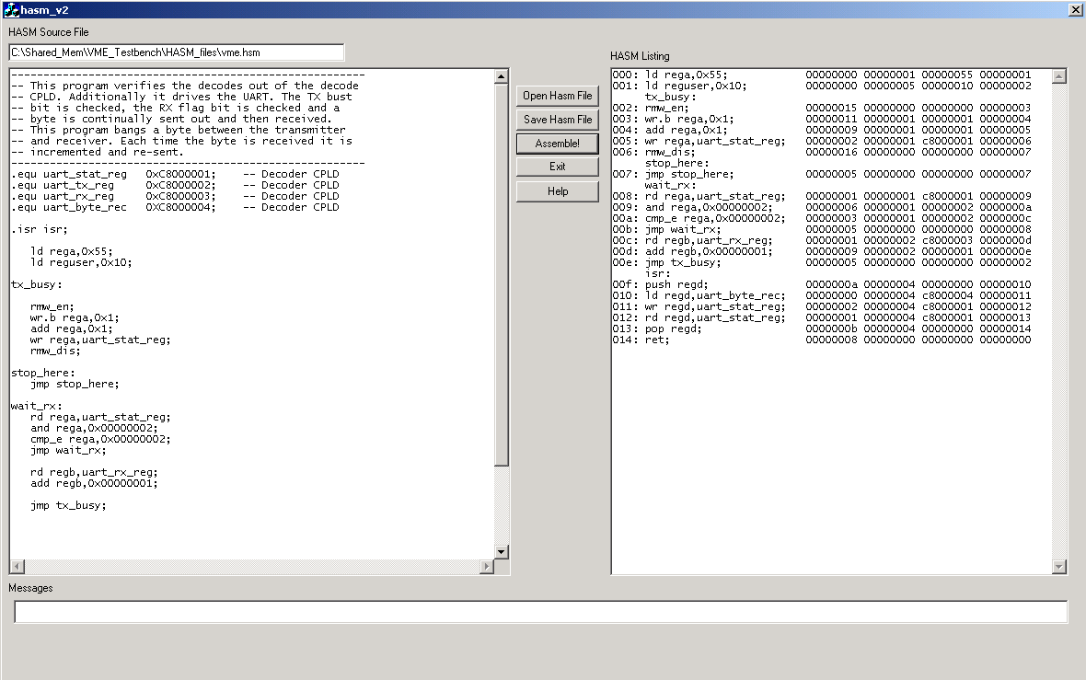

The HASM user interface is shown above. In the left window is a HASM source file. In the right window is the output of the HASM assembler. HASM source files are read into HASM through the “Open Hasm File” button in the center of the interface. HASM files may be added in the left-hand source window and then saved via the “Save Hasm File” button. Below the “Save Hasm File” button is the “Assemble” button. This button causes HASM to assemble the contents of the Source window. The button “Exit” exits HASM. The “Help” button displays this help file in HTML. The Messages window at the bottom of the HASM user screen displays error messages generated by HASM during assembly.

The listing window presents the output of the assembler as the HASM simulator will see it. The four columns of numbers are encoded test vectors read by the simulator. For each instruction in the HASM file there is a corresponding vector. The instruction that caused the generation of the vector is shown on the left hand side of the vector. Next to the instruction is the line number at which the instruction resides in the vector list. All jump and call instructions reference this line number. The first column of the four numbers that make up the vector is the instruction number. Instruction numbering is as follows:

Instruction | Number
LD | 0x00000000
RD | 0x00000001
WR | 0x00000002
CMP_E | 0x00000003
CMP_NE | 0x00000004
JMP | 0x00000005
AND | 0x00000006
OR | 0x00000007
RET | 0x00000008
ADD | 0x00000009
PUSH | 0x0000000A
POP | 0x0000000B
CALL | 0x0000000C
RDMEM | 0x0000000D
WRMEM | 0x0000000E
RDBRST | 0x0000000F
WRBRST | 0x00000010
WR.b | 0x00000011
WR.w | 0x00000012
RD.b | 0x00000013
RD.w | 0x00000014
RMW_EN | 0x00000015
RMW_DIS | 0x00000016
RD.t | 0x00000017
WR.t | 0x00000018
RDBRST.b | 0x00000019
RDBRST.w | 0x0000001A
RDBRST.t | 0x0000001B
WRBRST.b | 0x0000001C
WRBRST.w | 0x0000001D
WRBRST.t | 0x0000001E
DELAY | 0x0000001F
WRI | 0x00000020
WRI.b | 0x00000021
WRI.w | 0x00000022
WRI.t | 0x00000023
RDI | 0x00000024
RDI.b | 0x00000025
RDI.w | 0x00000026
RDI.t | 0x00000027
CMPI_E | 0x00000028
CMPI_NE | 0x00000029
LDRR | 0x0000002A
SHL | 0x0000002B
SHR | 0x0000002C

The second column defines the target register for this particular instruction. Registers are numbered as follows.

Register | Number
REGA | 0x00000001
REGB | 0x00000002
REGC | 0x00000003
REGD | 0x00000004
REGUSER | 0x00000005

The third number is a literal value. It is copied into the vector list exactly as it appears in the source code. There are some instructions that have a register in the place of the literal value. In this event the register encoding is as above.

The last number in the vector list is the offset of the next instruction to be executed.

ISR Directive:

The .isr directive causes a hidden vector to be planted at the start of the vector file. The format of the .isr vector is four integers long. The first number is used as the offset of the instruction jumped to when the machine_interrupt line is brought high. The remaining three numbers in the vector are not used. The isr vector is always written to the vector file whether there is an .isr directive or not. For purposes of stability the HASM source file should always have a .isr directive and a corresponding interrupt service routine. (It could simply be a ret instruction).
The HASM simulator has the following features:

Registers:
The HASM cycle simulator contains five 32-bit general-purpose registers. Most HASM instructions operate on one of these five registers. The five registers are referred to as REGA, REGB, REGC, REGD and REGUSER. REGUSER is slightly different from the other four registers in that its contents are driven out of the cycle_simulator module. The intention behind the user register is that it may be used to generate signals specific to a bus interface. An example of this would be generation of the VME address modifier signals. REGUSER functions identically to the first four registers and may be used in any instruction that targets any of the first four registers.

Internal Memory:
The HASM cycle simulator contains an internal 256-long word memory used as the data source and data destination during burst read and burst write cycles. This 256-word memory can only be read or written using the RDMEM and WRMEM instructions.

Equates:
HASM supports equates. Literal values may be given names through the equate directive. In this way, registers in the target FPGA may be referred to by their names rather than their address. Additionally, bit masks may be defined by equates and then used in LD, AND and OR instructions. Equates are defined by the .equ directive. Equates may appear anywhere in the source file. The .equ directive must begin at the first column of the source line.

Interrupt:
The HASM cycle simulator supports a single interrupt input. When the interrupt line is set high, the cycle simulator will complete the current instruction, push the offset of the next instruction onto the stack and then jump to the label defined by the .isr directive. The RET instruction can be used to return from an interrupt service routine. The .isr directive must begin on the first column of the source line.

Comments:
HASM allows comments. Comments must begin with a ‘-‘. Comments may appear after the semicolon of an instruction line. Full-line comments must have a ‘-‘ in the first column of the source line.

Labels:
Labels must begin on the first column of a source line. Labels must be terminated with a colon.

General Rules:

1) All lines must end with a ; (excluding comments)
2) Directives MUST begin on the first column. Directives include .isr and .equ.
3) Labels MUST begin on the fist column and end with a colon.
4) Literal values must be in hexadecimal and must begin with 0x.
5) An instruction cannot be on the same line as a label. HASM will ignore the instruction.

Instruction Set:

LD:
Load literal value into a register. First operand can only be one of the four registers. Second value can be a literal or a equate.
Examples:
LD rega,0x00000001;
Loads register A with 0x00000001.

LD regd,status_reg;
Loads register A with equate status_reg.

RD, RD.b, RD.w, RD.t:
Causes a external read cycle to the target FPGA through the bus interface module. The first operand in a read is the target register for the read data. The second operand is the address of the read operation. The address may be a literal value or a equate. Size of transfer is 32-bit
Examples:
rd rega,0x80000010;
Reads from address 0x80000010 and places data into register a.

rd regd,status_reg;
Reads from address stored in equate status_reg and places data in regd.

The read instruction may be modified to change the SIZ output during the transfer. Rd.b causes the SIZ lines to indicate a byte-wide read, rd.w causes the SIZ lines to indicate a word-wide read, rd.t causes the SIZ lines to indicate a triple word read. Rd alone defaults to a width of 32-bits.

WR, WR.b, WR.w, WR.t:
Causes a external write cycle to the target FPGA through the bus interface module. The first operand in a write is the data source register for the write data. The second operand is the address of the write operation. The address may be a literal value or a equate.
Examples:
WR rega,0x80000010;
Writes the contents of rega into the address 0x80000010.

WR regd,status_reg;
Writes the contents of regd to the address defined by the equate.

The write instruction may be modified to change the SIZ output during the transfer. wr.b causes the SIZ lines to indicate a byte-wide read, wr.w causes the SIZ lines to indicate a word-wide read. WR.t causes the SIZ lines to indicate a triple-word read. wr alone defaults to a width of 32-bits.

CMP_E:
Compare; jump if equal. The first operand is one of the four registers; the second operand is a literal value or an equate. If the register contents equal the literal or equate value, the instruction following the compare is skipped
Example:
LD rega,0x00000001;
CMP_E rega,0x00000001;
JMP main;
ADD rega,0x00000002;
The result of the above will be that the add instruction will execute.

CMP_NE:
Compare; jump if not equal. The first operand is one of the four registers; the second operand is a literal value or an equate. If the register contents do not equal the literal or equate value, the instruction following the compare is skipped
Example:
LD rega,0x00000001;
CMP_NE rega,0x00000001;
JMP main;
ADD rega,0x00000002;
The result of the above will be that the jmp instruction will execute.

JMP:
Causes unconditional jump to the label.
Example:
JMP main;

Causes program jump to the instruction at label ‘main’.

AND:
AND instruction. The first operand is a register, the second is a literal value or an equate. The contents of the target register are ANDed with the literal value.
Example:
LD rega,0x55555555;
AND rega,0x0000000F;

The result of the above will be that register A will contain a 0x5.

OR:
OR instruction. The first operand is a register, the second is a literal value or an equate. The contents of the target register are ORed with the literal value.
Example:
LD rega,0x55555555;
OR rega,0x0000000F;

The result of the above will be that register A will contain a 0xF.

RET:
Return instruction. The value at the top of the stack is used as the address of the next instruction to execute. There are no operands.

ADD:
ADD instruction. The first operand is a register, the second is a literal value or an equate. The literal or equate value is added to the contents of the target register.
Example:
LD rega,0x00000000;
ADD rega,0x00000001;

The result of the above will be that register A will contain a 0x1.

PUSH:
PUSH instruction. PUSH takes a register and pushes its contents onto the top of the stack.
Example:
LD rega,0x00000055;
PUSH rega;

The result of the above will be the most recent entry of the stack will be a 0x55.

POP:
POP instruction. POP takes the value at the top of the stack and loads it into the target register.
Example:
LD rega,0x00000055;
PUSH rega;
POP regd;

The result of the above will be that regd contains a 0x55 .

CALL:
CALL instruction. CALL stores the address of the next instruction on to the stack and then jumps to the label indicated in the call instruction.
Example:
CALL mem_load;
LD rega,0x00000002;

The result of the above will be that the stack will be loaded with the address of the LD rega,0x00000002 instruction and then execution will proceed at the address of mem_load.

RDMEM:
RDMEM reads from the cycle simulator’s internal 256 word memory. This instruction takes two operands; the first is the target register for the read data, the second operand is the register containing the address from which the data is to be read. This instruction is intended for use with burst operations.
Example:
LD regc,0x00000002;
RDMEM rega,regc;

The value stored at location 0x00000002 in internal memory is loaded into register a.

WRMEM:
WRMEM writes the value contained in the first register to the address stored in the second register.
Example:
LD regc,0x00000002;
LD rega,0xdeadbeef;
WRMEM rega,regc;

0xdeadbeef is written to address 0x00000002 in internal memory.

WRBRST, WRBRST.b, WRBRST.w, WRBRST.t:
WRBRST causes a write burst cycle to occur on the cycle simulator. WRBRST takes two operands; the first is the register containing the address of the first write cycle in the burst. The second operand is the number of words to burst. All burst cycles start at the first location in internal memory. Internal memory is the memory targeted by the RDMEM and WRMEM instructions.
Example:
LD rega,0x80000010;
WRBRST rega,0x00000004;

The above causes a burst write cycle of 4 words to occur starting at the external address 0x80000010. The source of the bursted data is the internal memory. Write burst always starts at address 0 of the internal memory. The WRBRST instruction may be modified with the .b, .w and .t suffixes.

RDBRST, RDBRST.b, RDBRST.w, RDBRST.t:
RDBRST causes a read burst cycle to occur on the cycle simulator. RDBRST takes two operands; the first is the register containing the address of the first read cycle in the burst. The second operand is the number of words to burst. All burst cycles start at the first location in internal memory. Internal memory is the memory targeted by the RDMEM and WRMEM instructions.
Example:
LD rega,0x80000010;
RDBRST rega,0x00000006;

The above causes a burst read cycle of 6 words to occur starting at the external address 0x80000010. Each data word read from the bus cycle model is stored sequentially in internal memory. RDMEM always starts at address 0 in the internal memory. The RDBRST instruction may be modified with the .b, .w and .t suffixes.

RMW_EN:
RMW_EN is HASM’s read-modify-write enable instruction. Execution of this instruction causes HASM’s cyc_rmw signal to be set high. This signal will remain high until execution of the RMW_DIS instruction.

RMW_DIS:
RMW_DIS is HASM’s read-modify-write disable instruction. Execution of this instruction causes HASM’s cyc_rmw signal to be set low.

DELAY:
The DELAY instruction can be used to cause the simulator to hold off executing the next instruction for some number of microseconds. It’s syntax is:
DELAY 10; -- Delay 10 microseconds

WRI, .b, .w, .t:
WRITE Indirect, causes the simulator to execute a write cycle to the address stored in the second register in the instruction. It’s syntax is:
WR rega,regb; -- Write the contents of register A into the address stored in register B

Appending .b causes an 8-bit write, .w causes a 16-bit write, .t causes a 24-bit write. The default size is 32-bits.

RDI, .b, .w, .t:
Read Indirect, causes the simulator to execute a read cycle to the address stored in the second register in the instruction. It’s syntax is:
RD rega,regb; -- Reads from the address in Register B placing the data in Register A

Appending .b causes an 8-bit read, .w causes a 16-bit read, .t causes a 24-bit read.

CMPI_E:
Compare indirect. Compares the value in the first register to the value in the second. The next instruction is skipped if the registers are equal. This instruction is a specific case of a CMP_E. The HASM assembler will automatically substitute a CMP_E with this instruction when it detects the CMP_E is operating on two registers.
It’s syntax is:
CMP_E rega,regb; -- Compare contents of Register A to contents of Register B
-- Skip next instruction if registers are equal

CMPI_NE:
Compare indirect. Compares the value in the first register to the value in the second. The next instruction is skipped if the registers are NOT equal. This instruction is a specific case of a CMP_NE. The HASM assembler will automatically substitute a CMP_NE with this instruction when it detects the CMP_NE is operating on two registers.
It’s syntax is:
CMP_NE rega,regb; -- Compare contents of Register A to contents of Register B
-- Skip next instruction if registers are not equal

LDRR:
Load the contents of one register with the contents of another register. The HASM assembler automatically substitutes this instruction for a LD when it detects the LD is operating on two registers. It’s syntax is:
LD rega,regb; -- Load register B with contents of register A

SHL:
Shift Left. This instruction shifts the register in the instruction the number of bits indicated in the instruction to the left (towards the MSB). It’s syntax is:
SHL rega,0x4; -- Shift the contents of register A left by four positions

SHR:
Shift Right. This instruction shifts the register in the instruction the number of bits indicated in the instruction to the right (towards the LSB). It’s syntax is:
SHL rega,0x4; -- Shift the contents of register A right by four positions

