HPC-16: testing of impl0 (VHDL)

M. Umair Siddiqui

Change Log
Date | Description | Authors
Sep 3, 2005 | First Release | M. Umair Siddiqui

Table of Contents
HPC-16: testing of impl0 (VHDL) i
Change Log ii
Table of Contents iii
1 Introduction 1
2 Test bench 2
3 Test program 3

1 Introduction
For CPU simulation, we designed following testbench, shown in figure 1.1. Traditional approach of providing low-level stimuli to DUT, and observing waveforms is tedious and useful for simple components only. Instead of directly providing low–level input signals, and observing the output waveforms, we added abstraction in CPU testbench, and make a reusable test harness for CPU. One can write such modular and maintainable test harness by modeling the system in which that design is expected to be used.
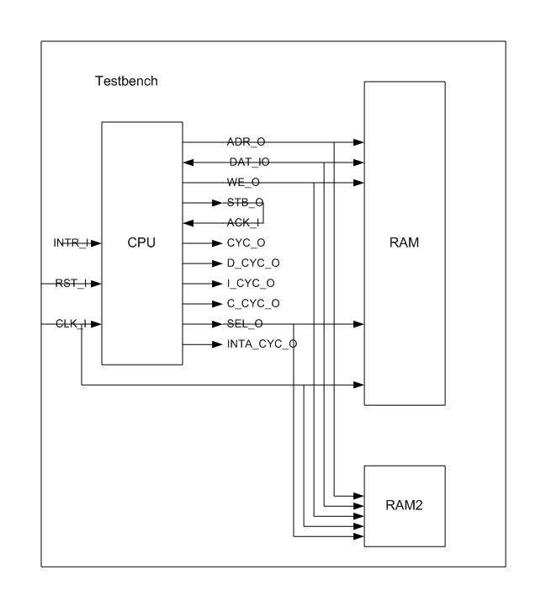
Figure: 1.1 – DUT and test harness

Microprocessor based designs like PC, embedded computer consist of memory (ROM/RAM), peripherals. By using Bus Functional Models of memory and peripherals, designer can simulate the target system using testbenches. A Bus Functional Model is a model that emulates internal operations as well as bus interfaces and bus transactions.

In testbench we will not model complex system like PC motherboard but a simple system containing a RAM for code and data storage. To test the system, assembly programs are manually converted into machine language and store in file and a RAM was designed model which is able to initialize itself from file contents. The manual machine language conversion is a difficult task, so we tested microprocessor with simple programs, rather than writing comprehensive testing suite. The ModelSim (and other HDL simulators), allows designer to monitor any signal present in any level of hierarchy. We probed the external and internal signals of CPU and RAM contents. We inspected these results manually (by observing waveforms), verify the CPU operations as per specifications.

2 Test bench
The “abstract” view of testbench for CPU is shown in figure 6.2, testbench instantiates CPU (DUT) and two RAM instances: “ram” and “ram2” and connect them with each other, in addition generates clock and reset signals.

The “ram” is instance of entity “ramNx16”, which is configurable BFM of RAM, which supports asynchronous read and synchronous write operations. This type of RAM is commonly available in ASICs and FPGA vendor libraries. The total no. of locations (each 16-bit) is configurable and specified using generic constant “adr_width”. This model can automatically initialize it self during simulation from formatted text file; the file name is also specified using another generic “init_file_name”. The clock signal is provided to both CPU and RAMs. The “ramNx16” has separate data input and (tri-state) output but they are connected to same bidirectional data bus of CPU, therefore only one data line in shown in figure. The address lines (adr_width – 1 .. 0) are connected to slice of address bus (adr_width .. 1) of CPU. The “ramNx16” has a write enable signal which is connected to WE_O pin of CPU and output enable signal; the output enable signal of “ramNx16” is not shown in figure as it is connected to inverted version of WE_O pin of CPU. In addition “ramNx16” supports byte access; two control signals “ub” and “lb” are provided for accessing upper byte and lower byte of 16-bit word, respectively. The “ramNx16”’s instance “ram” is interface at “0000”h location, and used to store the testing code.

The “ram2” is instance of entity “ram8x16”. “ram8x16” is similar to “ramNx16”, but it has only 8 locations. These locations are initialized using 8 generic constants “init_n” (n = 0 – 7). All the testing programs are manually converted in binary format, to reuse same program for different data, we use separate ram instance for storing data.

The top level entity “test” is designed to be a general and reusable test harness for many test programs. For this purpose the “test” includes several generic values. The simulation environments provide support to override the default generic values before simulation, either as command-line parameters or through menus selection. The generic constants are provided to specify clock period, CPU’s PC and SP preset values, “ram” instance’s address width/no of locations and initialization file name, eight generic constants “ram2_init_n” for initialization of “ram2” instance, “ram2_adr” for specifying the interfacing location of “ram2”. These values can be easily configured to simulate any program on HPC-16 CPU.

The test bench provides the reset signal to CPU for 5 clock cycles. After reset CPU starts its activity. The ModelSim and other simulators provide facility to monitor any port, signal or shared variable, present in any level of hierarchy. Therefore not only we can monitor the CPU interfaces but also the internal registers in CPU datapath, state of control unit (maintained in cur_state and nxt_state signal) and contents of both “ram” and “ram2”. By monitoring these waveforms, we made necessary correction in CPU and finally verified the essential operations of CPU.

3 Test program
We already mentioned that due to unavailability of essential software tools for HPC-16, like assembler, complier etc; we have manually converted programs into appropriate binary format for testbench. It was therefore, not feasible for us to write bigger assembly programs and then manually convert them, also the main purpose was to test the working of instructions, not to bench mark the CPU performance. The performance bench marking is an advanced issue; we shall deal it in future releases (Insha Allah). For rest of this section we describe how the simple program given bellow is executed during simulation, the simulation waveforms are given in results section.

.code
.org 0 |adr |
li r0, adr(opr1) |0000|01001_001, 0000_0000, 1111_1111, 0000_0000
li r6, adr(opr2) |0004|01001_001, 0110_0000, 1111_1111, 0000_0010
ld r2, [r0] |0008|00001_000, 0010_0000
ld r3, [r6] |000A|00001_000, 0011_0110
add r2, r3 |000C|00110_001, 0010_0011
li r8, adr(result)|000E|01001_001, 1000_0000, 1111_1111, 0000_0100
st r2, [r8] |0012|00010_000, 0010_1000,
hlt |0014|11111_000, 0000_0000
.data
opr1
7fff |ff00|0111_1111, 1111_1111
opr2
1 |ff02|0000_0000, 0000_0001
result
???? |ff04|

This simple program written in HPC-16 assembly language adds two 16-bit integer variables and stores the result into third variable; these variables will be stored in “ram2”. On right hand side the machine language decoding of program is given. First R0 register is loaded with address of first operand (ff00h), in next instruction R6 register is loaded with address of second operand (ff02h). Next two instructions load the actual operands into R2 and R3 registers using register indirect/base addressing mode. Then R3 is added to R2 and result is stored in R2. Next instruction load the address of third variable (ff04h) into R8, then result in R2 register is stored to address pointed by R8. Finally there is halt instruction, which stops the CPU from further instruction execution.

To load this program into “ramNx16”, the program after machine language translation was slightly converted. The “ramNx16” model require initialization file contain lines of following format.

<address (dec)>:<16-bit data (bin)>

Each line contain address of location where the data need to be stored in decimal with out zero padding, followed by colon and then raw 16-bit binary data with out any underscore, hyphen or comma. The initialization file was given name “add2_init_ram.txt”, file contents are given below:

0:0100100100000000
1:1111111100000000
2:0100100101100000
3:1111111100000010
4:0000100000100000
5:0000100000110110
6:0011000100100011
7:0100100110000000
8:1111111100000100
9:0001000000101000
10:1111100000000000

Next we generated new simulation configuration in ModelSim and specify the following generic values:

clk_period = 40 ns
half_clk_period = 20 ns
cpu_pc_preset_value = X”0000”
cpu_sp_preset_value = X”001e”
ram_adr_width = 4
file_name_prefix = “add2”
sim_stop_time = 3000 ns
ram2_adr = X”ff00”
ram2_init_0 = X”7fff”
ram2_init_1 = X”0001”

The simulation is performed at 25 MHz, according to Xilinx synthesis tool report, the current HPC-16 implementation supports maximum 35 MHz clock. Since code is simple there is no chance for any exception, so instead of wasting space for interrupt vectors we used that space, during simulation excessive chunks of memory (RAM models) degrade the simulation performance. For this program, we use “ramNx16” instance with 16 locations (adr_width = 4) and specified “0000”h and “0001e”h for preset values of PC and SP. To specify the initialization file, we need to specify the prefix “add2”, “test” entity require that file name of initialization file should end with “_init_ram.txt”. The “ram2” is interfaced at “ff00”h (address of first operand). Then the data operands are given as “ram2_init_0” and “ram2_init_1”.

