PROGRAMMING:
The usual way of programming a processor is to write the code into an editor, assemble/compile it using some tools and create binary files. This requires working out in software domain. Since I’m not a software person, I’ve used a much simple approach to program it.

A Perl script is written to create “rom.v” file for simulation. Perl script to be run in command line mode would ask to enter mnemonics and further relevant parameters, if required.
e.g. you entered instruction mnemonic Ldi (Ld immediate data); you’ll be asked to enter 8-bit data.
If mnemonic you entered is Ld or ST or some ALU instruction, you’ll be asked for Negation bit, I/O/MEMORY field and 7-bit address.
Some instructions like UARTstat, UARTrd etc., don’t require any field data.
Entering wrong instruction mnemonic will result in insertion of NOP instruction, not really implemented but will waste one processor cycle.

This script however, is not smart enough to check whether you made any mistake in entering field data. e.g. If you entered 6 or 7-bits instead of 8-bits in Ldi instruction field, you’ll get 1 or 2 bits less in the instruction and incorrect instruction in your “rom.v” .

This script is tested using ActivePerl 5.16 on Windows Operating System. Line number 8 and 12 in perl script contain path of output files “rom.v” and “asm.txt”. You can edit it for your system.

List of Mnemonics:
END, JMP, Ld, Ldi, ST, ADD, SUB, MUL, DIV, AND, OR, XOR, GT, GE, EQ, LE, LT, PRE, ETY, RST, LdTC, LdACC, UARTrd, UARTwr, UARTstat.
These are indeed same as defined in the instruction Set.
All are Case-Sensitive.
EXAMPLE PLC PROGRAM:
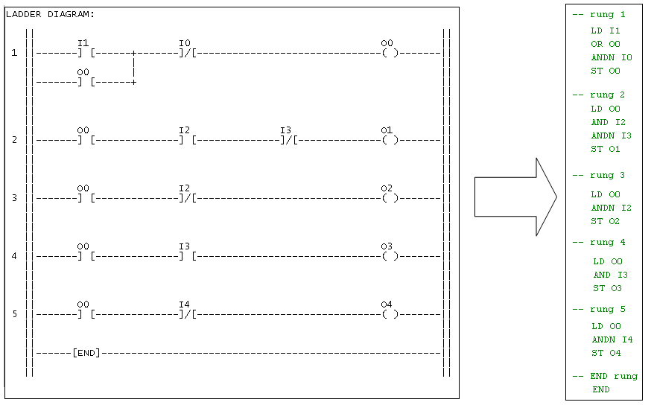

A PLC ‘Ladder Diagram’ is usually converted to ‘Instruction List’ program, as shown above.
This program then can be entered to “rom.v” using the Perl script.
For rung-1 above, there are four instructions:
- LD I1
- Enter the mnemonic Ld.
- Negate? Y or N should be N.
- i/o/b/B should be i
- address is 0000001
- OR O0
- Enter the mnemonic OR
- Negate? Y or N should be N
- i/o/b/B should be o
- address is 0000000
- ANDN I0
- Enter the mnemonic AND
- Negate? Y or N should ne Y (because of ADDN)
- i/o/b/B should be I
- address is 0000000

- ST O0
- Enter the mnemonic ST
- Negate? Y or N should be N
- i/o/b/B should be o
- address is 0000000

Last rung is END instruction, which means end of ladder diagram and start-over again.
Entering the mnemonic END would ask whether start is 0? Say Y.

This is one of the simplest programs containing Load, Store, AND, OR and END.

