Programmable DCT Accelerator with a 16-bit Microcontroller

Advisor: Dr. Vijay K. Madisetti

Authors:
Arish Alreja
Chung Ching Lin
Dhruv Srivastava
Girish Jain
Michael Smith
Navraj Singh
Ramanathan Palaniappan
Sunpyo Hong

Rev. 1.1
July 31, 2026
Revision History
Rev. | Date | Author | Description
1.0 | 5/04/2007 | Arish Alreja | Initial Draft
1.1 | 7/06/2007 | Arish Alreja | Modified, for submission to www.opencores.org

TABLE OF CONTENTS

1. Introduction 2
2. System Architecture 3
I. Processor Architecture 4
II. Wishbone Compliant DCT Core 5
3. Operation 6
I. MicroController Toolflow 6
II. Programming the Microcontroller 6
III. DCT Operation 8
4. Software 13
I. Sample Application, Integrated with RTOS 13
II. Verification 13
5. References 14
6. Appendix A. DCT Wishbone Specification 15

Introduction

The DCT Accelarator with a 16 bit Microcontroller was undertaken as a class project for ECE 4273 taught by Dr. Vijay K. Madisetti at the Georgia Institute of Technology, Atlanta GA during the Spring 2007 semester.

This project implements a DCT Hardware accelerator + 16 bit Microcontroller System augmented with an external memory. The system may be used in an application which requires fast computation of DCT’s along with other general purpose computing functions as well.

The 16 bit Microcontroller used in this system has been written by Dr. Juergen Sauermann. The 64 point DCT core used has been written by Mr. Michael Krepa. The additional memory added to the system uses a memory model developed by Mr. Jamil Khatib. All of the above have been obtained from www.opencores.org .

During the course of the project, the following developments were undertaken

- Wishbone compliance of the MDCT core (Wishbone Wrapper)
- Integration of 16 bit MCU, WB compliant MDCT core, and memory to provide a wishbone interconnected system.
- 16 bit MCU assembly code to execute DCT’s and create 4x4 and 2x2 tiles, this code has also been integrated into the RTOS of the 16 bit MCU.

System Architecture

The system uses the Wishbone interface of the 16 bit microcontroller to tie it to the MDCT Core (modified with a wishbone wrapper), and a Wishbone compliant dual port external memory (64 kB). The following block diagram represents the system simulated at the tesbench level.
Processor

Internal Mem.

External
Mem.
DCT Core
0x2001
INPIMAGE
WB
CHIP
SEL.
LOGIC
Internal Mem.
8kb
Top 8K
Reset
Reset
Mem to File

Reset
Figure 1. System Architecture as simulated in the testbench

The 16 bit microcontroller has 8kB of internal memory. The wishbone interface is used only when a location greater than 8192 or 0x2000 is addressed. Due to this region, the first 8kB of the External Dual Port memory is not accessed by the processor, leaving only 56kB on the external memory accessible.

Since the processor has to communicate with both the Dual Port External memory, and the Wishbone Compliant MDCT core the system includes Chip Select Logic which accesses the MDCT core at addresses 8193 and 8194 (0x2001 and 0x2002) so that the distinction between accesses the DCT core and external memory can be made in software. The DCT core is assigned addresses of 8193 and 8194 (0x2001, 0x2002) via the chip select logic, which functions as the arbiter controlling connectivity between the Wishbone interfaces of the Processor to the DCT and External Memory.

The testbench schematic shows the block level interconnects between the processor, DCT core and external memory along with all the accompanying logic for selecting different modules (chip select). The INPIMAGE block and MEM to File block in the testbench are solely for simulation verification purposes. The INPIMAGE block reads from text files and populates the external memory with raw data (before the DCT is computed, while the whole system is in RESET. The Mem to File module logs all the data that is written into the external memory into a text file, which was used for verification against MATLAB scripts.

Processor Architecture
The 16 bit microcontroller for this project was chosen from www.opencores.org . In its original version, it was authored by Dr. Juergen Sauermann. Its main features include an 8 KB unified internal program and data memory, 2 data registers (RR and LL) both supporting different addressing modes and a limited instruction set. There is no accumulator or a flag register. The addressing is 16 bits and the registers are all 16 bits wide. One of the primary features of this 16 bit microcontroller is that it is wishbone compatible.

Instruction decoding and execution follows the use of machine cycles M1 and M2, which are scaled down versions of the CLOCK. Different instructions require different combinations of M1 and M2. The signal T2 is half the clock frequency.

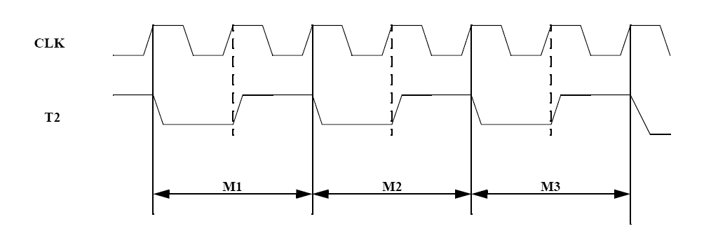
Figure 2. T2 Signal for instruction decode timing.

Wishbone Compliant DCT Core

The original DCT core is a two dimensional discrete cosine transform engine employing multiplier-less parallel distributed arithmetic. This core has a simple I/O interface, which is described in the core specification. However, this interface is not WISHBONE compliant. Following is a description of the WISHBONE wrapper designed to make the core WB compliant.

The following block diagram illustrates how the WISHBONE wrapper surrounds the original DCT core to make the interface WISHBONE compliant.

Figure 3. DCT wishbone wrapper.
MDCT
core
clk
rst
dcti
idv
dcto
odv
Memory Buffer
(64 words,
16 bits wide)
CLK_I
RST_I
STB_I
DAT_I()
CYC_I
DAT_O()
ACK_O
WE_I
WISHBONE Wrapper
16
8
8
RE

Logic
8 bits
8 bits
Data_In
Data Out

Logic
WR

The DCT wishbone datasheet is at the end of this document, and the standard specication is on www.opencores.org .

Operation

MicroController Toolflow
The 16bit Microcontroller comes with its own set of tools to help compile, assemble, simulate and debug programs. It also has its own RTOS (Real Time Operating System).
- C Compiler: Basic C compiler, doesn’t support ‘struct’ or ‘long’
- Assembler : Assembles code to binary, and generates other files helpful in debug.
- Simulator : A simulator written in software, takes in binary and symbol files and simulates the program, can be used to check the VHDL simulation’s final output.

> cd sim simulate
/sim> test.bin test.sym

- Makemem : A Utility to create the 8 Kb on chip memory file in VHDL, while loading the compiled program (binary) on it.
- RTOS : A pre-emptive switching operating system is included in the file rtos.
Code can be inserted into the rtos program and compiled to run with the operating system.

Programming the Microcontroller
Programming the Microprocessor goes through 3 steps, or 2 steps if programming in Assembly
- Compiling C code to assembly
- Assembling Assembly code to binary (Assembly coders start here)
- Loading the binary into the vhdl memory

- Compiling the C code to assembly code:
The compiler is available in the form of an executable named cc80.exe in the directory ‘compiler’.
It takes a C file as an input argument and generates the corresponding assembly code.
The commands are as follows
> cd compiler
/compiler>cc80 memptop filename.c filename.asm

Memtop is the upper limit of the on chip memory. The value is 0x2000 (8192 bytes)
Sample compiler directive:
/compiler> cc80 0x2000 ../test.c ../test.asm (../means 1 directory up)

This directive will compile the file test.c and generate test.asm.

- Assembling assembly code to generate binaries:

The assembler executable is named assembler.exe and is located in the directory ‘asm’. It takes a .asm file and generates the following kind of files

- .bin (Used by makemem to generate vhdl memory)
- .lst (Assembly code indented with the Program Counter and OPCODE listed
for each assembly instruction, useful for debugging purposes)
- .sym (Used by software simulator (/sim/simulator.exe), List of the
symbols for loops etc in the assembly code)
- .ihx (Intel Hex file, used to load code in HW, not relevant to simulation)

The uses of the other files (.lst, .sym, .ihx) are discussed in a late

> cd asm
asm> assembler file.asm file.bin file.lst file.sym file.ihx

It is not necessary to specify the .lst, .sym, .ihx filenames. The assembler assigns them automatically.

/asm> assembler ../test.asm ../test.bin

- Loading the binary into the on chip vhdl memory file for simulation (makemem):

The compiled binary needs to be loaded into a program memory to be simulated in Modelsim. The binary code is stored on the 8 Kb on chip memory, defined by mem_content.vhd.

Whenever changes made to the assembly code are to be simulated in Modelsim, the memory (mem_content.vhd) needs to be recreated and then refreshed in the Modelsim project.
This task of creating a new mem_content.vhd is accomplished by the makemem utility. The makemem utility takes in a binary file and creates a new mem_content.vhd. If an existing mem_content.vhd exists, it is overwritten.

The following directives are used to load the program into the 8 Kb on chip memory.

> cd memory
/memory> makemem ../test.bin

Following this a new mem_content.vhd file is created.
Note: If the MODELSIM project is open, and mem_content.vhd is recreated. The new mem_content.vhd must be recognized and recompiled by MODELSIM in order for a new simulation to run properly.

DCT Operation

WISHBONE Compliant Core
With the WISHBONE wrapper in place, the latency of the system increases to 87 clock cycles, due to a two cycle delay in transferring output data to DAT_O via the new output memory buffer. Another major difference is in the way the DCT values are output. Due to the requirement of making DAT_O signal 8-bits wide, the 12-bit dcto output is first converted into a 16-bit output by zero-padding. The 16-bit output values are then stored in a dual port output memory buffer, from which data is sent out 8-bits at a time. The description of the output buffer is described in more detail later.

Reading/Writing
The DCT core has a WISHBONE slave interface. A WISHBONE master (for example a processor) can initiate either block or single read/write cycles. The typical series of single write cycles recommended for writing 64 values to the DCT core interface is as follows:

Single Write
Clock Edge 0:
- Processor presents valid data on its DAT_O
- Processor asserts WE_O to indicate WRITE cycle
- Processor asserts CYC_O and STB_O to indicate start of cycle/phase

Setup, Edge 1:
- DCT core asserts its ACK_O
- DCT core prepares to latch data on its DAT_I
- DCT core asserts its ACK_O in response to STB_O to indicate latched data
- Processor monitors ACK_I, and prepares to terminate the cycle

Clock Edge 1:
- DCT core latches data on its DAT_I
- Processor negates STB_O, CYC_O, and WE_O (recommended) to indicate the end of the cycle
- DCT core negates its ACK_O in response to negated STB_O

The above described operation on two clock edges can be carrier out 64 times, with any intermediate “quite” periods as per the requirements of the processor, to write 64 data values to the DCT core.

The figure below summarizes this sequence as a timing diagram.
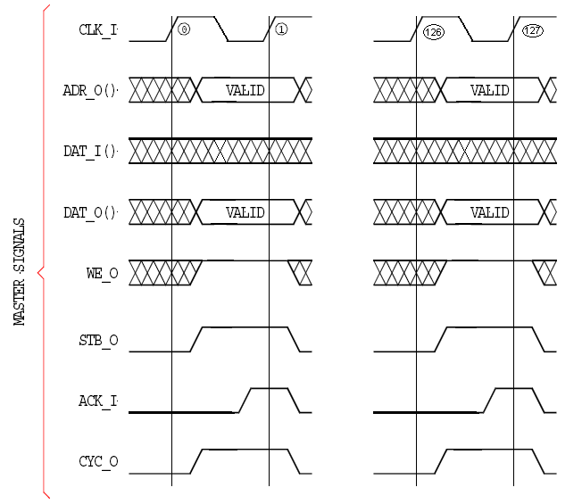
Figure 13. Timing diagram for Single WRITE cycle

As mentioned earlier, a Block Write cycle can also be used to write 64 data values to the DCT core. The follow steps describe this writing scheme:

Block Write
Clock Edge 0:
- Processor asserts WE_O (WE_I for the DCT core) to indicate a WRITE cycle
- Processor asserts its STB_O and CYC_O to indicate cycle start
Setup, Edge 1:
- DCT core prepares to latch data on its DAT_I
- Processor monitors ACK_I, and prepares to terminate current data cycle
Clock Edge 1:
- DCT core latches data on its DAT_I
Setup, Edge 2:
- DCT core keeps ACK_O asserted
- DCT core prepares to latch data on its DAT_I
- Processor monitors ACK_I, and prepares to terminate current data cycle
Clock Edge 2:
- DCT core latches data on its DAT_I
…
Repeat the above two steps 61 times
Setup Edge 64:
- DCT core keeps ACK_O asserted
- DCT core prepares to latch data on its DAT_I
- Processor monitors ACK_I, and prepares to terminate current data cycle
Clock Edge 64:
- DCT core latches data on its DAT_I
- Processor terminates cycle by negating STB_O, CYC_O and WE_O (recommended)
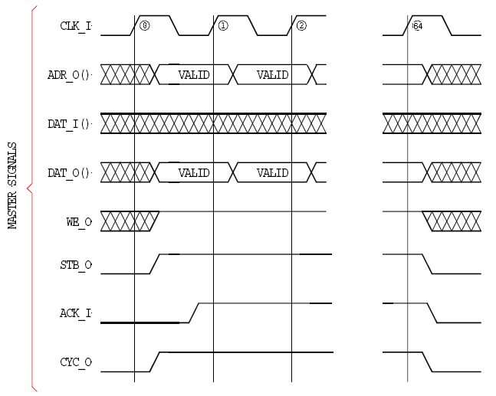
Figure 14. Timing diagram for Block WRITE cycle.

Once data has been written into the DCT core using either Block or Single Write, the DCT core outputs the DCT results after 85 clock cycles from the time of the first latched data value. Since the output is 16-bits wide, it is first written to a 64 word memory buffer. As soon as the first data value has been written to the output buffer, ACK_O goes high, which signals the processor to start a read cycle.

Block Read
The recommended scheme for reading the DCT values is Block Read. A block read cycle consists of the following sequence. The clock edge numbers are counted with the reference clock edge being the one where the first input data value is latched into the DCT core. Please read this carefully because it is assumed the processor will start reading at the 86th clock cycle (with the 1st clock cycle being referenced to the time when first data was written to DCT core).
Clock Edge 86 (counted from the first data value that was written to the DCT core):
- Processor negates WE_O to indicate a READ cycle
- Processor asserts CYC_O and STB_O to indicate start of a cycle/phase

Setup, Edge 87:
- DCT core asserts its ACK_O, indicating data is available to be read from output buffer
- DCT core presents valid data on its DAT_O
- Processor monitors ACK_I, and prepares to latch DAT_I

Clock Edge 87:
- Processor latches data on DAT_I

Setup, Edge 88:
- DCT core keeps ACK_O asserted
- DCT core presents valid data on DAT_O
- Processor monitors ACK_I, and prepares to latch DAT_I

Clock Edge 88
- Processor latches data on DAT_I

…
Repeat the above 2 steps 126 times
…
Setup, Edge 215:
- DCT core keeps ACK_O asserted
- DCT core presents valid data on DAT_O
- Processor monitors ACK_I, and prepares to latch DAT_I

Clock Edge 215:
- Processor latches data on DAT_I
- Processor terminates cycle by negating STB_O and CYC_O

The timing diagram summarizing the above sequence is given on the next page.

Output Memory Buffer
The DCT cores output was originally 12 bits. The processor core only accepts 8 bit inputs. To handle this conflict the original 12 bits was extended to 16 bits and passed into an output buffer. The output buffer then sends out data 8 bits at a time. Addressing is handled internally. When reading it first reads the upper 8 bits at the current read address. The next time data is read from the output buffer it is read from the lower 8 bits at the current address and the read address pointer is subsequently incremented by one. Each time data is written to the output buffer the write address increments by one. The read and write addresses return to zero after incrementing 64 times.

Software
The 16 bit Microcontroller has support for C programming in the form of a compiler. The discerning feature however is the RTOS that accompanies the microcontroller. It allows for high level programming, with task switching driven by interrupts, timers etc.

Sample Application, Integrated with RTOS
A sample application was written to test the system, written in assembly, this application was verified and integrated with the RTOS to implement the processing of multiple tasks on the 16 bit MCU, with DCT computation being done with the MDCT core.

The assembly code was split into 3 separate routines
- Read Data from External Memory and transfer to DCT.
- Read DCT output and Transfer to External Memory.
- Create 4x4 and 2x2 tiles from the DCT.

All assembly routines were tested in an assembly only program. The assembly routines were then split up and integrated into the RTOS program that was available with the 16 bit Microcontroller (rtos.c). The assembly code was inlined into separate tasks, which switch in a round robin fashion from an external interrupt generated in the testbench. The task switching and dependencies among different tasks (DCT output can’t be read until all 64 DCT input’s have been received), were resolved in rtos.c using different global variables as flags to avoid inappropriate task switching avoiding any possibility of the microcontroller hanging.

Verification
For verification of the DCT blocks, a 64x64 pixel section of the lena image was imported into the external memory for DCT calculation. The simulation was run for about 10 minutes or so (only 3x64 point blocks could be simulated in that simulation period). The DCT outputs of the 3x64 point blocks were verified to be correct, and the 4x4 and 2x2 tiles were also verified to be functioning correctly.
Furthermore, 3 sets of 64 point DCT’s validated the task switching and correct looping in the functional part of each task. Although complete verification and code coverage could not be executed in the given time frame. The system was validated to a reasonable extent and found to be functioning correctly.

- References

- Wishbone Specification Rev. B3 (www.opencores.org/
- 16 bit Microcontroller Documentation (www.opencores.org/
- MDCT core Documentation (www.opencores.org/
- Wishbone Compliant MDCT Core Specification (WB_MDCT_SPEC.doc, available with this package)
- Appendix A. DCT Wishbone Specification
According to Rule 2.15 of WISHBONE SoC Architecture Specification Rev. B.3
Applicable to VHDL module "wboprt08.vhdl".
1. The module wboprt08.vhdl was designed against WISHBONE specification B.3.
2. The type of interface is SLAVE.
3. The interface supports the following signals:
- CLK_I
- DAT_I()
- DAT_O()
- RST_I
- ACK_O
- CYC_I
- STB_I
- WE_I

4. The optional ERR_O signal is not supported.
5. The optional RTY_O signal is not supported.
6. The port size is 8 bit.
7. The granularity is 8 bit.
8. The maximum operand size is 16 bit.
9. The data transfer ordering is BIG/LITTLE ENDIAN
10. The sequence of data transfer through the port is UNDEFINED.
11. There are no known constraints on the clock signal.

