Wishbone Wrapper for the MDCT core

Advisor: Dr. Vijay K. Madisetti

Authors:
Arish Alreja
Chung Ching Lin
Dhruv Srivastava
Girish Jain
Michael Smith
Navraj Singh
Ramanathan Palaniappan
Sunpyo Hong

Rev. 1.0
July 31, 2026
Revision History
Rev. | Date | Author | Description
1.0 | 7/7/2006 | Arish Alreja | Initial Draft
1.1

Wishbone Wrapper Architecture
The MDCT core for which this wrapper has been developed was written by Mr. Michael Krepa and is available on www.opencores.org . Wishbone compliance was required to interface and integrate this core with the 16 bit Microcontroller. A wishbone wrapper for the MDCT core was developed to facilitate integration with the other components of the system.

The original DCT core is a two dimensional discrete cosine transform engine employing multiplier-less parallel distributed arithmetic. This core has a simple I/O interface, which is described in the core specification. The following block diagram illustrates how the WISHBONE wrapper surrounds the original DCT core to make the interface WISHBONE compliant.
Figure 7. DCT wishbone wrapper.
MDCT
core
clk
rst
dcti
idv
dcto
odv
Memory Buffer
(64 words,
16 bits wide)
CLK_I
RST_I
STB_I
DAT_I()
CYC_I
DAT_O()
ACK_O
WE_I
WISHBONE Wrapper
16
8
8
RE

Logic
8 bits
8 bits
Data_In
Data Out

Logic
WR

Please refer to the WISHBONE specification Rev. B3 along with the WISHBONE datasheet for the DCT core at the end of this document for detailed information about the function of the various I/O signals.

DCT Operation
Non-WISHBONE Compliant Core

The operation of the Non-WISHBONE compliant DCT core is described in the MDCT spec. The core samples input date at the dcti pin when idv is high, and when eight input values are read internal DCT processing is started. Latency between first latched input data and first DCT transformed output is 85 clock cycles. Thereafter, it takes 64 clock cycles to produce 64 DCT output values.
Regarding output DCT handling, there is odv pin - when high means that dcto output is valid (dcto output is 2D DCT transformed data).
Below is example of host data transfer to MDCT core (only output values after first DCT stage are presented, ie. odv1 and dcto1).

Figure 10. MDCT operation

MDCT core uses synchronous internal RAM (they are connected within core top level which is MDCT entity).
RAM write access example:

Figure 11. Synchronous RAM write access
RAM read access example:
Figure 12. Synchronous RAM/ROM read access

RAM read access waveform is also applicaple to on-chip ROM memories used. There is one cycle delay between read address and output data valid.

WISHBONE Compliant Core
With the WISHBONE wrapper in place, the latency of the system increases to 87 clock cycles, due to a two cycle delay in transferring output data to DAT_O via the new output memory buffer. Another major difference is in the way the DCT values are output. Due to the requirement of making DAT_O signal 8-bits wide, the 12-bit dcto output is first converted into a 16-bit output by zero-padding. The 16-bit output values are then stored in a dual port output memory buffer, from which data is sent out 8-bits at a time. The description of the output buffer is described in more detail later.

Reading/Writing
The DCT core has a WISHBONE slave interface. A WISHBONE master (for example a processor) can initiate either block or single read/write cycles. The typical series of single write cycles recommended for writing 64 values to the DCT core interface is as follows:

Single Write
Clock Edge 0:
- Processor presents valid data on its DAT_O
- Processor asserts WE_O to indicate WRITE cycle
- Processor asserts CYC_O and STB_O to indicate start of cycle/phase

Setup, Edge 1:
- DCT core asserts its ACK_O
- DCT core prepares to latch data on its DAT_I
- DCT core asserts its ACK_O in response to STB_O to indicate latched data
- Processor monitors ACK_I, and prepares to terminate the cycle

Clock Edge 1:
- DCT core latches data on its DAT_I
- Processor negates STB_O, CYC_O, and WE_O (recommended) to indicate the end of the cycle
- DCT core negates its ACK_O in response to negated STB_O

The above described operation on two clock edges can be carrier out 64 times, with any intermediate “quite” periods as per the requirements of the processor, to write 64 data values to the DCT core.

The figure below summarizes this sequence as a timing diagram.
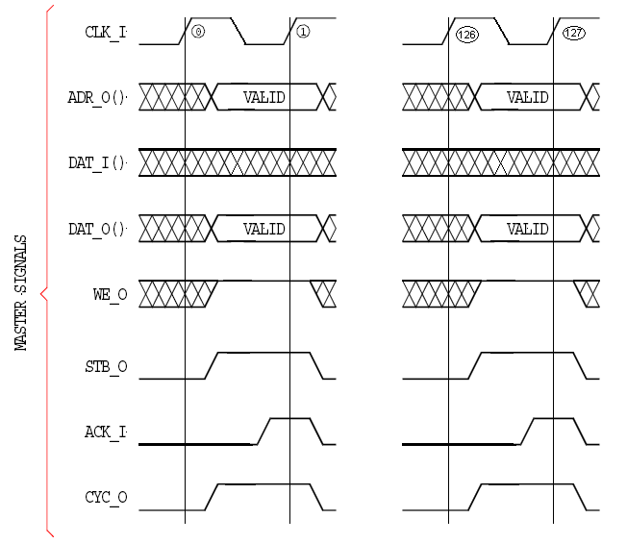
Figure 13. Timing diagram for Single WRITE cycle

As mentioned earlier, a Block Write cycle can also be used to write 64 data values to the DCT core. The follow steps describe this writing scheme:

Block Write
Clock Edge 0:
- Processor asserts WE_O (WE_I for the DCT core) to indicate a WRITE cycle
- Processor asserts its STB_O and CYC_O to indicate cycle start
Setup, Edge 1:
- DCT core prepares to latch data on its DAT_I
- Processor monitors ACK_I, and prepares to terminate current data cycle
Clock Edge 1:
- DCT core latches data on its DAT_I
Setup, Edge 2:
- DCT core keeps ACK_O asserted
- DCT core prepares to latch data on its DAT_I
- Processor monitors ACK_I, and prepares to terminate current data cycle
Clock Edge 2:
- DCT core latches data on its DAT_I…
Repeat the above two steps 61 times
Setup Edge 64:
- DCT core keeps ACK_O asserted
- DCT core prepares to latch data on its DAT_I
- Processor monitors ACK_I, and prepares to terminate current data cycle
Clock Edge 64:
- DCT core latches data on its DAT_I
- Processor terminates cycle by negating STB_O, CYC_O and WE_O (recommended)
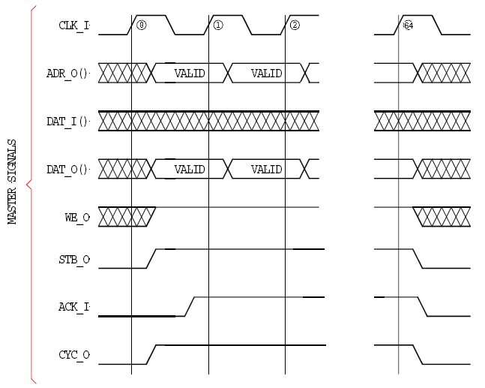
Figure 14. Timing diagram for Block WRITE cycle.

Once data has been written into the DCT core using either Block or Single Write, the DCT core outputs the DCT results after 85 clock cycles from the time of the first latched data value. Since the output is 16-bits wide, it is first written to a 64 word memory buffer. As soon as the first data value has been written to the output buffer, ACK_O goes high, which signals the processor to start a read cycle.

Block Read
The recommended scheme for reading the DCT values is Block Read. A block read cycle consists of the following sequence. The clock edge numbers are counted with the reference clock edge being the one where the first input data value is latched into the DCT core. Please read this carefully because it is assumed the processor will start reading at the 86th clock cycle (with the 1st clock cycle being referenced to the time when first data was written to DCT core).
Clock Edge 86 (counted from the first data value that was written to the DCT core):
- Processor negates WE_O to indicate a READ cycle
- Processor asserts CYC_O and STB_O to indicate start of a cycle/phase

Setup, Edge 87:
- DCT core asserts its ACK_O, indicating data is available to be read from output buffer
- DCT core presents valid data on its DAT_O
- Processor monitors ACK_I, and prepares to latch DAT_I

Clock Edge 87:
- Processor latches data on DAT_I

Setup, Edge 88:
- DCT core keeps ACK_O asserted
- DCT core presents valid data on DAT_O
- Processor monitors ACK_I, and prepares to latch DAT_I

Clock Edge 88
- Processor latches data on DAT_I…

Repeat the above 2 steps 126 times…
Setup, Edge 215:
- DCT core keeps ACK_O asserted
- DCT core presents valid data on DAT_O
- Processor monitors ACK_I, and prepares to latch DAT_I

Clock Edge 215:
- Processor latches data on DAT_I
- Processor terminates cycle by negating STB_O and CYC_O

The timing diagram summarizing the above sequence is given on the next page.

Output Memory Buffer
The DCT cores output was originally 12 bits. The processor core only accepts 8 bit inputs. To handle this conflict the original 12 bits was extended to 16 bits and passed into an output buffer. The output buffer then sends out data 8 bits at a time. Addressing is handled internally. When reading it first reads the upper 8 bits at the current read address. The next time data is read from the output buffer it is read from the lower 8 bits at the current address and the read address pointer is subsequently incremented by one. Each time data is written to the output buffer the write address increments by one. The read and write addresses return to zero after incrementing 64 times.

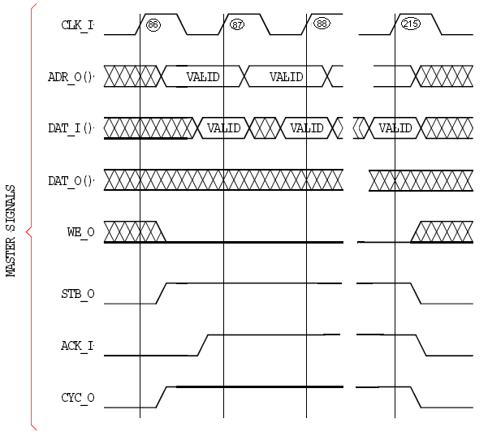
Figure 15. Timing diagram for Block READ cycle. Clock edges are numbered.such that edge 0 is referenced to the first data input latched into the DCT core.

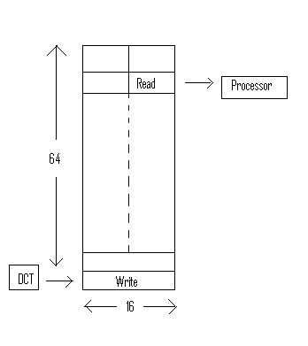
Figure 16. Block diagram for the output memory buffer.

Appendix A DCT Wishbone Specification
According to Rule 2.15 of WISHBONE SoC Architecture Specification Rev. B.3
Applicable to VHDL module "wboprt08.vhdl".

1. The module wboprt08.vhdl was designed against WISHBONE specification B.3.
2. The type of interface is SLAVE.
3. The interface supports the following signals:
- CLK_I
- DAT_I()
- DAT_O()
- RST_I
- ACK_O
- CYC_I
- STB_I
- WE_I
4. The optional ERR_O signal is not supported.
5. The optional RTY_O signal is not supported.
7. The port size is 8 bit.
8. The granularity is 8 bit.
9. The maximum operand size is 16 bit.
10. The data transfer ordering is BIG/LITTLE ENDIAN
11. The sequence of data transfer through the port is UNDEFINED.
12. There are no known constraints on the clock signal.

