
SpaceWire
IP Core
Design Document

Mail to Authors:
btltz
btltz@opencores.org

Rev. 0.1
July 29, 2026

This page has been intentionally left blank.
Revision History
Rev. | Date | Author | Description
0.1 | 02/04/05 | btltz | First Draft

Contents
Introduction 2
Architecture 2
Operation 2
Registers 2
List of Registers 2
Register 1 – Description 2
Clocks 2
IO Ports 2
Appendix A 2
Appendix B 2
Index 2

Introduction
“SpaceWire (SpW) is a Network for space applications composed of nodes and routers interconnected through bi-directional high-speed digital serial links.”
This core has two top modules:
☉ 1. The “SpW interface”. Means a “interface” for SpW network nodes (such as a uP, a ASIC) or Routers to the SpW network.
☉ 2. The SpW Router which composed “SpW interfaces”, a dynamic Switch Matrix
The “SpW interface” could be integrated as a communication peripheral a SoC.
The “Router “ could be a switch device for SpW network.

Architecture
Some notes:
In the PPU, all outputs is not registered, so signal to the receiver and the transmitter are all used as synchronous signals to avoid unsuited operation.

Operation

SpW Interface

DS
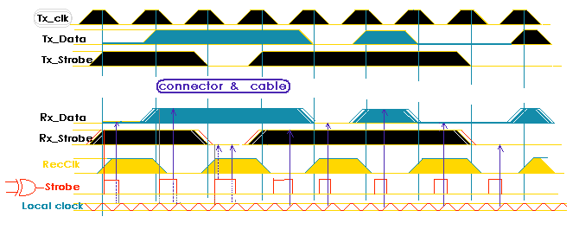

CODEC
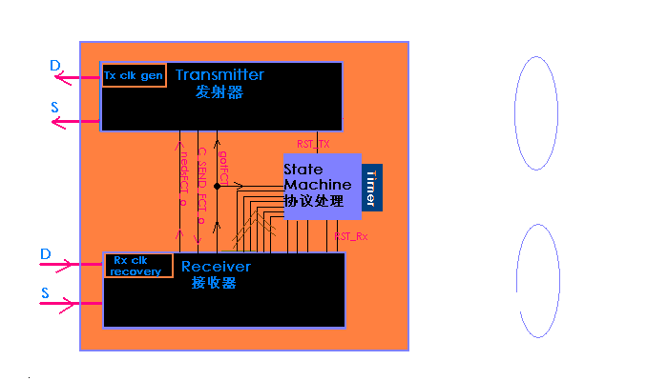
    - PPU
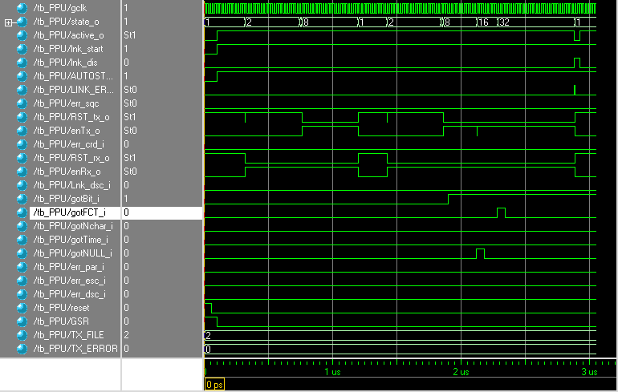
    - Transmitter
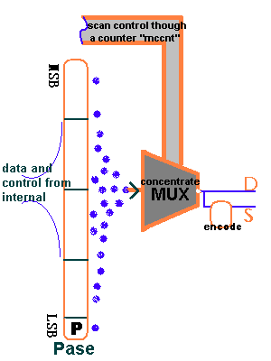

    - Receiver
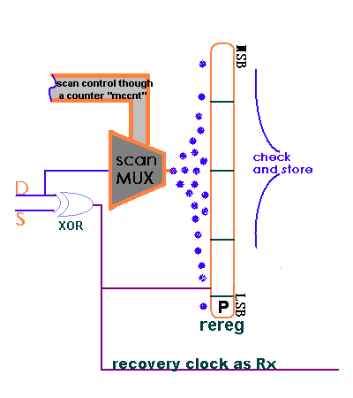

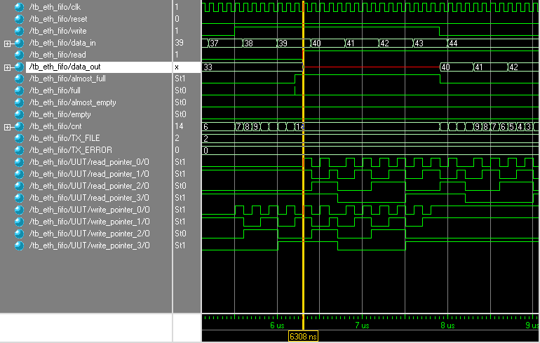

Router
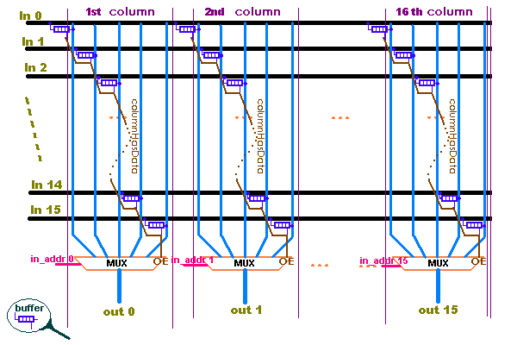

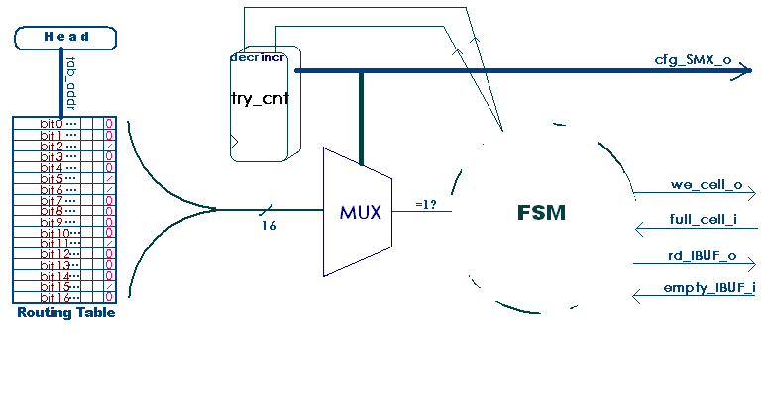

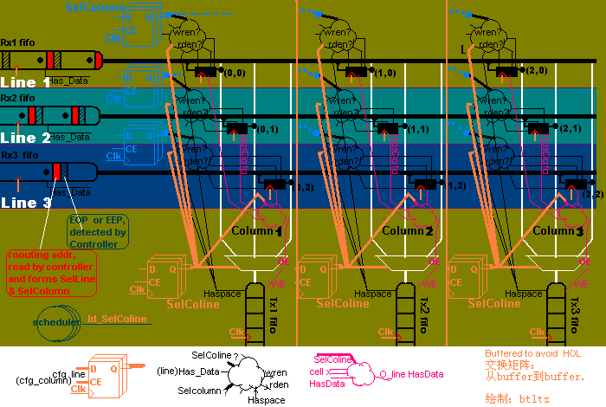

Registers
This section specifies all internal registers. It should completely cover the interface between the core and the host as seen from the software view.

List of Registers
Name | Address | Width | Access | Description
Table 1: List of registers

Register 1 – Description
(You shall choose the style of register you prefer. Do not use both options in one and the same document.)
Bit # | Access | Description
Reset Value:
Reg_Name: 0000h

31 | 30 | 29 | 28 | ... | 8 | 7 | 6 | 5 | 4 | 3 | 2 | 1 | 0
Table 2: Description of registers
Reset Value:
Reg_Name: 0000h

Clocks
This section specifies all the clocks. All clocks, clock domain passes and the clock relations should be described.

Name | Source | Rates (MHz) |  |  | Remarks | Description
Name | Source | Max | Min | Resolution | Remarks | Description
clk_pad_i | Input Pad | 10 | 4 | 0.1 | Duty cycle 70/30. | For external interface.
wb_clk_I | PLL | 200 | - | - | Must be synchronized to sm_clk_i | System clock.
sm_clk_i | Input port | 55 | 40 | 1 | There are multi-clocks paths. | Clock 55MHz for State machine.
Table 3: List of clocks

IO Ports
This section specifies the core IO ports.

Port | Width | Direction | Description
wb_clk_i | 1 | Input | Block’s WISHBONE Clock Input
wb_rst_i | 1 | Input | Block’s WISHBONE Reset Input
wb_sel_i | 4 | Input | Block’s WISHBONE Select Inputs
foo_pad_o | 1 | Output | Block’s foo output to output pad
…
Table 4: List of IO ports

Name
This section may be added to outline different specifications.

Name
This section may be added to outline different specifications.

This section contains an alphabetical list of helpful document entries with their corresponding page numbers.

