RDIC Design Description

Version 2.0.1
December 1, 2009

Technica Corporation
45245 Business Court, Suite 300
Dulles, VA 20166
703.662.2000 phone
703.662.2001 fax
www.technicacorp.com

Table of Contents
Abstract 1
1 Introduction 2
1.1 Java Optimized Processor 3
1.2 Data Flow 3
2 Design Requirements 5
3 Functional Description 7
3.1 RDIC Top-Level Description 7
3.1.1 RDIC Top-Level Ports 8
3.1.2 RDIC Instantiated Components 10
3.2 Memory Access Arbitrator 10
3.2.1 Memory Access Arbitrator Ports 11
3.2.2 Instantiated Components 13
3.2.2.1 Arbitration Path 14
3.2.2.2 Address Path 16
3.2.2.2.1 Virtual Memory Addressing Paradigm 17
3.2.2.2.2 JOP Memory Space 21
3.2.2.2.3 Physical Memory Addresses 22
3.2.2.2.4 Write Address Decoder 23
3.2.2.2.5 Read Address Decoder 24
3.2.2.2.6 Read Data Acknowledge 24
3.2.2.3 Data Path 25
3.2.2.4 Acknowledge Path 25
3.3 Memory Interface Controller 26
3.3.1 Memory Interface Controller Ports 28
3.3.2 DDR SDRAM Preprocessor 30
3.3.2.1 Ports of DDR SDRAM Preprocessor 31
3.3.2.2 DDR SDRAM Preprocessor Instantiated Components 33
3.3.2.2.1 Active_Select 34
3.3.2.2.2 Configure Trigger Select 36
3.3.2.2.3 Read Data Processor 37
3.3.3 Operation FIFO 37
3.3.4 Bank FIFO 37
3.3.5 Column Address FIFO 38
3.3.6 Data FIFO 38
3.3.7 DDR SDRAM Controller 39
3.3.7.1 Ports of DDR SDRAM Controller 40
3.3.7.2 DDR SDRAM Initialization 42
3.3.7.2.1 Mode Register 44
3.3.7.2.1.1 Burst Lengths 45
3.3.7.2.1.2 Burst Types 45
3.3.7.2.1.3 Read Latency 46
3.3.7.2.1.4 Operating Mode 46
3.3.7.3 DDR SDRAM Controller Normal Operation 46
4 Summary 48
5 Acronym List 49
Appendix 50

List of Figures
Figure 1. RDIC Structural Description 2
Figure 2. Sample System Configuration 3
Figure 3. Configuration “A” Data Flow 4
Figure 4. Configuration “B” Data Flow 5
Figure 5. RDIC Model 7
Figure 6. DDR SDRAM RDIC Top-Level Signal Description 8
Figure 7. Structural Description of Memory Access Arbitrator 11
Figure 8. Arbitration Path Description 14
Figure 9. Arbitration State Machine 15
Figure 10. Address Path Description 16
Figure 11. Virtual Address Mapping Scheme 17
Figure 12. Fields of Virtual Memory Address 17
Figure 13. Memory Partition 22
Figure 14. Ports of Write Address Decoder 23
Figure 15. Ports of Read Address Decoder 24
Figure 16. Read Data Acknowledge Ports 25
Figure 17. Data Path Description 25
Figure 18. Acknowledge Path Ports 25
Figure 19. Memory Interface Controller Functional Description 27
Figure 20. DDR SDRAM Preprocessor Functional Description 31
Figure 21. DDR SDRAM Row Activation 34
Figure 22. Active Select FSM Process 35
Figure 23. Read Data Processor 37
Figure 24. Operation FIFO 37
Figure 25. Bank FIFO 38
Figure 26. Column Address FIFO 38
Figure 27. Data FIFO 38
Figure 28. DDR SDRAM Controller 39
Figure 29. DDR SDRAM Initialization Process 44
Figure 30. DDR_ADR_O Mode Register Settings 45
Figure 31. DDR SDRAM Normal Operation 47

List of Tables
Table 1. Top-Level Ports 8
Table 2. Memory Access Arbitrator Ports 11
Table 3. Supported Priority Levels 15
Table 4. Virtual Memory Map 18
Table 5. JOP’s Writeable Memory Space 21
Table 6. Physical Address Contents 23
Table 7. Wishbone Memory Access Associations 23
Table 8. Ports of Memory Interface Controller 28
Table 9. DDR SDRAM Preprocessor Ports 32
Table 10. Configure Trigger Select 36
Table 11. Ports of DDR SDRAM Controller 40
Table 12. DDR SDRAM Command Description 42
Table 13. Burst Definition 45
Table 14. Read Latency Settings 46

Abstract
Technica Corporation is sponsoring a new open source project called Wizardry-Dynamically Reconfigurable System-on-Chip (Wizardry). It is an intelligence system that will be used to enhance control of data traversing a network. As a part of the Wizardry Project, the developmental design objective is to create a memory controller allowing multiple components to access shared memory resources. The memory controller is called the Reconfigurable Double Data Rate Synchronous Dynamic Random Access Memory Interface Controller (RDIC). The RDIC is presented as a tool providing Wizardry devices with priority-based access to shared memory resources.

Introduction
The ML401 Virtex-4 Evaluation Platform board contains a Double Data Rate (DDR) Synchronous Dynamic Random Access Memory (SDRAM) that is capable of operating at a high frequency, storing 512 megabits of data. Since this device is not internal to the Field-Programmable Gate Array (FPGA), it provides a more efficient FPGA device utilization. It is necessary that all Wizardry components have read and write access to this Random Access Memory (RAM), requiring design of a memory controller allowing multiple components to acquire access to the DDR SDRAM without hindering overall speed and size of the Wizardry design. RDIC, as depicted in Figure 1, is designed to facilitate access to the DDR SDRAM.
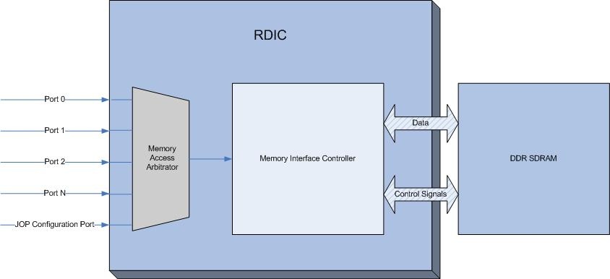
Figure 1. RDIC Structural Description
RDIC uses the Wishbone System-on-Chip (SoC) Interconnection Architecture for Portable Internet Protocol (IP) cores as a general-purpose interface. As such, it defines the standard data exchange between IP core modules.
The Wishbone interconnect is a flexible design methodology for use with semiconductor IP cores. Its purpose is to foster design reuse by alleviating SoC integration problems. This is accomplished by creating a common interface between IP cores and improves portability and reliability of the system.
RDIC is Wishbone compliant and includes the following key features:
- Standardized interface for devices to access memory
- Support for a variety of data width, with range-adjustable granularity
- Full support of priority-based memory access
- Virtual memory addressability for each port
RDIC enables Wizardry to store data that may be processed upstream. Verification of Wizardry functionality is enhanced by the addition of this memory controller to the overall Wizardry design. Several design requirements, detailed in Section 2, have been established to ensure flexible control and use of the memory.

Java Optimized Processor
The Java Optimized Processor (JOP) is an implementation of the Java Virtual Machine (JVM) in hardware. JOP is one way to use a configurable Java processor in small, embedded, real-time systems. JOP is used as the user interface to interactively configure the system at runtime with the capability of adding, removing, and rearranging components that are connected to the RDIC.
JOP can also be used as a task scheduler that determines the overall system function. This task scheduler orchestrates module interaction by controlling the flow of data from one task to the next. Each task performs a portion of the overall system function. Figure 2 illustrates a sample system configuration.
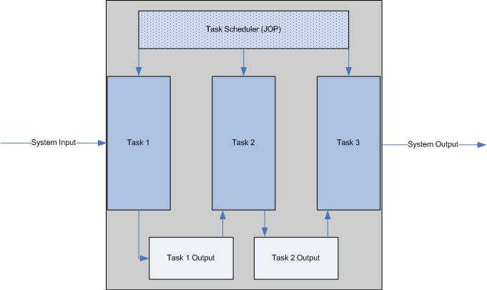
Figure 2. Sample System Configuration
In this configuration, system input data is processed first by Task 1 and then by Tasks 2 and 3. The cumulative function of all tasks defines overall system function.

Data Flow
The JOP is the component in Wizardry that gives the system its reconfigurability. As a task scheduler, JOP determines overall system operation and flow of data based on user input. Figure 3 and Figure 4 illustrate two examples in which data flow may be configured by the JOP. The data flow diagrams provide a high-level view of the data transfer process to and from the user, as well as data transfer between devices. All data must first be stored into the DDR SDRAM before it is accessible by any other device.
Consider a system with four connected devices with tasks scheduled, as follows:
- Task A receives network data for processing.
- Task B processes the output data of Task A.
- Task C processes the output data of Task B.
- Task D also processes the output data of Task B.
- JOP displays the output of Tasks C and D.
The dataflow that achieves this connectivity is presented in Figure 3.
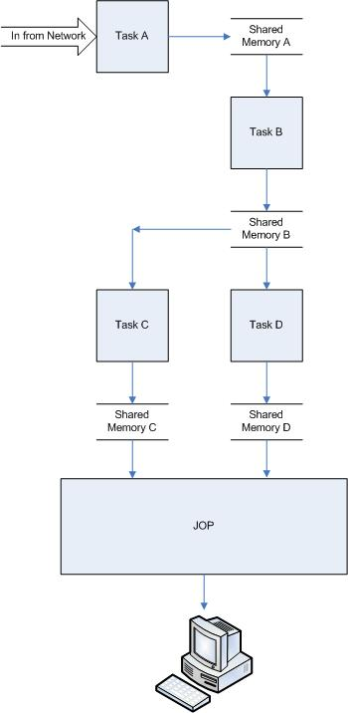
Figure 3. Configuration “A” Data Flow
JOP is the bridge between the user and the system. The user can view output of shared memory locations for all devices. In Figure 3, the shared memory locations of Tasks C and D are viewed through JOP. The flow of data, configured by the JOP, defines system functionality and may be modified at runtime.
Figure 4 illustrates a second data flow configuration example. This configuration illustrates the possibility of any task being able to process the output of any other task. Tasks are scheduled as follows:
- Task 1 parses frame data and stores it to the shared memory.
- Task 4 reads the parsed data stored by Task 1 and searches for a pattern.
- Task 2 reads data stored by Task 4 and stores the processed data to shared memory.
- Task 3 reads shared data from Tasks 1 and 2, resulting in the modification of the frame.
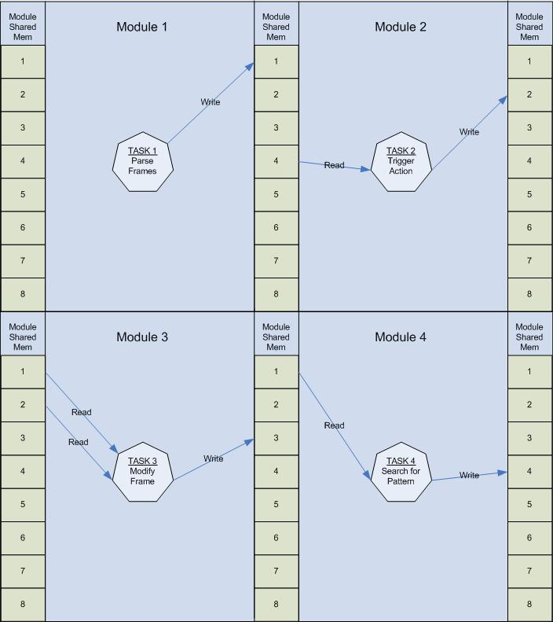
Figure 4. Configuration “B” Data Flow
As illustrated in Figure 3 and Figure 4, the system may be configured in multiple ways, thus greatly influencing functionality.

Design Requirements
The RDIC must be compatible with the current implementation of Wizardry. To ensure proper integration and performance, the design must adhere to the following requirements:
- Integrate with current Wizardry components
- Be compatible with the Infineon DDR SDRAM and adhere to the specifications provided for memory
- Be designed with reconfigurability in mind
Allow additional components to be added or removed
Provide flexible address mapping for each associated component
- Be designed with general DDR SDRAM use in mind, providing compatibility with various DDR SDRAM devices
- Have a multiplexed Memory Controller
- Have minimum FPGA device utilization
- Have a programmable number of system interface ports (8 maximum)
- Have configurable port priority
- Support multi-port system interface data path widths of 8, 16, 32, and 64 bits
- Allow DDR SDRAM Controller to handle all memory tasks, including initialization and refresh cycles
- Have programmable burst lengths (2, 4, or 8 for DDR1 and 4 or 8 for DDR2)

Functional Description
This section provides a high-level functional description of each module in the RDIC, identifying the overall function and purpose, as well as:
- A brief description of each port
- Identification of signals associated with each entity
- List of any additional components
- Detailed functional description of each component
Figure 5 depicts the design and composition of the RDIC, which comprises two modules: The Memory Access Arbitrator and the Memory Interface Controller.
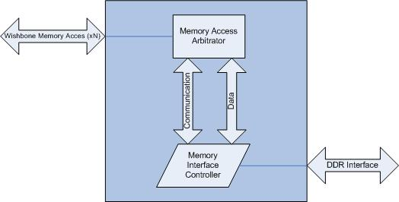
Figure 5. RDIC Model

RDIC Top-Level Description
Function of the RDIC from the highest level incorporates the use of multiple port declarations including Wishbone Memory Access and DDR Interface ports. Wishbone Memory Access ports are used to provide each component with read and write access to memory. DDR Interface ports communicate with the DDR SDRAM, send and receive read and write data, and provide necessary initialization signals to the memory. Memory Access ports connect directly to the Memory Access Arbitrator, while DDR Interface ports connect directly to the DDR SDRAM.
Figure 6 illustrates the source and destination of all top-level signals.

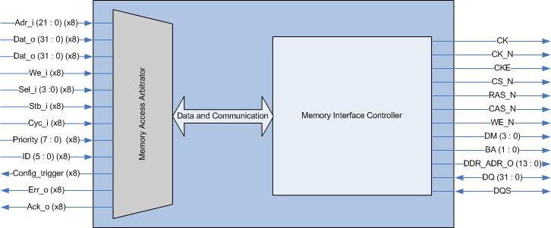
Figure 6. DDR SDRAM RDIC Top-Level Signal Description

RDIC Top-Level Ports
Table 1 provides a detailed description of Wishbone Memory Access and DDR Interface ports, identifying port name, direction, bit width, and type.
Table 1. Top-Level Ports
Port Name | Direction | Bit Width | Port Type | Description
Adr_i | IN | 22 | Wishbone Memory Access | Address of memory location to be read or written from.
Dat_i | IN | 32 | Wishbone Memory Access | Input data written to memory.
Dat_o | Out | 32 | Wishbone Memory Access | Output data read from memory.
We_i | IN | 1 | Wishbone Memory Access | Indicates whether device wants to read or write from memory. When set, indicates write; when clear, indicates read.
Sel_i | IN | 4 | Wishbone Memory Access | Indicates where valid data resides on the Dat_i signal during write,and where it is expected during read. Each bit n of Sel_i corresponds to byte n of Dat_i. When asserted, valid data resides on that byte of Dat_i.
Stb_i | IN | 1 | Wishbone Memory Access | When asserted, along with Cyc_i, indicates that the device is attempting to read or write from memory.
Cyc_i | IN | 1 | Wishbone Memory Access | The cycle input Cyc_i, when asserted, indicates that a valid bus cycle is in progress. The signal is asserted for the duration of all bus cycles.
Priority | IN | 8 | Wishbone Memory Access | Indicates the priority associated with the connected device. Used by the Memory Access Arbitrator to grant access to the DDR SDRAM. Lower vector values indicate higher priority.
ID | IN | 5 | Wishbone Memory Access | Indicates the type of device connected. Used by the Memory Access Arbitrator to keep track of connected devices and device types.
Config_trigger | OUT | 1 | Wishbone Memory Access | Signals connected to device to retrieve configuration data from memory.
Err_o | OUT | 1 | Wishbone Memory Access | Indicates that device may not access memory requested.
Ack_o | OUT | 1 | Wishbone Memory Access | Indicates that write data stored to memory or read data retrieved from memory is valid.
CK | OUT | 1 | DDR Interface | Differential clock output. All address and control signals into the DDR SDRAM are sampled on the positive edge of CK. Input read data from the DDR SDRAM is referenced to the positive and negative edge of CK.
CK_N | OUT | 1 | DDR Interface | Differential clock output. All address and control signals into the DDR SDRAM are sampled on the negative edge of CK_N. Input read data from the DDR SDRAM is referenced to the positive and negative edge of CK_N.
CKE | OUT | 1 | DDR Interface | Clock Enable. CKE HIGH activates, and CKE Low deactivates the internal clock signals, device input buffers, and output drivers of the DDR SDRAM.
CS_N | OUT | 32 | DDR Interface | Chip Select. All DDR SDRAM commands are ignored when CS_N is registered HIGH, which refers to the DDR SDRAM chip not being selected for use.
RAS_N | OUT | 32 | DDR Interface | Row Address Strobe. Along with CS_N, defines the command being entered to the DDR SDRAM.
CAS_N | OUT | 1 | DDR Interface | Column Address Strobe. Along with CS_N, defines the command being entered to the DDR SDRAM.
WE_N | OUT | 1 | DDR Interface | Write Enable. Along with CS_N, defines the command being entered to the DDR SDRAM.
DM | OUT | 4 | DDR Interface | Data Mask. Mask signal for write data (DQ). Value contained on DQ is masked when DM is sampled HIGH coincident with that input data during a Write access.
BA | OUT | 2 | DDR Interface | Bank Address: Defines the bank where an active, read, write, or precharge command is being applied. Also determines if the mode register or extended mode register of the DDR SDRAM is to be accessed.
DDR_ADR_O | OUT | 24 | DDR Interface | Provides the row address for Active Commands, and the column address and auto precharge bit for read/write commands to the DDR SDRAM.
DQ | INOUT | 32 | DDR Interface | Data bus, which contains the data written to or read from the DDR SDRAM.
DQS | INOUT | 1 | DDR Interface | Data Strobe. Input with read data, output with write data. Used to capture read data.
All connected devices must also be Wishbone compliant. For this reason, interfaces must assert Cyc_i and must remain asserted for the duration of the read or write cycle. Cyc_i must be asserted no later than the rising clock edge that qualifies the assertion of Stb_i. Cyc_i must be negated no earlier than the rising clock edge that qualifies the negation of Stb_i.

RDIC Instantiated Components
The following components are included in the top-level structural description of the RDIC:
- Memory Access Arbitrator
- Memory Interface Controller
Sections 3.2 and 3.3 describe the functionality of each component and the interdependence between the two modules.

Memory Access Arbitrator
The Memory Access Arbitrator is the front-end interface for RDIC, providing necessary handshaking signals to each connected device, while granting memory access on a priority basis. The Memory Access Arbitrator meets the following requirements:
- Integrate with current Wizardry components
- Be designed with reconfigurability in mind
Allow additional components to be added or removed
Provide flexible address mapping for each associated component
- Have a multiplexed Memory Controller
- Have minimum FPGA device utilization
- Have a programmable number of system interface ports (8 maximum)
- Have configurable port priority
- Support multi-port system interface data path widths of 8, 16, 32, and 64 bits
Figure 7 illustrates the function and structure of the Memory Access Arbitrator.
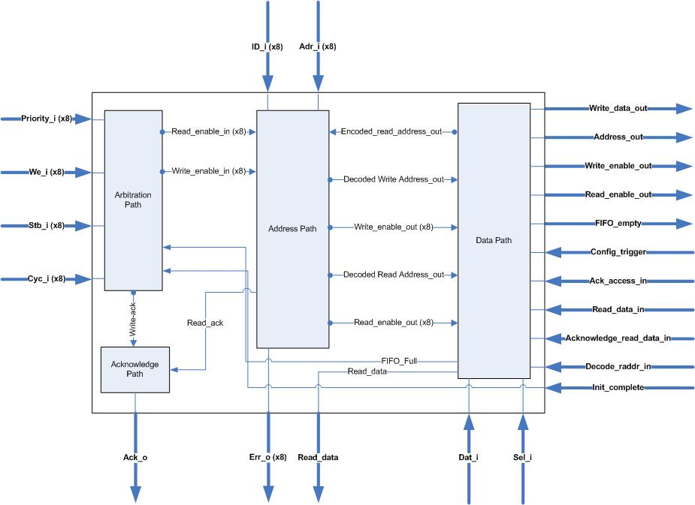
Figure 7. Structural Description of Memory Access Arbitrator

Memory Access Arbitrator Ports
The Memory Access Arbitrator has many entity-declared ports. Table 2 provides a detailed description of Wishbone Memory Access and Preprocessor Interface ports, identifying the port name, direction, bit width, and type.
Table 2. Memory Access Arbitrator Ports
Port Name | Direction | Bit Width | Port Type | Description
Adr_i | IN | 22 | Wishbone Memory Access | Address of memory location from where to read or write.
Dat_i | IN | 32 | Wishbone Memory Access | Input data written to memory.
Dat_o | OUT | 32 | Wishbone Memory Access | Output data read from memory.
We_i | IN | 1 | Wishbone Memory Access | Indicates whether device wants to read or write from memory. When set, indicates write; when clear, indicates read.
Sel_i | IN | 4 | Wishbone Memory Access | Indicates where valid data resides on the Dat_i signal during write and where it is expected during read. Each bit n of Sel_i corresponds to byte n of Dat_i. When asserted, valid data resides on that byte of Dat_i.
Stb_i | IN | 8 | Wishbone Memory Access | When asserted, along with Cyc_i, indicates that the device is attempting to read or write from memory.
Cyc_i | IN | 1 | Wishbone Memory Access | When asserted, along with Stb_i, indicates that the device is attempting to read or write from memory.
ID_i | IN | 5 | Wishbone Memory Access | Unique label used to identify the type of device that is connected.
Err_o | OUT | 6 | Wishbone Memory Access | When asserted, indicates that the requested ID is unconnected to the system and may not be accessed.
Ack_o | OUT | 5 | Wishbone Memory Access | Signal to connected device indicating memory access has been granted.
Priority_i | IN | 8 | Wishbone Memory Access | Indicates the priority associated with the connected device. Used by the Memory Access Arbitrator to grant access to the DDR SDRAM. Lower vector values indicate higher priority.
Ack_access_out | OUT | 1 | Preprocessor Interface | When asserted, pops data from the Write_read_fifo of the mux.
Write_data_out | OUT | 32 | Preprocessor Interface | Contains the data to be written to the DDR SDRAM. Validated by the assertion of the Write_enable_out signal.
Address_out | OUT | 24 | Preprocessor Interface | Contains the address of data being written to or read from the DDR SDRAM. Validated by the assertion of either the Write_enable_out signal or the Read_enable_out signal.
Write_enable_out | OUT | 1 | Preprocessor Interface | When asserted, a write operation is to be executed by the DDR SDRAM Controller.
Read_enable_out | OUT | 1 | Preprocessor Interface | When asserted, a read operation is to be executed by the DDR SDRAM Controller.
FIFO_empty_out | OUT | 1 | Preprocessor Interface | When asserted, indicates that no incoming operations are detected from the Memory Access Arbitrator.
Acknowledge_read_data_in | IN | 1 | Preprocessor Interface | When asserted, informs the Memory Access Arbitrator that new data is available on Read_data_out.
Read_data_in | IN | 1 | Preprocessor Interface | Contains the data read from the DDR SDRAM. Validated by the assertion of the Ack_read_data_out signal.
Decode_read_addr_in | IN | 32 | Preprocessor Interface | Contains the data read from the DDR SDRAM. Validated by the assertion of the Ack_read_data_out signal.
Init_complete | IN | 1 | Preprocessor Interface | When asserted, informs the Memory Access Arbitrator that the DDR SDRAM initialization procedure is complete.
In Table 2, ports that are only 1-bit wide are control signals.

Instantiated Components
The Memory Access Arbitrator is comprised of four subcomponents, which are the following:
- Arbitration Path
- Address Path
- Data Path
- Acknowledge Path
The following sections provide a detailed explanation of each subcomponent.

Arbitration Path
The Arbitration Path component grants devices connected to the Wishbone Memory Access ports access to the DDR SDRAM. The priority associated with each device is used to arbitrate access to the memory. Devices with a higher priority (lower magnitude) are granted access to memory first, while devices with lower priority are granted access last. Figure 8 illustrates the structure and ports of the Arbitration Path.
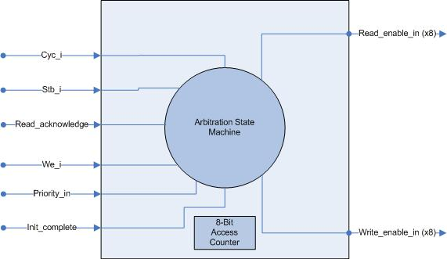
Figure 8. Arbitration Path Description
The Arbitration State Machine is at the heart of the Arbitration Path. This state machine uses an 8-bit counter in conjunction with the priority of devices requesting access to determine if access can be granted. Figure 9 illustrates the function of the Arbitration State Machine.
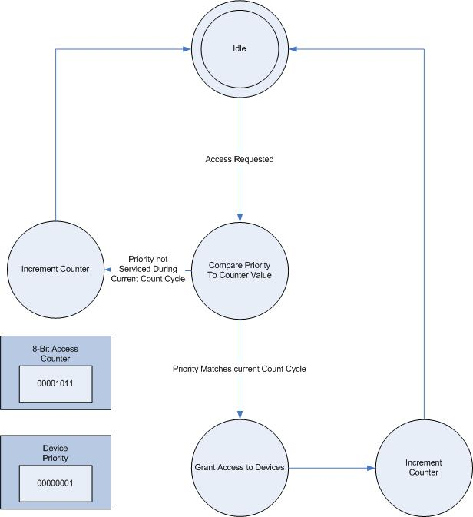
Figure 9. Arbitration State Machine
When a device requests access to memory, the priority of that device is compared to the current value of the access counter. Depending on the result of this comparison, the Arbitration State Machine will perform one of the following functions:
- Defer until a later access count cycle
- Grant during the current access count cycle
Each bit that is set in the counter value corresponds to a priority level that may be granted access during the current access cycle. In Figure 9, the device requesting access has a priority value of “00000001,” and the counter value is “00001011.” Devices with priority “00000001,” “00000010,” or “00001000” may access memory during this access cycle. The device requesting access in this illustration will have access to the memory. Table 3 delineates the memory access paradigm for memory access arbitration.
Table 3. Supported Priority Levels
Priority Level | Corresponding 8-Bit Binary Value
Level 1 | “00000001”
Level 2 | “00000010”
Level 3 | “00000100”
Level 4 | “00001000”
Level 5 | “00010000”
Level 6 | “00100000”
Level 7 | “01000000”
Level 8 | “10000000”
Priority levels are one-hot encoded and, therefore, only one bit may be set to indicate a particular priority.
In the event that multiple devices have the same priority during the current access cycle, the device connected to the lowest port number is granted access first. Access is then granted to the next highest port with the same priority, and so forth. For example, suppose that Wishbone Memory Access Port 1 has the same priority as Port 8. If these two ports are vying for access during the same memory access cycle, Port 1 will receive access, followed by Port 8. This convention addresses priority conflicts for devices connected with the same priority.

Address Path
The Address Path is responsible for mapping the virtual address space of each connected device to the real physical address space of the DDR SDRAM. It is also responsible for asserting an acknowledge signal to the appropriate device when the requested data has been read. Each connected device views the virtual address space as if it encompasses the entire memory. A virtual memory addressing scheme is employed to allow each device to access its own private memory space, as well as a portion of each of the other devices’ shared memory spaces. Figure 10 illustrates the structure and ports of the address path.
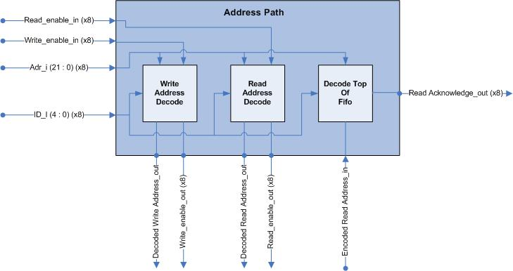
Figure 10. Address Path Description
The 22-bit address, Adr_i, is decoded from a virtual address into a physical address. The Write Address Decode component is used to translate the address locations to be written in memory, while the Read Address Decode component converts addresses to be read from memory. The Decode Top of First In First Out (FIFO) is used to assert the acknowledge signal to the appropriate device as data is read from memory.
The virtual memory address space for each device is mapped in a specific manner. Figure 11 illustrates the overall layout of the virtual address map for each device.
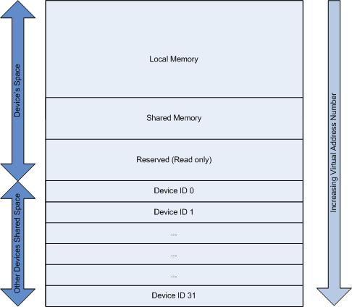
Figure 11. Virtual Address Mapping Scheme
Lower addresses are for the device’s own personal use, while higher addresses indirectly reference the shared memory space of other devices. Shared memory space may be read by performing a read from the virtual address space dedicated to that particular device. However, writing to another device’s shared memory space may not occur.

Virtual Memory Addressing Paradigm
Virtual memory addressing allows non-contiguous memory locations to be addressed as if they were all contiguous. The virtual memory addresses are decoded to physical memory addresses used to access specific locations on the DDR SDRAM. Virtual memory addressing allows each component to access the shared memory location of other connected devices without specific knowledge of where the shared memory is physically located on the DDR SDRAM. A virtual memory address contains three fields, as shown in Figure 12.
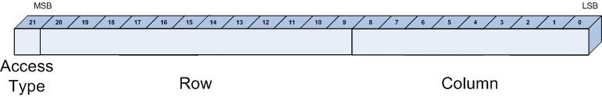
Figure 12. Fields of Virtual Memory Address
Virtual address space is the total number of virtual address locations for each device. Table 4 defines the virtual address space for each device.
Each address includes an access type, row, and column. The virtual address space is divided into two major partitions, demarcated by the access type field. The access type field indicates whether the virtual memory address is local to the device (when set to zero) or whether it is a reference to the shared portion of another device (when set to one). Local memory space consists of the following:
- Private Data: Accessed only by the device.
- Sharable Data: Written by the device, but may be read by another device.
- Reserved Data: Read by the device, but written by JOP.
Table 4 details the virtual addressing scheme, indicating the range of addresses corresponding to each memory designation and a description of the designated range.
Table 4. Virtual Memory Map
Decimal  Representation | Access Type  (Bit 21) | Row  (Bits 20 to 9) | Column  (Bits 8 to 0) | Description
0 | 0 | 000000000000 | 000000000 | Private
… | 0 | … | …
1769471 | 0 | 110101111111 | 111111111
1769472 | 0 | 110110000000 | 000000000 | Sharable
 | 0 | … | …
1835007 | 0 | 110111111111 | 111111111
1835008 | 0 | 111000000000 | 000000000 | Reserved
… | 0 | … | …
2097151 | 0 | 111111111111 | 111111111
2097152 | 1 | 000000000000 | 000000000 | ID0
… | 1 | … | …
2162687 | 1 | 000001111111 | 111111111
2162688 | 1 | 000010000000 | 000000000 | ID1
… |  | … | …
2228223 | 1 | 000011111111 | 111111111
2228224 | 1 | 000100000000 | 000000000 | ID2
… | … | … | …
2293759 | 1 | 000101111111 | 111111111
2293760 | 1 | 000110000000 | 000000000 | ID3
… | … | … | …
2359295 | 1 | 000111111111 | 111111111
2359296 | 1 | 001000000000 | 000000000 | ID4
… | … | … | …
2424831 | 1 | 001001111111 | 111111111
2424832 | 1 | 001010000000 | 000000000 | ID5
… | … | … | …
2490367 | 1 | 001011111111 | 111111111
2490368 | 1 | 001100000000 | 000000000 | ID6
… | … | … | …
2555903 | 1 | 001101111111 | 111111111
2555904 | 1 | 001110000000 | 000000000 | ID7
… | … | … | …
2621439 | 1 | 001111111111 | 111111111
2621440 | 1 | 010000000000 | 000000000 | ID8
… | … | … | …
2686975 | 1 | 010001111111 | 111111111
2686976 | 1 | 010010000000 | 000000000 | ID9
… | … | … | …
2752511 | 1 | 010011111111 | 111111111
2752512 | 1 | 010100000000 | 000000000 | ID10
… | … | … | …
2818047 | 1 | 010101111111 | 111111111
2818048 | 1 | 010110000000 | 000000000 | ID11
… | … | … | …
2883583 | 1 | 010111111111 | 111111111
2883584 | 1 | 011000000000 | 000000000 | ID12
… | … | … | …
2949119 | 1 | 011001111111 | 111111111
2949120 | 1 | 011010000000 | 000000000 | ID13
… | … | … | …
3014655 | 1 | 011011111111 | 111111111
3014656 | 1 | 011100000000 | 000000000 | ID14
… | … | … | …
3080191 | 1 | 011101111111 | 111111111
3080192 | 1 | 011110000000 | 000000000 | ID15
… | … | … | …
3145727 | 1 | 011111111111 | 111111111
3145728 | 1 | 100000000000 | 000000000 | ID16
… | … | … | …
3211263 | 1 | 100001111111 | 111111111
3211264 | 1 | 100010000000 | 000000000 | ID17
… | … | … | …
3276799 | 1 | 100011111111 | 111111111
3276800 | 1 | 100100000000 | 000000000 | ID18
… | … | … | …
3342335 | 1 | 100101111111 | 111111111
3342336 | 1 | 100110000000 | 000000000 | ID19
… | … | … | …
3407871 | 1 | 100111111111 | 111111111
3407872 | 1 | 101000000000 | 000000000 | ID20
… | … | … | …
3473707 | 1 | 101001111111 | 111111111
3473708 | 1 | 101010000000 | 000000000 | ID21
… | … | … | …
3538943 | 1 | 101011111111 | 111111111
3538944 | 1 | 101100000000 | 000000000 | ID22
… | … | … | …
3604479 | 1 | 101101111111 | 111111111
3604480 | 1 | 101110000000 | 000000000 | ID23
… | ... | … | …
3670015 | 1 | 101111111111 | 111111111
3670016 | 1 | 110000000000 | 000000000 | ID24
… | … | … | …
3735551 | 1 | 110001111111 | 111111111
3735552 | 1 | 110010000000 | 000000000 | ID25
… | … | … | …
3801087 | 1 | 110011111111 | 111111111
3801088 | 1 | 110100000000 | 000000000 | ID26
… | … | … | …
3866623 | 1 | 110101111111 | 111111111
3866624 | 1 | 110110000000 | 000000000 | ID27
… | … | … | …
3932159 | 1 | 110111111111 | 111111111
3932160 | 1 | 111000000000 | 000000000 | ID28
… | … | … | …
3997695 | 1 | 111001111111 | 111111111
3997696 | 1 | 111010000000 | 000000000 | ID29
… | … | … | …
4963231 | 1 | 111011111111 | 111111111
4063232 | 1 | 111100000000 | 000000000 | ID30
… | … | … | …
4128767 | 1 | 111101111111 | 111111111
4128768 | 1 | 111110000000 | 000000000 | ID31
… | … | … | …
4194303 | 1 | 111111111111 | 111111111
Either the Write Address Decode component or the Read Address Decode component decodes memory addresses for access to the DDR SDRAM. Virtual memory addresses are decoded into the physical memory address, which corresponds to the physical placement of the memory element on the DDR SDRAM. The following Section 3.2.2.2.2 explains the format of the physical address.

JOP Memory Space
JOP’s virtual memory address space is somewhat different from the address space discussed in Table 4. Although JOP may only write data to the reserved sections, it can still access the sharable portions of memory. Therefore, shared memory locations may be addressed and read in the same manner. When JOP attempts to write data to the DDR SDRAM, the memory address space is arranged in a different order. A detailed explanation of JOP’s writable memory space is provided in Table 5.
Table 5. JOP’s Writeable Memory Space
Unused  (Bits 21 to 19) | Port Select  (Bits 18 to 16) | Row  (Bits 15 to 9) | Column  (Bits 8 to 0) | Description
X | 000 | 0000000 | 000000000 | Port 0 Reserved
… | 0 | … | …
X | 000 | 1111111 | 111111111 | Port 0 Configuration Trigger
X | 001 | 0000000 | 000000000 | Port 1 Reserved
… | 001 | … | …
X | 001 | 1111111 | 111111111 | Port 1 Configuration Trigger
X | 010 | 0000000 | 000000000 | Port 2 Reserved
… | 010 | … | …
X | 010 | 1111111 | 111111111 | Port 2 Configuration Trigger
X | 011 | 0000000 | 000000000 | Port 3 Reserved
… | 011 | … | …
X | 011 | 1111111 | 111111111 | Port 3 Configuration Trigger
X | 100 | 0000000 | 000000000 | Port 4 Reserved
… | 100 | … | …
X | 100 | 1111111 | 111111111 | Port 4 Configuration Trigger
X | 101 | 0000000 | 000000000 | Port 5 Reserved
… | 101 | … | …
X | 101 | 1111111 | 111111111 | Port 5 Configuration Trigger
X | 110 | 0000000 | 000000000 | Port 6 Reserved
… | 110 | … | …
X | 110 | 1111111 | 111111111 | Port 6 Configuration Trigger
X | 111 | 0000000 | 000000000 | Port 7 Reserved
… | 111 | … | …
X | 111 | 1111111 | 111111111 | Port 7 Configuration Trigger
The highest address for each port, row “1111111” and column “111111111” are designated as configuration triggers. When JOP has finished writing configuration data in the reserved section of memory, writing to the highest address may then occur. This causes the Memory Access Controller to assert a Config_trigger_out signal to the appropriate device port. This mechanism enables JOP to write configuration data to the reserved sections of memory and to inform each device of the existence of new configuration data.

Physical Memory Addresses
A physical memory address indicates the actual location of memory on the DDR SDRAM. A physical memory address contains a bank, row, and column. Figure 13 illustrates the layout of the physical memory space.
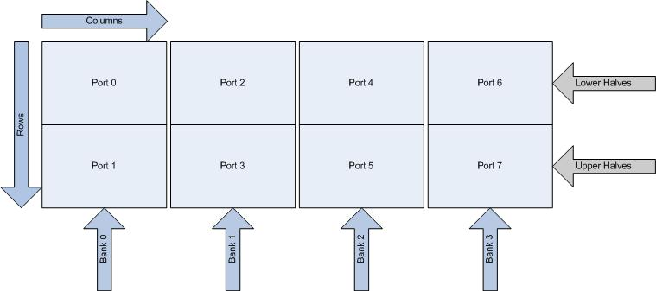
Figure 13. Memory Partition
Since the DDR SDRAM consists of four separate banks, memory space is distributed among each port. Each bank serves as the memory space for two of the eight connected devices. For example, a device connected to Port 0 of the Wishbone Memory Access Interface will access physical memory space of Bank 0. More specifically, Port 0 accesses the lower rows of the Bank 0. This partitioning scheme enables the address decoder to map virtual addresses to the appropriate physical address location. Each physical memory address contains three fields: Bank Select, Row, and Column. Table 6 illustrates the composition of a physical memory address.
Table 6. Physical Address Contents
Bit Location | Corresponding Field
23 – 22 | Bank Select
21 – 9 | Bank Row
8 – 0 | Bank Column
The Write Address Decode and Read Address Decode convert virtual memory addresses to physical memory addresses, detailed in Sections 3.2.2.2.4 and 3.2.2.2.5.

Write Address Decoder
The Write Address Decoder is responsible for translating a virtual address for data to be written to memory as a physical address. When a connected device writes to an address location, that address location must be converted from a virtual memory address to a physical address location designated for that specific port. Each of the eight Wishbone Memory Access ports has a specific portion of memory designated. Figure 14 illustrates the ports associated with the Write Address Decoder.
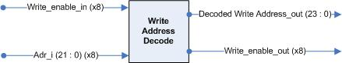
Figure 14. Ports of Write Address Decoder
Upon Write_enable being set by the Memory Access Arbitrator, the Write Address Decoder translates the 22-bit virtual address into a 24-bit physical address. This component cross-references the Wishbone Memory Access port with the appropriate bank. For example, the enable of Wishbone Memory Access Port 0 cross-references with Bank 0. A lookup table is used to properly associate each port’s Write_enable with the proper bank.
This component also uses the Wishbone Memory Access port to determine which half of the bank is designated for that device. For example, Wishbone Memory Access Port 1 writes to the upper half of the Bank 0. Similarly, each port has a specific portion of address locations associated with it. Table 7 illustrates the lookup table used to assign each port with a portion of the DDR SDRAM.
Table 7. Wishbone Memory Access Associations
Wishbone Access Port | Corresponding Bank | Corresponding Rows of Memory
0 | 0 | Lower half of rows
1 | 0 | Upper half of rows
2 | 1 | Lower half of rows
3 | 1 | Upper half of rows
4 | 2 | Lower half of rows
5 | 2 | Upper half of rows
6 | 3 | Lower half of rows
7 | 3 | Upper half of rows

Read Address Decoder
The Read Address Decoder is responsible for translating the virtual address for data to be read from memory into a physical address on the DDR SDRAM. When a connected device reads from an address location, that address location must be converted from a virtual memory address to the physical address location designated for the requested data. Each of the eight Wishbone Memory Access ports has a specific portion of memory designated. Figure 15 illustrates the ports associated with the read address decoder.
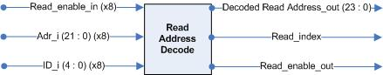
Figure 15. Ports of Read Address Decoder
Upon read enable being set by the Memory Access Arbitrator, the read address decoder translates the 22-bit virtual address into a 24-bit physical address. This component must perform the following steps to translate a read address:
- Determine the ID from which to read.
- Find the port associated with that ID.
- Generate the appropriate bank and portion (upper of lower) for that port.
If the device is attempting to read from its own personal private data or reserved data, the virtual address may be cross-referenced with the Wishbone Memory Access port to determine the bank and portion (upper or lower) for the physical memory address. The bank, row, and column may then be generated and sent to the Data Path as the decoded read address. However, if the device is attempting to read from another device’s shared memory space, the decoder must first determine if the device ID attempting to be read from is actually connected to the Wishbone Memory Access interface. If it is not, the requesting device will not be able to read from that device and will receive an error signal.

Read Data Acknowledge
This component stores the port number of the device requesting read access into a FIFO. Upon each acknowledgement of read data from memory, Read Data Acknowledge asserts an acknowledge signal to the appropriated device. Assertion of the acknowledge bit indicates to the device that the requested read access has been granted. Figure 16 illustrates the ports associated with this entity.
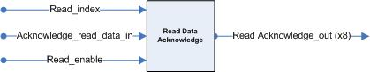
Figure 16. Read Data Acknowledge Ports
Read index corresponds to the port number of the device requesting access. Upon receiving a Read_enable setting, the Read_index is stored into a FIFO data structure. When the Acknowledge_read_data_in signal is received from the Memory Interface Controller, the proper port is sent an acknowledge signal.

Data Path
The Data Path is responsible for packaging memory accesses and assembling them in FIFO data structures. Figure 17 depicts the ports of the data path.
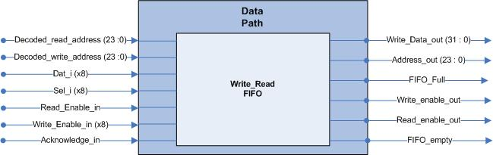
Figure 17. Data Path Description
The data path has a read/write FIFO that contains all memory access requests. Each memory access consisting of Write_data_out, Address_out, Write_enable_out, and Read_enable_out is delivered to the Memory Interface Controller. This component also has a FIFO full signal, indicating that no more reads or writes should be pushed to the data structure. The Memory Interface Controller with the assertion of acknowledge_in pops memory accesses from the FIFO.

Acknowledge Path
This component sends an acknowledge signal to the appropriate Wishbone Memory Access port upon a successful read or write. When the Memory Access Arbitrator asserts a write enable, the Acknowledge Path will assert an Acknowledge to the corresponding port. Similarly, when Read Data Acknowledge asserts a read acknowledge signal, the Acknowledge Path will assert the Acknowledge to the corresponding Wishbone Memory Access port, as shown in Figure 18.
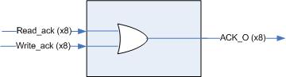
Figure 18. Acknowledge Path Ports
Each of the eight Ack_o ports connects directly to each of the Wishbone Memory Access ports. These acknowledge signals inform the connected device that the memory request has been successfully granted.

Memory Interface Controller
The Memory Interface Controller is responsible for communicating directly with the Memory Access Arbitrator and the DDR SDRAM. The Controller is the back-end interface to the memory technology providing necessary communication signals to transmit data to and from the memory. The Controller meets the following subset of requirements:
- DDR SDRAM Controller handles all memory tasks, including initialization and refresh cycles
- Be compatible with the Infineon DDR SDRAM and adheres to memory specifications
- Be designed with reconfigurability in mind.
- Be designed with general DDR SDRAM use in mind and provide compatibility with various DDR SDRAM devices
- Have minimum FPGA device utilization
- Support multi-port system interface data path widths of 8, 16, 32, and 64 bits
- DDR SDRAM Controller handles all memory tasks, including initialization and refresh cycles
- Have programmable burst lengths (2, 4, or 8 for DDR1 and 4 or 8 for DDR2)
Figure 19 describes the functional description of the Memory Interface Controller, including the interconnection of its instantiated components.
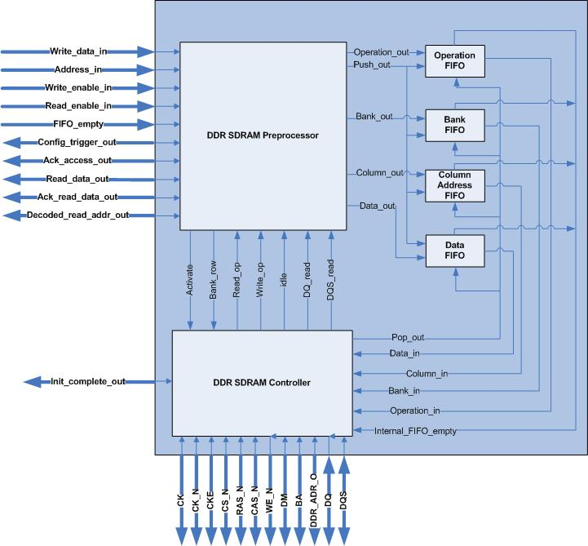
Figure 19. Memory Interface Controller Functional Description
The Memory Interface Controller has top-level ports categorized as Preprocessor Interface and DDR Interface. The Preprocessor Interface ports permit communication between the DDR SDRAM Preprocessor and the Memory Access Arbitrator. The DDR SDRAM Preprocessor uses the Preprocessor Interface ports to receive data being read and to deliver data that is stored to the DDR SDRAM. The DDR SDRAM Controller uses the DDR Interface ports for direct communication with the DDR SDRAM. Control signals pass through these ports to perform read and write operations.
The Controller’s Interface and FIFO Interface are ports internal to the Memory Interface Controller. The following components are also included in the structural description of the Memory Interface Controller:
- DDR SDRAM Preprocessor
- Operation FIFO
- Bank FIFO
- Column Address FIFO
- Data FIFO
- DDR SDRAM Controller
Functionality of each component and interdependence between the modules are described in the following sections.

Memory Interface Controller Ports
Table 8 provides a detailed description of the Memory Interface Controller top-level ports, identifying port name, direction, bit width, and type.
Table 8. Ports of Memory Interface Controller
Port Name | Direction | Bit Width | Port Type | Description
Write_data_in* | IN | 32 | Preprocessor Interface | Contains the data to be written to the DDR SDRAM. Validated by the assertion of the Write_enable_in signal.
Address_in* | IN | 24 | Preprocessor Interface | Contains the address of data being written to or read from the DDR SDRAM. Validated by the assertion of either the Write_enable_in signal or the Read_enable_in signal.
Write_enable_in | IN | 1 | Preprocessor Interface | When asserted, a write operation is to be executed by the DDR SDRAM Controller.
Read_enable_in | IN | 1 | Preprocessor Interface | When asserted, a read operation is to be executed by the DDR SDRAM Controller.
Fifo_empty_in | IN | 1 | Preprocessor Interface | When asserted, indicates that no incoming operations are detected from the Memory Access Arbitrator.
Config_trigger_out | OUT | 8 | Preprocessor Interface | When the ith bit is asserted, informs the ith port of the Memory Access Arbitrator that new configuration data is available in the DDR SDRAM.
Ack_access_out | OUT | 1 | Preprocessor Interface | When asserted, pops data from the Write_read_fifo of the Memory Access Arbitrator.
Read_data_out* | OUT | 32 | Preprocessor Interface | Contains the data read from the DDR SDRAM. Validated by the assertion of the Ack_read_data_out signal.
Ack_read_data_out | OUT | 1 | Preprocessor Interface | When asserted, informs the Memory Access Arbitrator that new data is available on Read_data_out.
Decoded_read_address_out* | OUT | 24 | Preprocessor Interface | Contains the address location of the data read from the ram. Validated by the assertion of the Ack_read_data_out signal.
Init_complete_out | OUT | 1 | Preprocessor Interface | When asserted, informs the Memory Access Arbitrator that the DDR SDRAM initialization procedure is complete.
CK | OUT | 1 | DDR Interface | Differential clock output. All address and control signals into the DDR SDRAM are sampled on the positive edge of CK. Input read data from the DDR SDRAM is referenced to the positive and negative edge of CK.
CK_N | OUT | 1 | DDR Interface | Differential clock output. All address and control signals into the DDR SDRAM are sampled on the negative edge of CK_N. Input read data from the DDR SDRAM is referenced to the positive and negative edge of CK_N.
CKE | OUT | 1 | DDR Interface | Clock Enable. CKE HIGH activates, and CKE Low deactivates the internal clock signals, device input buffers, and output drivers of the DDR SDRAM.
CS_N | OUT | 1 | DDR Interface | Chip Select. All DDR SDRAM commands are ignored when CS_N is registered HIGH, which refers to the DDR SDRAM chip not being selected for use.
RAS_N | OUT | 1 | DDR Interface | Row Address Strobe. Along with CS_N defines the command being entered to the DDR SDRAM.
CAS_N | OUT | 1 | DDR Interface | Column Address Strobe. Along with CS_N defines the command being entered to the DDR SDRAM.
WE_N | OUT | 1 | DDR Interface | Write Enable. Along with CS_N defines the command being entered to the DDR SDRAM.
DM* | OUT | 4 | DDR Interface | Data Mask. Mask signal for write data (DQ). Value contained on DQ is ignored when DM is sampled HIGH. Each bit corresponds to the byte being ignored.
BA | OUT | 2 | DDR Interface | Bank Address: Defines which bank an active, read, write or precharge command is being applied. Also determines if the mode register or extended mode register of the DDR SDRAM is to be accessed.
DDR_ADR_O* | OUT | 22 | DDR Interface | Provide the row address for active commands, and the column address and auto precharge bit for read/write commands to the DDR SDRAM
DQ* | INOUT | 32 | DDR Interface | Data bus, which contains the data written to or read from the DDR SDRAM
DQS | INOUT | 1 | DDR Interface | Data Strobe: Input with read data, output with write data. Remains in the High-Z state when no read or write data transfer is being performed.  DQ is sampled at the transition of DQS to capture read data, and DQ is validated at the transition of DQS to store data.
* indicates that the port has a variable bit width to accommodate for actual DDR SDRAM type being used. The bit width shown represents the requirements for the stacked 256 Mbit DDR SDRAM used for this design.

DDR SDRAM Preprocessor
The DDR SDRAM Preprocessor communicates directly with the Memory Access Arbitrator, the DDR SDRAM Controller, and all FIFOs through the Preprocessor Interface, Controller’s Interface, and FIFO Interface ports, respectively. Figure 20 illustrates the functional description of the DDR SDRAM Preprocessor.
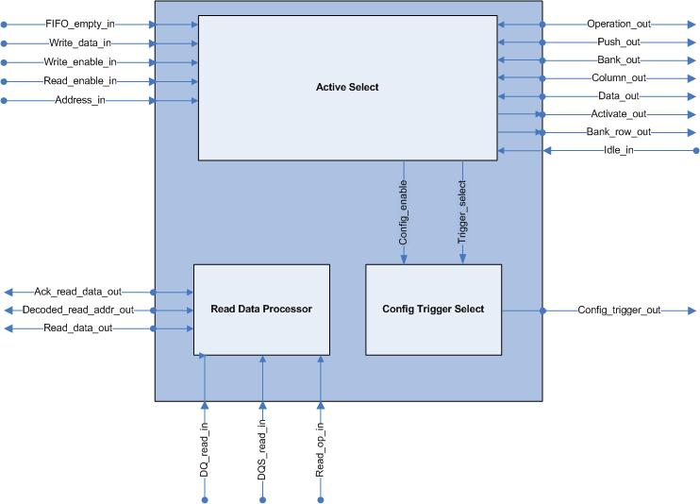
Figure 20. DDR SDRAM Preprocessor Functional Description
The Controller’s Interface ports are used for communication between the DDR SDRAM Preprocessor and the DDR SDRAM Controller. The DDR SDRAM Preprocessor uses these ports to initiate active commands via Active Select, while the Read Data Processor uses these ports to receive data read from the DDR SDRAM. These ports also inform the Read Data Processor of the DDR SDRAM Controller’s current execution state.
Active Select uses the FIFO Interface ports to send DDR SDRAM access request data to all FIFOs when a read or write operation is present.

Ports of DDR SDRAM Preprocessor
Table 9 provides a detailed description of the DDR SDRAM Preprocessor top-level ports, identifying port name, direction, bit width, and type.
Table 9. DDR SDRAM Preprocessor Ports
Port Name | Direction | Bit Width | Port Type | Description
Write_data_in* | IN | 32 | Preprocessor Interface | Contains the data to be written to the DDR SDRAM. Validated by the assertion of the Write_enable_in signal.
Address_in* | IN | 24 | Preprocessor Interface | Contains the address of data being written to or read from the DDR SDRAM. Validated by the assertion of either the Write_enable_in signal or the Read_enable_in signal.
Write_enable_in | IN | 1 | Preprocessor Interface | When asserted, a write operation is to be executed by the DDR SDRAM Controller.
Read_enable_in | IN | 1 | Preprocessor Interface | When asserted, a read operation is to be executed by the DDR SDRAM Controller.
Fifo_empty_in | IN | 1 | Preprocessor Interface | When asserted, indicates that no incoming operations are detected from the Memory Access Arbitrator.
Read_data_out* | OUT | 32 | Preprocessor Interface | Contains the data read from the DDR SDRAM. Validated by the assertion of the Ack_read_data_out signal.
Ack_read_data_out | OUT | 1 | Preprocessor Interface | When asserted, informs the Memory Access Arbitrator that new data is available on Read_data_out.
Decoded_read_address_out* | OUT | 24 | Preprocessor Interface | Contains the address location of the data read from the ram. Validated by the assertion of the Ack_read_data_out signal.
Config_trigger_out | OUT | 8 | Preprocessor Interface | When the ith bit is asserted, informs the ith port of the Memory Access Arbitrator that new configuration data is available in the DDR SDRAM.
Activate_out | OUT | 1 | Controllers Interface | When asserted, alerts the DDR SDRAM Controller that a new bank and row should be activated.
Bank_row_out* | OUT | 15 | Controllers Interface | Contains the bank and row address to be activated.
Read_op_in | IN | 1 | Controllers Interface | When asserted, informs the DDR SDRAM Preprocessor that the current operation being executed by the DDR SDRAM Controller is a read operation.
Idle_in | IN | 1 | Controllers Interface | When asserted, informs the DDR SDRAM Preprocessor that the DDR SDRAM Controller is in the idle state and ready to begin an operation.
DQ_read_in* | IN | 32 | Controllers Interface | Contains input data read from the DDR SDRAM.
DQS_read_in | IN | 1 | Controllers Interface | Remains in the High-Z state when no read data transfer is being performed.  DQ_read_in is sampled at the transition of DQS_read_in to capture read data.
Operation_out | OUT | 2 | FIFO In  Interface | Contains the operation type that is received from the Operation FIFO. It is used to specify if a read or write operation is to be executed.
Push_out | OUT | 1 | FIFO In  Interface | When asserted, sends the operation type and data to all FIFOs.
Bank_out | OUT | 2 | FIFO In  Interface | Contains the Bank Address that is delivered to the Bank Address FIFO. It is used to specify which bank will be accessed during a read or write command.
Column_out* | OUT | 9 | FIFO  Interface | Contains the column address that is delivered to the Column Address FIFO. It is used to specify the correct DDR SDRAM memory location.
Data_out* | OUT | 32 | FIFO Interface | Contains the write data that is delivered to the Data FIFO.
* Indicates that the port has a variable bit width to accommodate for actual DDR SDRAM type being used. The bit width shown represents the requirements for the stacked 256 Mbit DDR SDRAM used for this design.

DDR SDRAM Preprocessor Instantiated Components
The following components are included in the structural description of the DDR SDRAM Preprocessor:
- Active_Select
- Configure_Trigger_Select
- Read_Data_Out_FIFO
A thorough explanation, provided in Section 3.3.2.2.1 through Section 3.3.2.2.3, describes the functionality of each component and the interdependence between modules.

Active_Select
Active Select is a Finite State Machine (FSM) that is responsible for determining the number of banks and rows that may be active simultaneously to achieve a faster data transfer rate. It also determines if the current write operation is a configuration acknowledgement that must be interpreted.
There are four banks used for storage that are available in the DDR SDRAM. Each bank holds up to one fourth of the total amount of physical address space in the DDR SDRAM and contains rows and columns that are used as the physical address to be accessed. For example, if each bank has “n” number of rows and each row has “m” number of columns, each bank would have “n x m” total addressable locations. In order to access any column, the row in which the specific column exists must be activated. For proper operation of the DDR SDRAM, only one row per bank may be active at any instance. This allows a maximum of four rows, each in a different bank, to be active at one time, as illustrated in Figure 21.
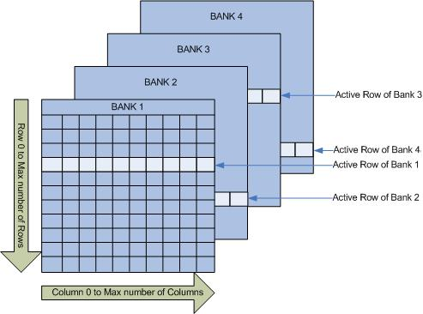
Figure 21. DDR SDRAM Row Activation
The most significant bits of Address_in represent the bank and row address to be activated. Figure 22 demonstrates the conceptual process used to determine which operation to perform. Banks may be activated in any order. For that reason, bank activation refers to the order in which bank values are received.
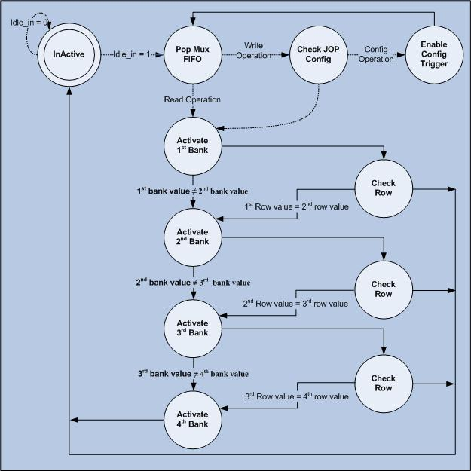
Figure 22. Active Select FSM Process
The Active Select FSM must first receive an asserted Idle_in signal, which indicates that the DDR SDRAM Controller is awaiting new instructions. Once this condition has been met, a read or write operation is popped from the Memory Access Arbitrator FIFO. This is achieved by asserting the Ack_access_out signal when the Memory Access Arbitrator FIFO is not empty during the Pop Mux FIFO state. During a write operation, the Active_Select FSM will determine if data must be delivered to the DDR SDRAM Controller for storage or if a new configuration has been previously written to memory.
A new configuration is determined by receiving a write operation to the last reserved memory address location of a specific device. If a value of ‘1’ exists at every bit of Address_in, excluding the three most significant bits, this delineates the last reserved memory address location of any device. The three most significant bits of Address_in, validated by the assertion of config_enable_out, are delivered to Configure_Trigger_Select described in Section 3.3.2.2.2, through the Configuration Interface ports.
If a new configuration is not verified, the Active_Select FSM begins the process of activating banks, as illustrated in Figure 22, to make the incoming information available to the DDR SDRAM Controller for further processing. All Activate states assert the activate signal and provide the corresponding bank and row address values on Bank_row_out for the DDR SDRAM Controller. In addition, all data required to perform the requested DDR SDRAM access operation, including the bank address, is also pushed onto the FIFOs by asserting Push_out and providing proper data to the corresponding FIFO.
If a new DDR SDRAM access request is from the same bank but different row of any pending access request, the Active_Select FSM must exit the bank activation process and return to the Inactive state where it remains until the DDR SDRAM Controller return to its idle state.

Configure Trigger Select
The Configure Trigger Select component provides the Config_trigger_out signal to alert any device that the JOP has stored new configuration data, and is available in the DDR SDRAM. The Configure Trigger Select component is activated by the assertion of the config_enable_in signal provided by Active_Select. The trigger select signal, which contains the three most significant bits of Address_in, validated by the assertion of the config_enable_in signal, is used to determine the value presented on Config_trigger_out, as illustrated in Table 10.
Table 10. Configure Trigger Select
Trigger Select | Config_trigger_out | Port Number
000 | 00000001 | 0
001 | 00000010 | 1
010 | 00000100 | 2
011 | 00001000 | 3
100 | 00010000 | 4
101 | 00100000 | 5
110 | 01000000 | 6
111 | 10000000 | 7
Config_trigger_out is one-hot encoded so that each bit can be set to indicate new configuration data for devices connected to a particular port.

Read Data Processor
The Read Data Processor is a FIFO that delivers the data read from the DDR SDRAM after a read command has been initiated. Figure 23 illustrates the signals flowing to and from the Read Data Processor.
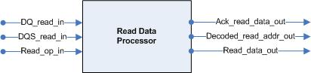
Figure 23. Read Data Processor
The assertion of the Read_op_in signal notifies the Read Data Processor that the DDR SDRAM Controller has delivered a read request to the DDR SDRAM. The Read Data Processor will begin a cycle counter to count the read latency to know when the data is to be expected from the DDR SDRAM. The read latency is the delay, in clock cycles, between the registration of a read command and the availability of the first output data.
Once the data is received along with the detection of the edge transition of the DQS_read_in signal, the data delivered to the Memory Access Arbitrator, validated by the assertion of the Ack_read_data_out signal.

Operation FIFO
The Operation FIFO contains a queue of the operations to be performed by the DDR SDRAM Controller. Figure 24 shows the signals flowing to and from the Operation FIFO.
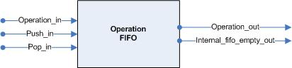
Figure 24. Operation FIFO
Once the DDR SDRAM Preprocessor asserts the push_in signal, the Operation FIFO stores the value contained on Operation_in. Operation_in is a 2-bit signal. Each signal corresponds to a write or read operation when asserted. The pop_in signal, asserted by the DDR SDRAM Controller, places the requested data on the operation_out signal. The Operation FIFO asserts internal_fifo_empty_out when all data has been removed.

Bank FIFO
The Bank FIFO contains a queue of banks to be accessed by the DDR SDRAM Controller. Figure 25 shows the signals flowing to and from the Bank FIFO.
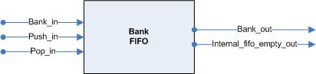
Figure 25. Bank FIFO
When the DDR SDRAM Preprocessor asserts the push_in signal, the Bank FIFO stores the value contained on bank_in. Bank_in is a 2-bit signal corresponding to the selected bank. The pop_in signal, asserted by the DDR SDRAM Controller, places the requested data on the Bank_out signal. The Bank FIFO asserts internal_fifo_empty_out once all data has been removed.

Column Address FIFO
The Column Address FIFO contains a queue of the columns to be accessed by the DDR SDRAM Controller. Figure 26 shows the signals flowing to and from the Column Address FIFO.
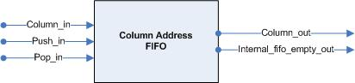
Figure 26. Column Address FIFO
Once the DDR SDRAM Preprocessor asserts the push_in signal, the Column Address FIFO stores the value contained on Column_in. Column_in is a 9-bit signal corresponding to the selected column. The pop_in signal, asserted by the DDR SDRAM Controller places the requested data on the Column_out signal. The Column Address FIFO asserts internal_fifo_empty_out when all data contained within has been removed.

Data FIFO
The Data FIFO contains a queue of the data to be written to the DDR SDRAM by the DDR SDRAM Controller. Figure 27 shows the signals flowing to and from the Data FIFO.
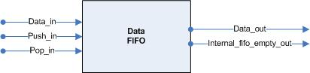
Figure 27. Data FIFO
When the DDR SDRAM Preprocessor asserts the push_in signal, the Data FIFO stores the value contained on Data_in. Data_in is a 32-bit signal corresponding to the data being written. The pop_in signal, asserted by the DDR SDRAM Controller, places the requested data on the Data_out signal. The Data_FIFO asserts internal_fifo_empty_out once all data contained within is removed.

DDR SDRAM Controller
The DDR SDRAM Controller is an FSM, illustrated in Figure 28, which communicates directly with the DDR SDRAM and the DDR SDRAM Preprocessor. Several ports are available in the DDR SDRAM Controller. Theses ports include the Controller’s Interface, FIFO Interface, and DDR Interface. The Controller’s Interface is used to communicate with the DDR SDRAM Preprocessor. Active commands are initiated, and read operation results are delivered through these ports. The FIFO Interface ports are used to receive read and write operation data. The DDR Interface ports are used for direct communication with the DDR SDRAM. All read and write commands to the DDR SDRAM are delivered through these ports.
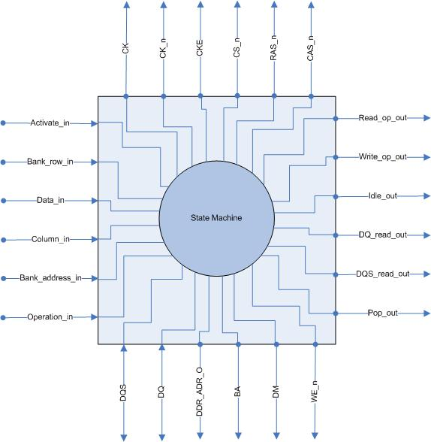
Figure 28. DDR SDRAM Controller

Ports of DDR SDRAM Controller
A detailed description of the DDR SDRAM Controller top-level ports identifying port name, direction, bit width, and type, is described in Table 11.
Table 11. Ports of DDR SDRAM Controller
Port Name | Direction | Bit Width | Port Type | Description
Activate_in | IN | 1 | Controllers Interface | When asserted, alerts the DDR SDRAM Controller that a new bank and row should be activated
Bank_row_in | IN | 22 | Controllers Interface | Contains the bank and row address to be activated.
Read_op_out | OUT | 1 | Controllers Interface | When asserted, informs the DDR SDRAM Preprocessor that the current operation being executed by the DDR SDRAM Controller is a read operation.
Write_op_out | OUT | 1 | Controllers Interface | When asserted, informs the DDR SDRAM Preprocessor that the current operation being executed by the DDR SDRAM Controller is a write operation.
Idle_out | OUT | 1 | Controllers Interface | When asserted, informs the DDR SDRAM Preprocessor that the DDR SDRAM Controller is in the idle state and is ready to begin an operation.
DQ_read_out | OUT | 32 | Controllers Interface | Contains the input data read from the DDR SDRAM.
DQS_read_out | OUT | 1 | Controllers Interface | Used to capture data contained on DQ_read_in.
Pop_out | OUT | 1 | FIFO Interface | When asserted, requests the operation type and data from all FIFOs.
Data_in | IN | 32 | FIFO Interface | Contains the write data that is obtained from the Data FIFO.
Column_in | IN | 9 | FIFO Interface | Contains the column address that is obtained from the Column Address FIFO. It is used to access the correct DDR SDRAM memory location.
Bank _address_in | IN | 2 | FIFO Interface | Contains the bank address that is obtained from the Bank Address FIFO. It is used to specify which bank is being accessed during a read or write command.
Operation_in | IN | 2 | FIFO Interface | Contains the operation type that is received from the Operation FIFO. It is used to specify if a read or write operation is to be executed.
CK | OUT | 1 | DDR Interface | Differential clock output. All address and control signals into the DDR SDRAM are sampled on the positive edge of CK. Input read data from the DDR SDRAM is referenced to the positive and negative edge of CK.
CK_N | OUT | 1 | DDR Interface | Differential clock output. All address and control signals into the DDR SDRAM are sampled on the negative edge of CK_N. Input read data from the DDR SDRAM is referenced to the positive and negative edge of CK_N.
CKE | OUT | 1 | DDR Interface | Clock Enable. CKE HIGH activates, and CKE Low deactivates the internal clock signals, device input buffers, and output drivers of the DDR SDRAM.
CS_N | OUT | 1 | DDR Interface | Chip Select. All DDR SDRAM commands are ignored when CS_N is registered HIGH, which refers to the DDR SDRAM chip not being selected for use.
RAS_N | OUT | 1 | DDR Interface | Row Address Strobe. Along with CS_N defines the command being entered to the DDR SDRAM.
CAS_N | OUT | 1 | DDR Interface | Column Address Strobe. Along with CS_N defines the command being entered to the DDR SDRAM.
WE_N | OUT | 1 | DDR Interface | Write Enable. Along with CS_N defines the command being entered to the DDR SDRAM.
DM | OUT | 4 | DDR Interface | Data Mask. Mask signal for write data (DQ). Value contained on DQ is ignored when DM is sampled HIGH. Each bit corresponds to the byte being ignored.
BA | OUT | 2 | DDR Interface | Bank Address. Defines which bank an active, read, write or precharge command is being applied. Also determines if the mode register or extended mode register of the DDR SDRAM is to be accessed.
DDR_ADR_O | OUT | 22 | DDR Interface | Provide the row address for active commands, and the column address and auto precharge bit for read/write commands to the DDR SDRAM
DQ | INOUT | 32 | DDR Interface | Data bus, which contains the data written to or read from the DDR SDRAM
DQS | INOUT | 1 | DDR Interface | Data Strobe. Input with read data, output with write data. Used to capture read data.

DDR SDRAM Initialization
DDR SDRAM must be initialized in a predefined manner, which is accomplished by issuing specific commands. Table 12 references how available DDR SDRAM commands are selected by the DDR SDRAM Controller.
Table 12. DDR SDRAM Command Description
COMMAND | CS_n | RAS_n | CAS_n | WE_n | DDR_ADR_O | Description
DESELECT (NO OPERATION (NOP)) | 1 | X | X | X | X | Instructs NOP to be performed by asserting CS_N to deselect the DDR SDRAM chip.
NOP | 0 | 1 | 1 | 1 | X | Instructs no operation to be performed by deselecting RAS_N, CAS_N, and WE_N, while CS_N is still active.
ACTIVE | 0 | 0 | 1 | 1 | Bank/Row | Select Bank and Activate Row. BA provides the bank address, and DDR_ADR_O provides the row address.
READ | 0 | 1 | 0 | 1 | Bank/Column | Select Bank, Column, and start read bursts; BA provides the bank address. DDR_ADR_O(0) – DDR_ADR_O(8) provide the column address.
WRITE | 0 | 1 | 0 | 0 | Bank/Column | Select Bank, Column, and start write bursts; DDR_ADR_O(0) – DDR_ADR_O(8) provide the column address.
BURST TERMINATE | 0 | 1 | 1 | 0 | X | Applies only to read bursts.
PRECHARGE | 0 | 0 | 1 | 0 | Code | Deactivate row in bank or banks. When DDR_ADR_O(10) is low, the value on BA determines which bank is precharged. When DDR_ADR_O (10) is high, all banks are precharged.
AUTO REFRESH | 0 | 0 | 0 | 1 | X | Retains data within the DDR SDRAM. Must be used at an average periodic interval of 7.8 µs (maximum)
MODE REGISTER SET | 0 | 0 | 0 | 0 | Op-Code | Selects the current operating mode of the DDR SDRAM.
The initialization process is illustrated in Figure 29. The DDR SDRAM must issue the commands as defined. Not doing so may result in undefined operation.
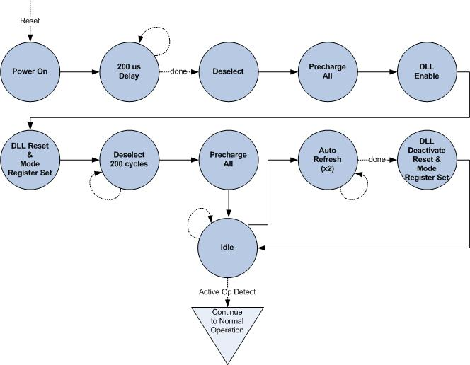
Figure 29. DDR SDRAM Initialization Process
After the clock is stable, the DDR SDRAM requires a 200 µs delay prior to applying an executable command. Once the 200 µs delay has been satisfied, a DESELECT or NOP command should be applied, and CKE should be brought HIGH. Following the NOP command, a PRECHARGE ALL command should be applied. Next, a MODE REGISTER SET command should be issued for the Extended Mode Register to enable the Delay Lock Loop (DLL) and to program the operating parameters. 200 Clock cycles are required between the DLL reset and any executable command. A PRECHARGE ALL command should be applied, placing the DDR SDRAM in the “all banks idle” state.
Once in the idle state, two AUTO refresh cycles must be performed. Additionally, a MODE REGISTER SET command for the Mode Register, with the reset DLL bit deactivated, must be performed. Following these cycles, the DDR SDRAM is ready for normal operation.

Mode Register
The DDR SDRAM Controller must set the Mode Register of the DDR SDRAM to define the specific mode of operation. This definition includes the selection of a burst length, Burst Type (BT), a Column Address Strobe (CAS) Latency, and Operating Mode. The burst length, burst type, and CAS Latency to be used during execution are parameterizable and may be changed to meet the requirements of the DDR SDRAM being used. The DDR SDRAM Controller programs the Mode Register when the command signals are set to the proper settings, as described in Table 12. BA must have the value “00” to access the Mode Register. The values contained on DDR_ADR_O specify the programmable settings of the Mode Register. Figure 30 illustrates the bits that affect each setting.
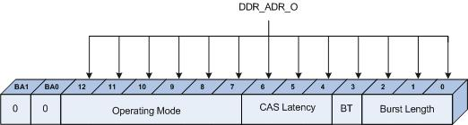
Figure 30. DDR_ADR_O Mode Register Settings
BA must be set to “00” in order to access the Mode Register.

Burst Lengths
Read and write accesses to the DDR SRAM are burst oriented, with the burst length being programmable. The burst length determines the maximum number of column locations that can be accessed for a given read or write command. Burst lengths of 2, 4, or 8 locations are available for both the sequential and the interleaved burst types. The burst length definition is described in Table 13.
Table 13. Burst Definition
Burst Length | Starting Column Address |  |  | Order of Accesses Within a Burst
Burst Length | Bit 2 | Bit 1 | Bit 0 | Type = Sequential | Type = Interleaved
2 |  |  | 0 | 0-1 | 0-1
2 |  |  | 1 | 1-0 | 1-0
4 |  | 0 | 0 | 0-1-2-3 | 0-1-2-3
4 |  | 0 | 1 | 1-2-3-0 | 1-0-3-2
4 |  | 1 | 0 | 2-3-0-1 | 2-3-0-1
4 |  | 1 | 1 | 3-0-1-2 | 3-2-1-0
8 | 0 | 0 | 0 | 0-1-2-3-4-5-6-7 | 0-1-2-3-4-5-6-7
8 | 0 | 0 | 1 | 1-2-3-4-5-6-7-0 | 1-0-3-2-5-4-7-6
8 | 0 | 1 | 0 | 2-3-4-5-6-7-0-1 | 2-3-0-1-6-7-4-5
8 | 0 | 1 | 1 | 3-4-5-6-7-0-1-2 | 3-2-1-0-7-6-5-4
8 | 1 | 0 | 0 | 4-5-6-7-0-1-2-3 | 4-5-6-7-0-1-2-3
8 | 1 | 0 | 1 | 5-6-7-0-1-2-3-4 | 5-4-7-6-1-0-3-2
8 | 1 | 1 | 0 | 6-7-0-1-2-3-4-5 | 6-7-4-5-2-3-0-1
8 | 1 | 1 | 1 | 7-0-1-2-3-4-5-6 | 7-6-5-4-3-2-1-0
In Table 13, “Bit” refers to the bit location of DDR_ADR_O.

Burst Types
Accesses within a given burst may be programmed to be either sequential or interleaved. This is referred to as the burst type and is selected with bit 3 of DDR_ADR_O. When asserted, the bursts will be interleaved and sequential when low. The columns will be accessed in the order as defined in Table 13.
The burst type is a parameter that may be changed to fit the specifications of the DDR SDRAM being used.

Read Latency
The read latency is the delay in clock cycles between the registration of a read command and the availability of the first piece of read data. The latency is a parameter that may be changed to fit the DDR SDRAM type being used. If a read command is registered at clock edge n, and the latency is m clocks, the data will be available on clock edge n + m. Table 14 defines possible settings allowed for the read latency.
Table 14. Read Latency Settings
Bit 6 | Bit 5 | Bit 4 | CAS Latency
0 | 1 | 0 | 2
0 | 1 | 1 | 3
1 | 0 | 1 | 1.5
1 | 1 | 0 | 2.5

Operating Mode
The normal operating mode is selected by issuing a Mode Register Set command with DDR_ADR_O bits 7 – 13. each set to zero and bits DDR_ADR_O bits 0 – 6 set to the desired values illustrated in Table 15.
Table 15. Operating Mode Settings
Bit 12 - 9 | Bit 8 | Bit 7 | Bits 6 - 0 | Operating Mode
0 | 0 | 0 | Valid | Normal Operation
0 | 1 | 0 | Valid | Normal Operation/Reset DLL
A DLL reset is initiated by issuing a Mode Register Set command with bit DDR_ADR_O(7) and bits DDR_ADR_O(9 – 12), each set to zero and bit DDR_ADR_O(8) set to one. All remaining bits are set to the desired values for Read Latency, burst type, and burst lengths.

DDR SDRAM Controller Normal Operation
Once initialization is complete, the DDR SDRAM Controller will set the DDR SDRAM to normal operating mode. The DDR SDRAM Controller may begin sending read and write operations to the DDR SDRAM. Figure 31 describes the process to successfully read and write data as quickly as possible.
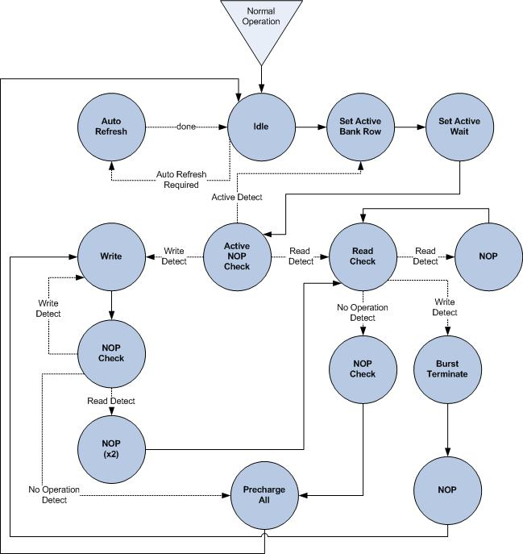
Figure 31. DDR SDRAM Normal Operation
While in the idle state, the DDR SDRAM Controller will wait for the assertion of the activate signal from the DDR SDRAM Preprocessor. Once asserted, the DDR SDRAM Controller will begin the process to activate the bank and row delivered by the DDR SDRAM Preprocessor. This will continue until activate is no longer asserted in the Active NOP Check state. A maximum of four active commands will be allowed by the DDR SDRAM Controller to aid in ensuring defined operation of the DDR SDRAM. Only four active commands are allowed because only one row per bank may be activated at any instance. There are only four banks available in any DDR SDRAM type.
Once the Active NOP Check state detects a read or write command, the DDR SDRAM Controller will request the required data from the FIFOs to execute the commands by asserting the Pop_out signal, and continue to the appropriate state for command execution. Each subsequent NOP state is provided to ensure proper timing before executing new commands. All NOP Check states view the top of the Operation FIFO for any read or write commands awaiting execution. After all operations within the FIFO have been executed, and validated by the assertion of the internal_Fifo_empty_out signal, a Precharge command will be executed to close all rows in all banks to prepare for the next set of instructions.
To execute a read command followed by a write command, a burst terminate command must be executed. To detect this execution pattern the Read state will also check the top of the Operation FIFO for a read or write command.
An auto refresh counter will be constantly counting in the background of the DDR SDRAM Controller. Once this counter reaches a specific range of values, an auto refresh command must be executed to retain the DDR SDRAM data. This counter will send an asserted auto_refresh signal to the DDR SDRAM controller to begin the auto refresh process. Auto refresh is only available from the idle state.

Summary
Each memory port allows access to the DDR SDRAM technology. The RDIC allows several devices to access the DDR SDRAM, each with a specific priority. The RDIC will enhance the functionality of Wizardry, and enable the connection of future modules to compete for access to the shared memory technology. Table 16 provides a reference to the sections that meet the requirements of the RDIC.
Table 16. Requirements Reference
Requirement | Definition
Integrate with current Wizardry components | Memory Access Arbitrator Section 3.2
Compatible with the Infineon DDR SDRAM and Adheres to the specifications provided for the memory | DDR SDRAM Controller Section 3.3.7
Design with reconfigurability in mind  Allow additional components to be added or removed | Memory Access Arbitrator Section 3.2
Provide flexible address mapping for each associated component | Address Path Section 3.2.2.2
Provide compatibility with various DDR SDRAM devices | DDR SDRAM Controller 3.3.7
Memory Controller must be multiplexed | Memory Access Arbitrator 3.2
Programmable number of system interface ports (8 max) | Memory Access Arbitrator Section 3.2
Configurable port priority | Arbitration Path Section 3.2.2.1
Support multi-port system interface data path widths of 8, 16, 32, and 64 bits | Memory Access Arbitrator Section 3.2
DDR SDRAM Controller handles all memory tasks, including initialization and refresh cycles | DDR SDRAM Controller Section 3.3.7
Programmable burst lengths (2, 4, or 8 for DDR1 and 4 or 8 for DDR2) | Burst Lengths Section 3.3.7.2.1.2

Acronym List
Acronym | Definition
BT | Burst Type
CAS | Column Address Strobe
DDR | Double Data Rate
DLL | Delay Lock Loop
EmPAC | Embedded Protocol Analyzing Classifier
eRCP | Enhanced Reconfigurable Content Processor
FIFO | First In First Out
FPGA | Field Programmable Gate Array
FSM | Finite State Machine
ID | Identification
IP | Internet protocol
JOP | Java Optimized Processor
JVM | Java Virtual Machine
NOP | No Operation
RAM | Random Access Memory
RDIC | Reconfigurable DDR SDRAM Interface Controller
SDRAM | Synchronous Dynamic Random Access Memory
SoC | System on Chip

Appendix
This section provides an additional reference for functionality of Wizardry. This section also illustrates how data transfers between the FPGA and user.
Configuring Wizardry Device
To configure any device, the system user enters the configuration request through the Internet connection of a personal computer. JOP translates the information into data compatible for the device and stores it into the DDR SDRAM. The device then retrieves new configuration information from the DDR SDRAM. Figure 32 illustrates the configuration process.
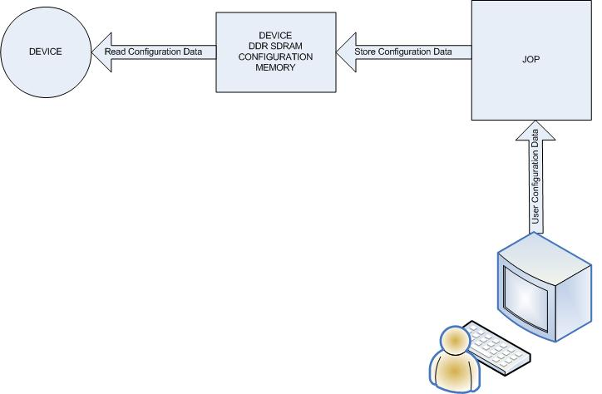
Figure 32. Configuring Wizardry Device
Displaying Wizardry Device Results
The device stores all data results that can be viewed by the user to its shared memory location in the DDR SDRAM. After receiving an instruction from the user to display results, JOP performs a read operation to display the requested data to the user. Figure 33 illustrates how data is displayed to the user.
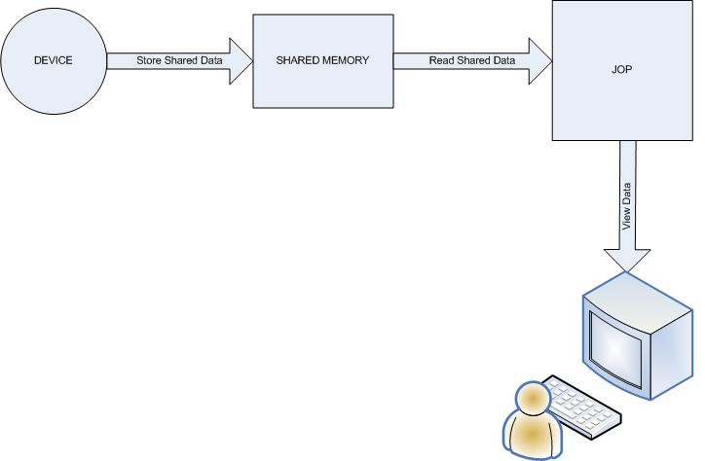
Figure 33. Displaying Wizardry Results
Device-to-Device Communication
In order for a device to access data stored by another device, the data must be stored into the shared memory location. Device 1 stores the data into its shared memory location. Device 2 may then perform a read operation to view the data within the shared memory location of Device 1. Device 2 may not write to the shared memory location of Device 1. Figure 34 illustrates device-to-device communication.
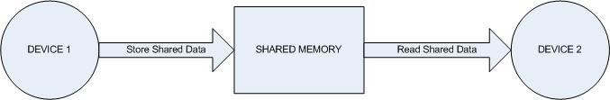
Figure 34. Device-to-Device Communication
Device Personal Storage
All devices are given memory space that may be used for private storage. This memory space is accessible by only the component in which it belongs. The device may store the data to the DDR SDRAM; however, only that device may read the data. Figure 35 illustrates a device’s personal storage.
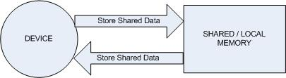
Figure 35. Device Personal Storage

